Covalent bonding: knowledge check
- What type of bonding does this diagram represent? Circle the answer.

covalent bonding ionic bonding metallic bonding
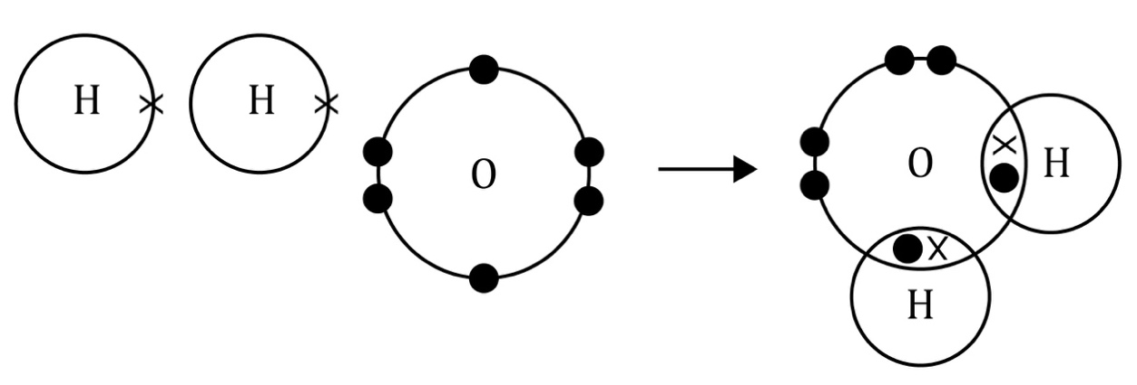
- Use the words to complete the sentences.

covalent electron electrons

non-metal outer

___________________________ bonding – this bonding occurs between ___________________________ atoms. In a single covalent bond, a pair of ___________________________ is shared electrons between two atoms.
These shared electrons are found in the ___________________________ shells of the atoms. Each atom contributes one ___________________________ to the shared pair of electrons.

Covalent bonding: test myself
- What types of elements are involved in covalent bonding?

Circle the correct answer.

metal and non-metal metals only non-metals only

Are covalent bonds strong or weak? Use the correct word to complete the sentence.

strong weak

Covalent bonds are ___________________________.

Which of these is a covalent molecule? Use the correct word to complete the sentence.

carbon dioxide sodium chloride aluminium

The covalent molecule is _____________________________________.

How many electrons are there in a single covalent bond? Use the correct word to complete the sentence.

four one two

There are ___________________________ electrons in a single covalent bond.

Covalent bonding: feeling confident? Try this!
- Complete the bonding diagram to represent the bonding in fluorine.

Covalent bonding: what do I understand?

Think about your answers and confidence level for each mini-topic. Decide whether you understand it well, are unsure or need more help. Tick the appropriate column.
Mini-topic | I understand  this well | I think I understand this | I need more  help
I can interpret diagrams representing covalent bonds.
I know that electrons are shared in covalent bonds.
I know the types of elements involved in covalent bonds.
Feeling confident? topics | I understand  this well | I think I understand this | I need more  help
I can complete a diagram to represent the formation of a covalent bond.

