Properties of stereoisomers – student sheet
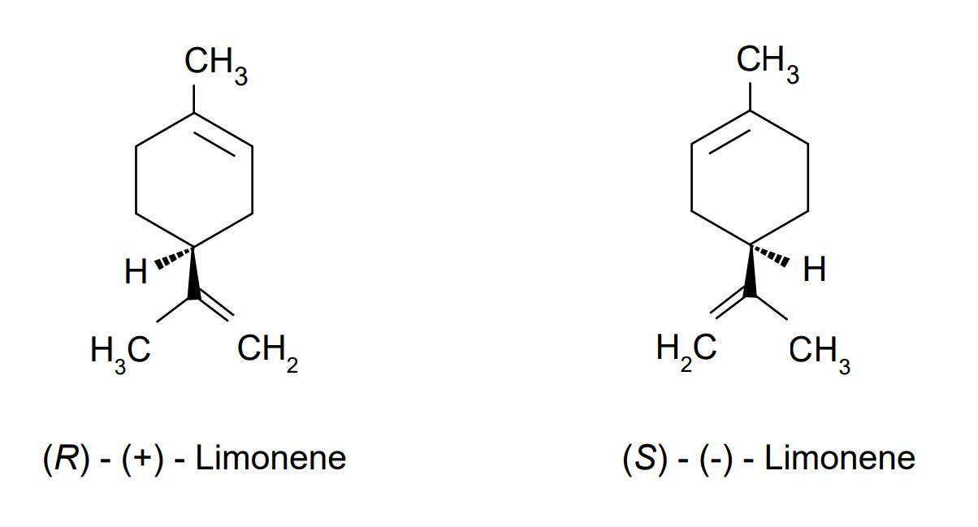
Limonene is a terpene present in orange and lemon oils. The enantiomers of limonene have markedly different odours – unscrew the tops of the bottles and sniff.

Questions
Would you expect the two stereoisomers of limonene to behave differently in their:
- Reaction with bromine?
- Reduction with hydrogen?
- Melting point?
- Boiling point?
- Infrared spectrum?
- Effect on plane of polarisation of plane-polarised light?
- Combustion?
- Mass spectrum?
Explain your answers.

Health, safety and technical notes
- Read our standard health and safety guidance here https://rsc.li/3fJh126
- Students must wear eye protection if carrying out steam distillation.
- Not needed for sniffing the stereoisomers.

