Ocean acidification could cause shark tooth corrosion

Original article by Mariana Kneppers. Adapted by Nina Notman.

Scientists investigate the impact of ocean acidity on blacktip reef shark teeth

Shark teeth are at risk of becoming more fragile as the oceans acidify due to rising carbon dioxide levels.

Researchers at Heinrich Heine University Düsseldorf made the discovery when they collected naturally discarded, intact teeth from the aquarium floor of a blacktip reef shark enclosure at Sea Life Oberhausen. They incubated the teeth for eight weeks in two separate tanks, one with a pH of 8.1 representing current oceanic conditions and one with a pH of 7.3, corresponding to the predicted conditions for 2300.

The researchers found the teeth they exposed to more acidic conditions experienced corrosion on the root, crown and serrations – compromising the teeth’s overall strength and causing them to break more easily. The loss of the serrations is particularly concerning, as sharks need these to bite into their prey and break it down into smaller pieces for swallowing.
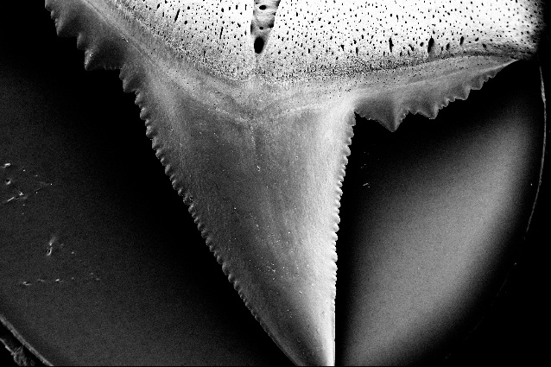
Climate change and an uncertain future
However, the scientists say that these laboratory results may not reflect what will actually happen in living sharks, as nature can sometimes adapt to changing conditions. Previous studies, for example, have shown that some shark species increase fluoride content in teeth in response to ocean acidification, which can help to protect teeth. Further research is needed on how increasingly acidic waters affect living blacktip reef sharks' teeth.

Source: © Steffen Köhler/Baum et al, 2025

Losing their edge. The blacktip reef sharks’ teeth showed corrosion to serrations, roots and crowns in more acidic waters
The acidity of oceans is increasing as a direct consequence of rising carbon dioxide levels in the atmosphere. Carbon dioxide from the atmosphere dissolves in oceans making the water more acidic. Scientists estimate that the oceans have taken up more than 30% of the carbon dioxide released from burning fossil fuels and deforestation since the industrial revolution.
This article is adapted from Could climate change cause sharks to lose their bite? in Chemistry World. Read the full article: rsc.li/43Ztgh5

