How microbes convert waste bottles into vanillin

Original article by Chemistry World. Adapted by Neil Goalby.

Chemistry is upcycling plastic monomers into higher value alternative products

Scientists in the UK have genetically engineered Escherichia coli (E coli) to transform plastic waste into vanillin. Instead of simply recycling plastic waste into more plastic, the system demonstrates for the first time that you can use plastic as a feedstock for microbial cells and transform it into something with higher value.

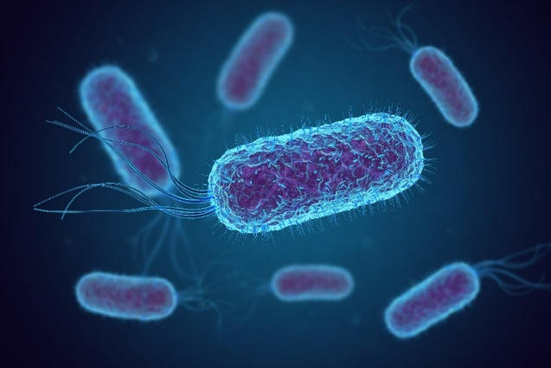
Polyethylene terephthalate (PET) is one of the most widely used types of plastic. Most existing recycling technologies degrade PET into its constituent monomers, ethylene glycol and terephthalic acid, then repurpose them in second-generation plastic materials. The researchers want to upcycle these monomers into alternative products.
The researchers used genetic engineering to create a strain of E coli that converts terephthalic acid into vanillin. Vanillin is the molecule responsible for the characteristic smell and taste of vanilla. Traditionally it is extracted from the vanilla plant, but global demand far outweighs supply from natural sources.

Source: © Shutterstock

Most E coli strains are harmless and live in our gut helping to produce vitamins
The modified E coli produces enzymes to convert terephthalic acid to vanillin through an oxidation, a methylation and two reduction steps. Through careful optimisation of reaction conditions and media, eventually a sweet spot was found where each of the enzymes was able to play its part in the biocatalytic transformation of terephthalic acid to vanillin.
Unfortunately, getting the cell to carry out the transformation was only half of the battle. A huge challenge is physically getting the substrate into the cell so that the chemistry can happen. To overcome this, the scientists added small amounts of alcohol that essentially poke holes in the cell membrane to increase its permeability. Another complexity was that vanillin itself is toxic to their new strain of E coli. To mitigate these toxicity issues, they removed the product from the reaction mixture in situ by extracting it into oleyl alcohol.
This is adapted from the article Genetically engineered microbes convert waste plastic into vanillin by James Washington in Chemistry World. Read the full article: rsc.li/49TaUkf

