
This resource has been downloaded from https://rsc.li/3m7TB59

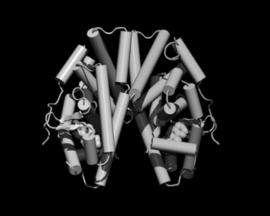
Oestrogen receptor
Reproduced with kind permission of Professor R E Hubbard, Department of Chemistry, University of York, UK.

