Name:………………………………………………..…. Date:………………………………………………………

Hydrogen fuel cells

In a fuel cell, the reaction between hydrogen and oxygen is controlled carefully. This section explains how a fuel cell works.

How a fuel cell works

In a fuel cell there is a thin sheet called a membrane which is about 2.5 mm thick. The material is made from a special plastic called Nafion. The membrane is made into the filling of a 'sandwich', as two platinum-coated carbon sheets are placed either side (see picture).

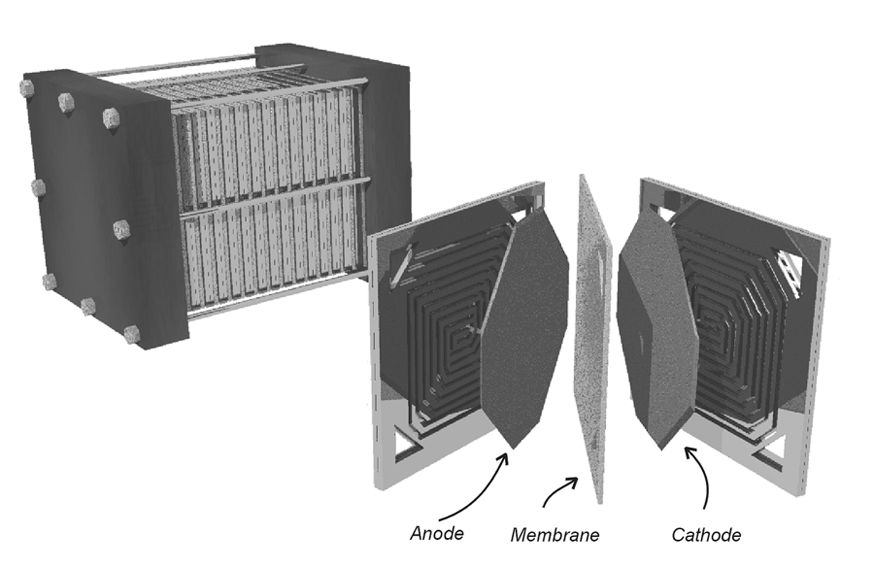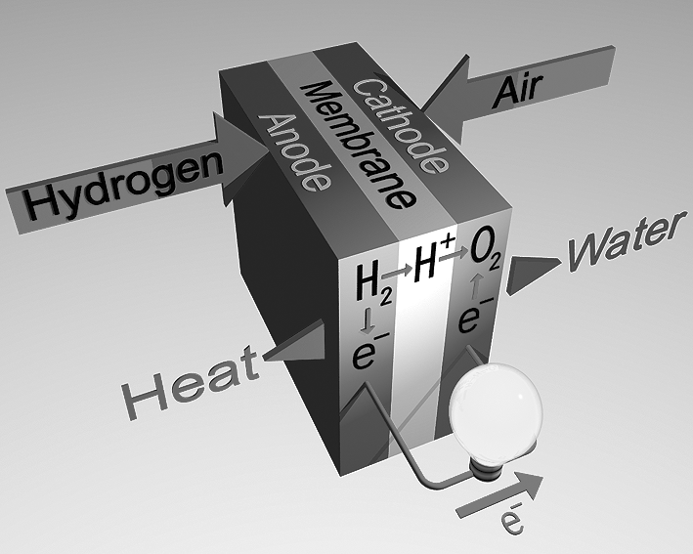
A hydrogen fuel cell showing the membrane
Reproduced with kind permission from Louise Potter, Johnson Matthey Fuel Cells.
The carbon sheets are the electrodes. The platinum acts as a catalyst, making the reactions at the electrodes go faster than they would if carbon alone were used. The same membrane can be used in two ways - to electrolyse water, producing hydrogen and oxygen and to make water by allowing hydrogen and oxygen to combine. A hydrogen fuel cell car will only use the membrane to make water. The hydrogen will come from a garage stocked with gas, much
in the same way as petrol stations are stocked with petrol today. The hydrogen in the garage will have been produced by fuel cells in a special place where the gas can be generated on a huge scale. Most likely, solar energy from the Sun will be used to produce electricity to electrolyse water, producing both hydrogen and oxygen.

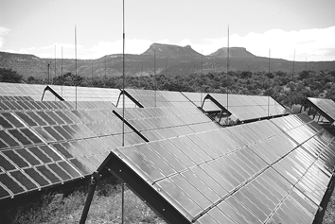

Solar panels

continued on next page



Hydrogen fuel cells
continued from previous page

In a car, the fuel cell will make water from hydrogen and oxygen.
At the anode (positive electrode), hydrogen gas is turned into hydrogen ions and electrons:
2H₂ (g)  4H⁺ (aq) + 4e⁻
The electrons move into the wire and out of the cell. They generate electricity to power the car. The hydrogen ions go through the membrane to the other electrode, the cathode. The electrons also return to the fuel cell at the cathode.
At the cathode (negative electrode) hydrogen ions react with the oxygen to form water molecules:
O₂ (g) + 4H⁺ (aq) + 4e⁻  2H₂O (l)
The fuel cell shown in Figure 1 is used to power a model car.
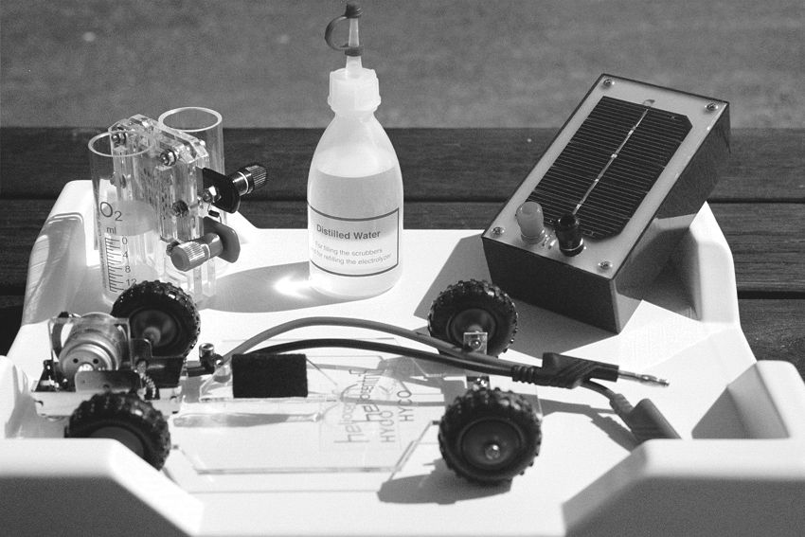 | 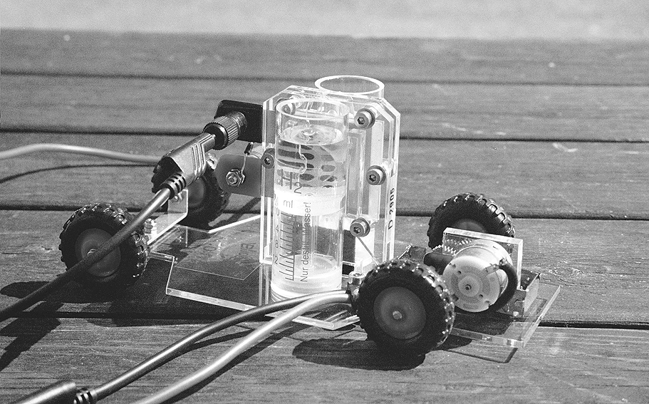

Figure 1: Hydrogen fuel cell used in a model car | Figure 2: Fuel cell charged up with hydrogen and oxygen
Figure 2 shows the fuel cell charged up with gases. The hydrogen tank looks empty but it is full of gas.
Figure 3 shows the car working – the atoms in the hydrogen gas molecules are being separated and ionised, the electrons are generating electricity which turns the electric motor, which turns the wheels.

Figure 3: It works! A hydrogen fuel cell powered car rolls into the distance...

continued on next page

Hydrogen fuel cells
continued from previous page

Questions
1. A lot of energy is released when hydrogen and oxygen react to make water. The fuel cell uses the same reaction, but what happens to the energy?
……………………………………………………………………………………………………………….……………………………………………………………………………………………………………….……………………………………………………………………………………………………………….
2. What is the energy released in the fuel cell hydrogen-oxygen reaction used for?
……………………………………………………………………………………………………………….……………………………………………………………………………………………………………….……………………………………………………………………………………………………………….
3. What would be needed to make a full-size car work using a fuel cell system?
……………………………………………………………………………………………………………….……………………………………………………………………………………………………………….……………………………………………………………………………………………………………….……………………………………………………………………………………………………………….
4. What gas will be produced from the exhaust of a fuel cell car? Will this help us reduce the 'greenhouse effect'?
……………………………………………………………………………………………………………….……………………………………………………………………………………………………………….……………………………………………………………………………………………………………….……………………………………………………………………………………………………………….
5. What are the good and bad points about using a fuel cell to power a car?
……………………………………………………………………………………………………………….……………………………………………………………………………………………………………….……………………………………………………………………………………………………………….……………………………………………………………………………………………………………….……………………………………………………………………………………………………………….……………………………………………………………………………………………………………….
6. What challenges must be solved to supply hydrogen gas to a network of garages? ……………………………………………………………………………………………………………….……………………………………………………………………………………………………………….……………………………………………………………………………………………………………….……………………………………………………………………………………………………………….

