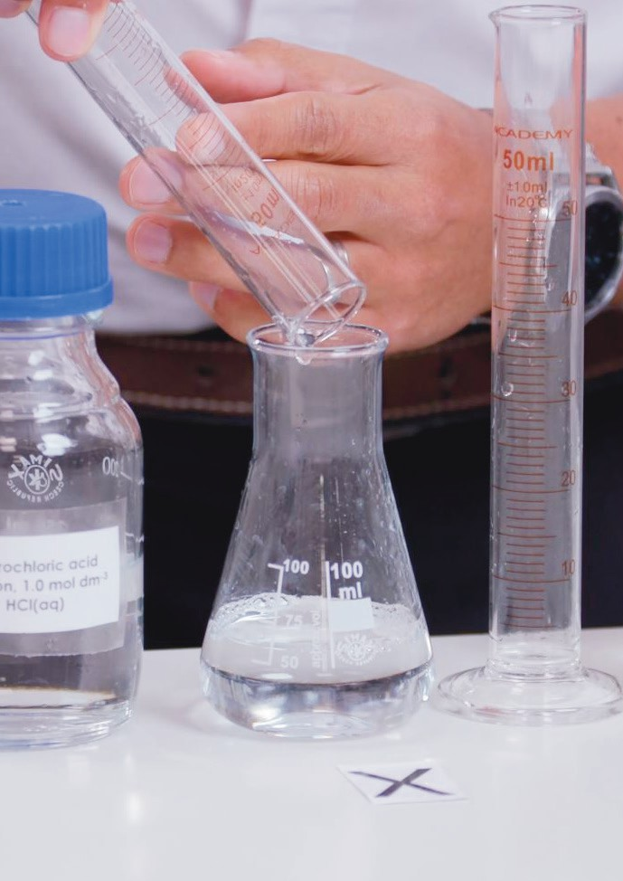



Rates of reaction
Practical video
Supporting resources

Registered charity number: 207890

Contents
Teacher notes 1
How to use this video 1
Notes on running the practical experiment 1
Key terms 2
Prior knowledge 3
Common misconceptions 3
Real-world contexts 4
Cross-curriculum links and skills 4
How to use the additional resources 4
Intended outcomes 5
Additional resources 6
Pause-and-think questions 6
Follow-up worksheet 9
Core 9
Challenge 11
Follow-up worksheet answers 13
Core 13
Challenge 15
Structure strip: suggested answer 16
Also available:
- Technician notes
- Integrated instructions
- Frayer models
- Johnstone’s triangle
Download the PDF and editable PowerPoint slides at rsc.li/40PFiXM.

Teacher notes
This resource supports the practical video Rates of reaction, available here: rsc.li/40PFiXM.
The value of experiencing live practical work cannot be overstated. Numerous studies provide evidence of its value in terms of learner engagement, understanding, results and the likelihood of continuing to study chemistry or work in a related field.
Use this video to complement live practical work, or to help learners understand the methods, equipment and skills when they cannot access the lab.

How to use this video
The video and additional resources are designed for you to use flexibly but read on for suggestions of how to use them with your learners.
Flipped learning
Show learners the video before the live practical lesson to help it run more smoothly and keep objectives in focus. This will build learners’ confidence and improve their outcomes in the lesson. Use questions from the set provided as part of the preparation task (for more on flipped learning, see rsc.li/3On7DQF).
Consolidation and revision
Show learners the video after the practical – either directly after the lesson or return to it as part of learners’ exam revision.
Revisiting the practical with a different focus
Practical experiments support many learning outcomes. Focusing on just one or two of those in a lesson will ensure you achieve the lesson’s aims. Use the video to revisit the experiment with a different focus.
Home learning
Whether it is remote teaching, homework, or individual learner absence, give learners an opportunity to engage with a practical experiment and the associated skills when they are not in the lab.
Other tips

Provide your own commentary
Mute the voice over and provide your own commentary. This will allow you to better engage with learners and adapt the video to the needs and objectives of your lesson.

Use questions
There are pause-and-think questions in two formats, one for teacher-led questions and discussion and a student worksheet for learners to use independently. Select from the list or create your own questions to engage learners and target specific aims.

Notes on running the practical experiment
Ask learners to work in pairs. Demonstrate how to set up the equipment first (either in-person or via the video) to emphasise health and safety issues. Remind learners that they must wear eye protection and direct them to the relevant student safety sheets (SSS): bit.ly/3T9fcwP.
It is important that all learners have access to a stop bath to dispose of their waste products as sodium thiosulfate solution (SSS034) reacts with hydrochloric acid (SSS020) to toxic produce sulfur dioxide gas. Explain that the stop bath is a solution of sodium carbonate/hydrogen carbonate (SSS033) with an acid- base indicator such as phenolphthalein (SSS70). It neutralises any remaining acid and the sulfur dioxide reacts with the water to produce sulfuric acid. If the indicator is showing the acidic colour, refresh the stop bath by adding more sodium carbonate solution. Ensure the room is well ventilated. A microscale version of the experiment is available from CLEAPSS: bit.ly/49GAeJ2.
Technician notes, including the equipment list, safety notes and disposal are available here: rsc.li/40PFiXM. Read our standard health and safety guidance (available from: rsc.li/3IAmFA0) and carry out a risk assessment before running any live practical.

Procedure for thiosulfate-acid reaction
- Measure 10 cm3 sodium thiosulfate solution and pour it into the conical flask.
- Measure 40 cm3 distilled water and add it to the conical flask.
- Place the flask on the black cross.
- Using a clean measuring cylinder, measure 10 cm3 hydrochloric acid.
- Add the acid to the flask, start the stop clock and swirl.
- Place the watch glass on top of the flask to limit breathing in sulfur dioxide gas.
- Time how long it takes until you can no longer see the black cross. Look at the cross from a distance of at least 20 cm above the top of the flask.
- Repeat the method using 20, 30, 40 and 50 cm3 sodium thiosulfate solution with 30, 20, 10 and 0 cm3 distilled water.
Integrated instructions
Integrated instructions use clear numbering, arrows and simple pictograms, like an eye to show when to make observations. They were developed using cognitive load theory and remove unnecessary information. Therefore, the instructions reduce extraneous load on learners, increasing the capacity of their working memory to think about what they are doing and why. Download the integrated instructions for this experiment at rsc.li/40PFiXM.

Key terms
  - Rate of reaction – the change in the concentration of the reactant or product per unit time.
  - Chemical change – a change in which one or more new substances are formed.
  - Reactant – a starting substance in a chemical reaction.
  - Product – a substance made during a chemical reaction.
  - Mass – a measure of the amount of matter in a substance.
  - Precipitate – an insoluble solid that forms when two solutions react.
  - Collision theory – for a chemical reaction to occur, two or more particles must collide in the correct orientation (the right way around) and with enough energy to break the bonds.
  - Activation energy – the minimum amount of energy required for a reaction to occur.
  - Temperature – a measure of how hot or cold an object is.
  - Concentration – the mass of solute dissolved in a fixed volume of solvent.
  - Pressure – the force per unit area.
  - Catalyst – a substance that changes the rate of reaction without ‘taking part’ in the reaction.
  - Surface area – the area of a solid chemical substance used in a chemical reaction.
  - Volume – a measure of the amount of liquid.
You will find a template and example Frayer model for the term ‘collision theory’ on the PowerPoint slides, available from: rsc.li/40PFiXM.

Prior knowledge
  - Understanding what chemical change is.
  - Dependent, independent and control variables.
  - Conservation of mass.
  - Reactions of acids.
  - Concept of rate per unit of time.
  - How changing conditions will affect the rate of reaction.
  - The concept of particle size.
  - Surface area to volume ratio.
  - Definition of a catalyst.
  - Collision theory.
  - The link between activation energy and rate.
  - Drawing graphs and calculating gradients using a tangent to a curve (for initial rate).

Common misconceptions
Difficulties related to chemical change
    - If you can’t see it, it has disappeared or was never there. Avoid using language surrounding chemical change that confuses learners, eg in this practical try to avoid the phrase ‘the cross has disappeared’ instead use the phrase ‘until you can no longer see the cross’.
    - All reactions are driven by two reactants. Demonstrate reactions with more and less, eg decomposition, than two reactants.
    - All reactants equally influence how fast a reaction proceeds. Introduce limiting reactants.
Application of collision theory
Learners can struggle to form a full answer including:
    - How the changing variable affects the reactants’ behaviours/properties.
    - How this relates to collision theory.
    - The concept of rate (per unit of time).
There is a lot going on here, so it is important to provide a clear scaffold for learners. Initially, the use of a structure strip (see the example at the end of this document) will help, followed by plenty of practice providing learners with similar but slightly different questions.
Catalysts
There are several misconceptions around the understanding of catalysts including:
    - Catalysts ‘are not involved’ in chemical reactions.
    - Catalysts break chemical bonds.
    - Catalysts increase the yield of the product.
    - Catalysts only affect the rate of the forward reaction.
Be careful with your language. The definition in some pre-16 specifications eg ‘catalysts change the rate of reaction but are not used up during the reaction’ can lead to misconceptions if the definition is not carefully unpacked and linked to the reaction profile, showing an alternative reaction pathway with a lower activating energy. This 5-minute demonstration (rsc.li/3MKUaR8) clearly shows the catalyst is involved in the reactions as the colour changes from pink to green and back to pink.
Graphs
If asked to draw another line on a graph (eg, volume of gas produced (y-axis) versus time (x-axis)) learners can struggle to know how to draw it. Should the start go up more steeply? Where does it plateau? Encourage learners to tell the story of their graph. Linking what is happening in the reaction vessel and their observations to what the graph is showing. Using a Johnstone’s triangle approach can also help here.
Download the PowerPoint slides on the webpage for an example: rsc.li/40PFiXM.

Drawing a tangent to a graph
Many learners find this challenging and depending on when you teach rates, they may be meeting the concept for the first time. Talk to your maths colleagues to find out when they teach tangents.

Real-world contexts
  - Highlight the importance of understanding rates of reaction to avoid dust explosions in food production, such as flour mills. Demonstrate how surface area affects rate with the Exhibition chemistry video Powder power: rsc.li/3Pl1hQD.
  - Link to careers, such as Misbah’s role as a senior principal scientist: rsc.li/3ufTrBg. She is a computational chemist and predicts which catalysts will be best at removing harmful pollutants from vehicles.
  - Read this CPD article (rsc.li/44xOh0A) for rates of reaction teaching tips and contexts, such as fighting infections, alcohol metabolism and more.

Cross-curriculum links and skills
This practical activity provides the opportunity to develop several ‘working scientifically’ skills and mathematical skills including:
  - Following instructions to carry out experimental techniques or procedures.
  - Identifying and controlling significant quantitative variables where applicable, and planning approaches to take account of variables that you cannot readily control.
  - Accurately measuring quantities and recording observations.
  - Drawing a graph with a line/curve of best fit.
  - Calculating the gradient of a graph by drawing a tangent to the curve.
  - Using the correct units and levels of accuracy when carrying out chemical calculations.

How to use the additional resources
Pause-and-think questions
Pause-and-think questions are supplied in two formats: a teacher version for ‘live’ questioning and a learner version that can be used during independent study. The timestamps allow you to pause the video when presenting it to your class, or learners to use the video for active revision.

Teacher version
The questions are in a table. You can use as many as are appropriate for your class and the learning objectives. Some questions have two timestamps to allow you to adapt the questions for different classes or scenarios. Pause the videos at the earlier timestamp to ask a question before you hear/see the answer, useful for revision or to challenge learners. Pause at the later timestamp to ask a question reflectively and assess whether learners have understood what they have just heard or seen. This would be useful when introducing a topic, for flipped learning or to provide additional support and encouragement.
Think about how you will ask for responses. Variation in how you ask for responses may help increase engagement. Learners could write and hold up short answers or they could discuss questions in groups. Not all answers are in the video. Some of the questions will extend learners’ thinking beyond its content or draw on prior learning.

Learner version
Provide the worksheet with the same questions in situations where there is not a teacher present to guide discussion during the video, eg homework, revision or remote learning.

Using the structure strip
Writing about chemistry encourages learners to reflect on their understanding, formulate new ideas and make links in new ways. Learners also need to practise for long-answer questions in exams. They can stick the structure strip in the margin and use the prompts to overcome ‘fear of the blank page’. Use it to consolidate learning after the practical and/or for revision. Read more at rsc.li/2P0JDlW.
Using the follow-up worksheet
There are two versions of the follow-up worksheet that you can use to reinforce learning. The core follow-up sheet focuses on collecting and processing experimental data from the sodium thiosulfate investigation shown in the video. The challenge follow-up sheet is based on the reaction between magnesium and hydrochloric acid. Task learners to process and interpret experimental data, including calculating the rate of reaction by drawing a tangent to a curve. They also need to apply their understanding of collision theory to answer some of the questions.
The answers to both versions of the student sheet are at the end of this document.

Intended outcomes
It’s important that the purpose of each practical is clear from the outset. Defining the intended learning outcomes consolidates this. Outcomes can be categorised as ‘hands on’ – what learners are going to do with objects – and ‘minds on’ – what learners are going to do with ideas to show their understanding. We have offered some differentiated suggestions for this practical. You can focus on just one or two, or make amendments based your learners’ needs (read more at rsc.li/2JMvKa5).
Consider how you will share outcomes and evaluation with learners to empower them to direct their own learning.

Hands on Minds on

Effective at a lower level

Effective at
a higher level
Learners correctly:
- Make observations and judgements about end points.
- Manipulate equipment.
- Accurately measure quantities.

Learners correctly:
- Accurately measure quantities and record observations.
- Use light sensors and dataloggers to achieve a more accurate end point.
Learners correctly:
- Understand that rate of reaction can be calculated from data using different experimental methods.
- Draw a graph with a line/curve of best fit.
Learners correctly:
- Identify and control significant quantitative variables where applicable and plan approaches to take account of variables that cannot readily be controlled.
- Calculate the gradient of a graph by drawing a tangent to the curve.
- Use collision theory to explain observations.

Additional resources

Pause-and-think questions
Teacher version
Timestamp(s) |  | Question | Answer/discussion points
00:53 | 01:02 | What factors affect the rate of reaction? | - Temperature  - Surface area  - Concentration  - Pressure  - Catalysts
01:15 | 01:29 | How could you monitor the rate of this reaction? | Monitor the production of sulfur by timing how long it takes until a black cross under the flask is no longer visible. You could observe this by eye or using a light sensor.
02:42 |  | Why do you think it is important to use a different measuring cylinder for each chemical? | To avoid contaminating the acid.
02:50 | 02:57 | What variables will you need to control in this experiment? | Concentration and volume of the hydrochloric acid, temperature.
03:13 | 03:32 | Why should you put a watch glass on top of the conical flask? | To limit breathing in and releasing toxic sulfur dioxide fumes into the classroom.
03:41 | 03:50 | Convert the time it took to not see the cross in A’s first repeat into seconds. | 1 minute = 60 seconds  3 × 60 = 180 seconds  180 + 44 = 224 seconds
05:57 | 06:41 | How do you work out the concentration of the sodium thiosulfate solution in A to E? | Note down the starting (stock bottle) concentration. Work out the dilution multiplier and times it by the starting concentration.
06:46 |  | Calculate the concentration of sodium thiosulfate in solutions B, C and D. | B: 2÷5 = 0.4 conc = 0.4 × 40 = 16 g dm-3  C: 3÷5 = 0.6 conc = 0.6 × 40 = 24 g dm-3  D: 4÷5 = 0.8 conc = 0.8 × 40 = 32 g dm-3
06:50 | 06:58 | How do you work out the average time for each concentration? | Add up all the times and divide by the number of repeats. Remember to discard any anomalous results first.
07:24 | 07:33 | How does the concentration of sodium thiosulfate solution affect the rate of reaction? | As you increase the concentration of sodium thiosulfate solution, the time it takes for you not to be able to see the black cross decreases. The rate increases.
07:48 | 08:03 | How can you keep the temperature the same? What temperature should it be below to limit the toxic sulfur dioxide? | We could do the experiment under controlled conditions, eg in a water bath. Keep the temperature below 50°C.
08:08 | 08:29 | Why do you think using a light sensor could lead to more accurate results? | The light sensor (and data logger) can give an exact time when you reach a chosen light intensity value. It is more consistent than human observation as it is hard to observe exactly the same point each time.

Pause-and-think questions
Learner version
Pause the video at the time stated to test or revise your knowledge of these practical experiments.
Time Question
01:02 What factors affect the rate of reaction?

01:29 How could you monitor the rate of this reaction?

02:42 Why do you think it is important to use a different measuring cylinder for each chemical?

02:57 What variables will you need to control in this experiment?

03:32 Why should you put a watch glass on top of the conical flask?

03:50 Convert the time it took to not see the cross in A’s first repeat into seconds.

06:41 How do you work out the concentration of the sodium thiosulfate solution in A to E?

06:46 Calculate the concentration of sodium thiosulfate in solutions B, C and D.

06:58 How do you work out the average time for each concentration?

07:33 How does the concentration of sodium thiosulfate solution affect the rate of reaction?

08:03 How can you keep the temperature the same? What temperature should it be below to limit the toxic sulfur dioxide?

08:29 Why do you think using a light sensor could lead to more accurate results?

Follow-up worksheet
This worksheet accompanies the RSC Rates of reaction video, available at rsc.li/40PFiXM. It shows the thiosulfate-acid reaction and explores the effect of concentration on rate of reaction.

Core
The following equipment was used to investigate how the concentration of sodium thiosulfate solution affects the rate of reaction with hydrochloric acid.
- Label the equipment.


- State the:
  - Dependent variable
  - Independent variable

- Write down two variables that must be controlled in this experiment.
i)
ii)
- Write your data in the results table and calculate the average time for concentrations A to E. Remember to remove any anomalies.
Concentration | Volume of | Volume of | Volume of | Time taken to not see |  |  | Average
 | sodium | water | hydrochloric | cross (s) |  |  | time (s)
 | thiosulfate solution (cm3) | (cm3) | acid (cm3)
 |  |  |  | Repeat 1 | Repeat 2 | Repeat 3
A | 10 | 40 | 10
B | 20 |  | 10
C | 30 |  | 10
D | 40 |  | 10
E | 50 |  | 10

- Calculate the concentration of sodium thiosulfate solution for each test and write the value in the final column of the table below.

Concentration | Volume of sodium thiosulfate solution (cm3) | Volume of water (cm3) | Concentration of sodium thiosulfate solution  (g dm-3)
A | 10
B | 20
C | 30
D | 40
E | 50
- Draw a graph on the axes provided.
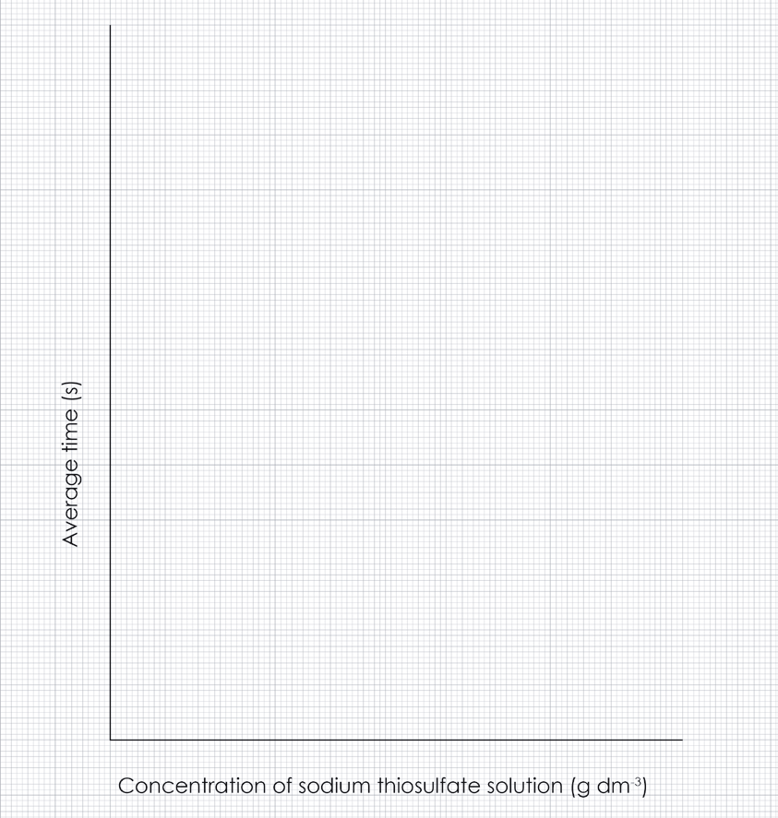

- Draw a line of best fit.
- Look at your graph and complete the sentence.
As the concentration of sodium thiosulfate solution increases

- Use your knowledge of collision theory to explain your answer to question 8. Choose from the following words:
number rate of reaction mass particles energy
increase decrease frequency volume

As the concentration of sodium thiosulfate solution increases, the of sodium thiosulfate
per unit also . Therefore, the of successful collisions will leading to an increase in the .

Challenge
A group of learners investigated the reaction between magnesium and excess hydrochloric acid. They measured the volume of gas produced every 10 seconds, then repeated the experiment at different concentrations.
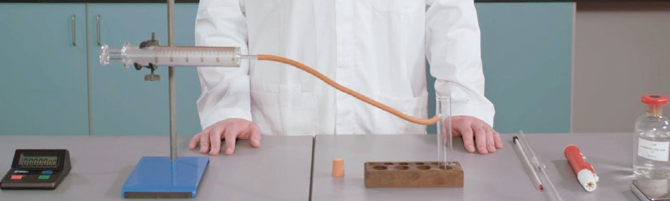

- Write a balanced symbol equation for the reaction
- State the independent, dependent and two control variables in this investigation.
Independent variable Dependent variable Control variables

The table below shows the results using a low concentration of hydrochloric acid.

Time (s) | 0 | 10 | 20 | 30 | 40 | 50 | 60 | 70 | 80 | 90 | 100 | 110 | 120
Volume of gas (cm3) | 0 | 17 | 30 | 39 | 48 | 56 | 60 | 64 | 66 | 68 | 69 | 70 | 70
- On the axes provided:
  - Plot the data from the table.
  - Draw a line of best fit.
  - Determine the rate of reaction at 25 s by drawing a tangent and calculating the gradient.


  - Describe how the rate of this reaction changes with time.

  - On the same graph, show how the rate changed when the learners increased the concentration of the hydrochloric acid. Label the line e.
- Temperature also affects the rate of reaction.
Using your knowledge of collision theory, explain how changing the temperature will affect the rate of reaction.

Follow-up worksheet answers

Core
- Correctly labelled equipment.
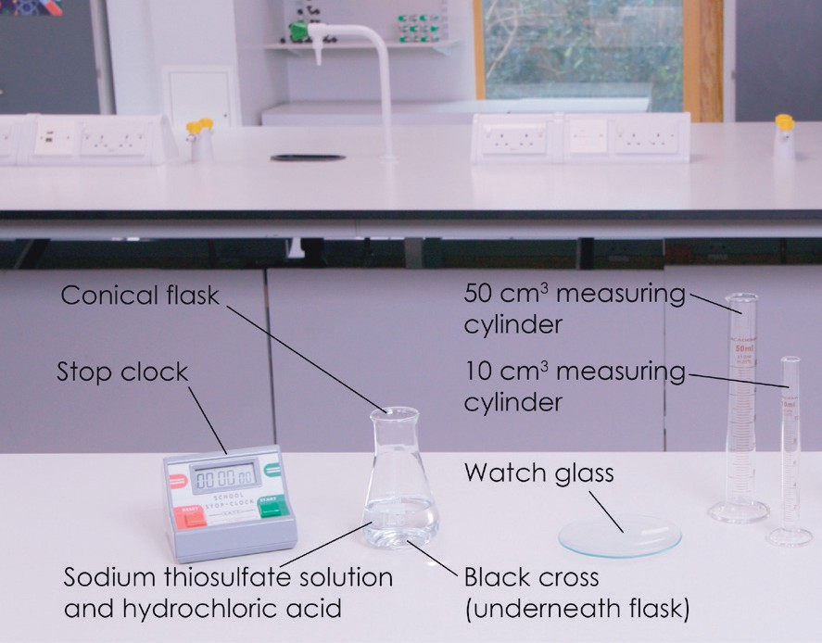

- Time.
- Concentration of sodium thiosulfate solution.
- Any two from: temperature, volume of the diluted sodium thiosulfate solution, volume of hydrochloric acid.
- Check that learners removed any anomalies, such as the repeat 2 time for concentration D in the example data.

Concentration | Volume of | Volume of | Volume of | Time taken to not see |  |  | Average
 | sodium | water | hydrochloric | cross (s) |  |  | time (s)
 | thiosulfate solution (cm3) | (cm3) | acid (cm3)
 |  |  |  | Repeat 1 | Repeat 2 | Repeat 3
A | 10 | 40 | 10 | 224 | 222 | 225 | 224
B | 20 | 30 | 10 | 112 | 118 | 114 | 115
C | 30 | 20 | 10 | 64 | 71 | 64 | 66
D | 40 | 10 | 10 | 41 | 57 | 39 | 40
E | 50 | 0 | 10 | 29 | 25 | 28 | 27

- Calculate the concentration of sodium thiosulfate for A to E and write the value in the final column of the table.

Concentration | Volume of sodium thiosulfate solution (cm3) | Volume of water (cm3) | Concentration of sodium thiosulfate solution  (g dm-3)
A | 10 | 40 | 8
B | 20 | 30 | 16
C | 30 | 20 | 24
D | 40 | 10 | 32
E | 50 | 0 | 40

- x-axis labelled Concentration of sodium thiosulfate solution (g dm-3) – scale goes up in 8 g dm-3 intervals from 0 to 40 g dm-3.
y-axis labelled Average time (s) – exact scale will depend on the results. Example graph provided.
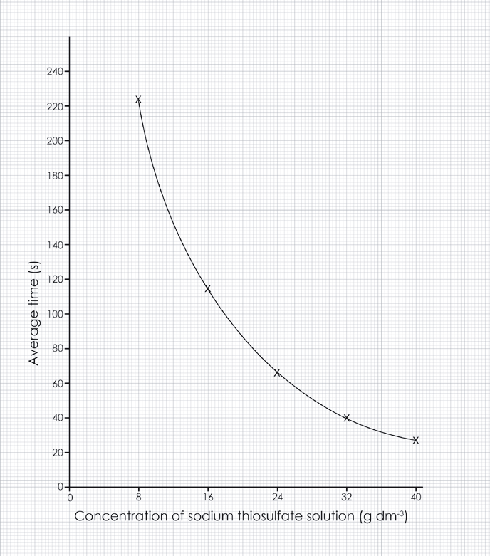

- Line of best fit – a smooth curve passing through the plotted points.
- The time taken to complete the reaction is shorter.
- As the concentration of sodium thiosulfate increases, the number of sodium thiosulfate particles per unit volume also increases. Therefore, the frequency of successful collisions will increase leading to an increase in the rate of reaction.

Challenge
- 2Mg(s) + 2HCl(aq) ➝ 2MgCl₂(aq) + H₂(g)
- Concentration of acid.
Volume of gas produced.
Two from: temperature, surface area of magnesium, length of magnesium, volume of hydrochloric acid.
- x-axis labelled Time (s) – scale goes up in 10 s intervals from 0 to 120 s.
y-axis labelled Volume of gas (cm3) – scale goes up in 20 cm3 intervals from 0 to 80 cm3.
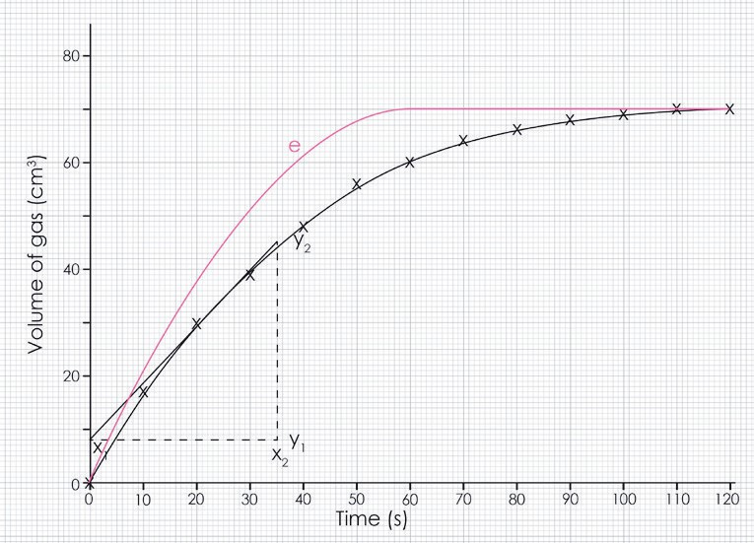

- Data from the table plotted correctly.
- Line of best fit drawn.
- Tangent to the curve drawn and gradient calculated correctly.
y₂ – y₁
Gradient =
x₂ – x₁

= 45.5 – 8
35 – 0

= 37.5
35
= 1.1 cm3 s-1
- At the start the rate of reaction is very quick, it then decreases until it eventually stops.
- Labelled line on graph to show how the rate changed when the learners increased the concentration of the hydrochloric acid.
- Increasing the temperature will increase the rate of reaction, because particles have more energy and so will move faster. This will mean more frequent collisions. More particles will also have energy greater than the activation energy, so more of the collisions will be successful.
Decreasing the temperature will decrease the rate of reaction because particles have less energy and so will move more slowly. This will mean less frequent collisions. Less particles will have energy greater than the activation energy, so less of the collisions will be successful.

Structure strip: suggested answer
Writing about chemistry encourages learners to reflect on their understanding, formulate new ideas and make links between ideas in new ways. Learners also need to practice for long-answer questions in examinations. The structure strip can be stuck in the margin of a page to provide prompts and overcome ‘fear of the blank page’. Use it to consolidate learning after the practical and/or for revision. Read more at rsc.li/2P0JDlW and see structure strips for other practical videos here: rsc.li/47fDhGS.
Question: Use your knowledge of collision theory to explain why increasing the surface area of calcium carbonate increases the rate of reaction when it reacts with sulfuric acid.

Rates of reaction Structure strip | Example answer
State collision theory. | For a reaction to occur, two or more particles must collide in the correct orientation and with enough energy.
Write a word and symbol equation for the reaction. | Calcium carbonate + sulfuric acid ➝ calcium sulfate + water + carbon dioxide CaCO₃(s) + H₂SO₄(aq) ➝ CaSO₄(aq) + H₂O(l) + CO₂(g)
Apply collision theory to this reaction. | For this reaction to occur, a particle of calcium carbonate must collide with a particle of sulfuric acid in the correct orientation and with enough energy.
Describe how increasing the surface are of calcium carbonate, affects the number of particles available to react. | It increases the number of particles per unit mass available to collide with the acid particles.
Explain how this increases the rate of reaction. | There will be more collisions between the calcium carbonate particles and the acid. Therefore, the frequency of successful collisions will increase, which will lead to an increase in rate of reaction.

Rates of reaction Structure strip | Rates of reaction Structure strip | Rates of reaction Structure strip | Rates of reaction Structure strip | Rates of reaction Structure strip
State collision theory. | State collision theory. | State collision theory. | State collision theory. | State collision theory.
Write a word and symbol equation for the reaction. | Write a word and symbol equation for the reaction. | Write a word and symbol equation for the reaction. | Write a word and symbol equation for the reaction. | Write a word and symbol equation for the reaction.
Apply collision theory to this reaction. | Apply collision theory to this reaction. | Apply collision theory to this reaction. | Apply collision theory to this reaction. | Apply collision theory to this reaction.
Describe how increasing the surface are of calcium carbonate, affects the number of particles available to react. | Describe how increasing the surface are of calcium carbonate, affects the number of particles available to react. | Describe how increasing the surface are of calcium carbonate, affects the number of particles available to react. | Describe how increasing the surface are of calcium carbonate, affects the number of particles available to react. | Describe how increasing the surface are of calcium carbonate, affects the number of particles available to react.
Explain how this increases the rate of reaction. | Explain how this increases the rate of reaction. | Explain how this increases the rate of reaction. | Explain how this increases the rate of reaction. | Explain how this increases the rate of reaction.

