Structure and bonding of carbon
- (a) Name these different forms of carbon.

A
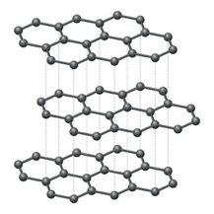

B
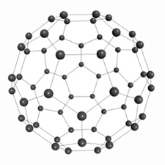

C
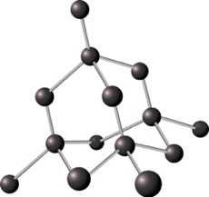

D
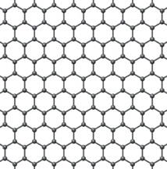

E
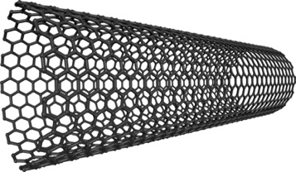

All images in the table: source © Shutterstock (5 marks)

(b) In which of the forms of carbon in question 1(a) does each carbon atom form four single covalent bonds?

______________________________________________________________ (1 mark)

(c) In the other forms of carbon, each atom forms three single covalent bonds. What happens to the single unpaired electron?

______________________________________________________________ (1 mark)

(d) Name the type of structure in:
- diamond

_________________________________________________________ (1 mark)
- graphite

_________________________________________________________ (1 mark)
- Buckminsterfullerene

_________________________________________________________ (1 mark)
- Buckminsterfullerene was the first fullerene to be discovered.
  - State the formula of a molecule of Buckminsterfullerene.

______________________________________________________________ (1 mark)
  - Look at the diagram of Buckminsterfullerene in question 1 (check your answer first), and then use the words below to describe the structure of a molecule of Buckminsterfullerene.

hexagons pentagons covalent spherical hollow

____________________________________________________________________________

____________________________________________________________________________

____________________________________________________________________________

____________________________________________________________________________

____________________________________________________________________________

____________________________________________________________________________

(5 marks)

Buckminsterfullerene was discovered in 1985. Scientists predicted many uses for this fullerene.
  - Suggest why Buckminsterfullerene could be used to deliver drugs to specific parts of the body.

____________________________________________________________________________

_____________________________________________________________________ (1 mark)
  - Suggest why Buckminsterfullerene could be used in lubricants.

____________________________________________________________________________

_____________________________________________________________________ (1 mark)
- The table shows the approximate melting points of some forms of carbon:
Form of carbon | Melting point/°C
diamond | 3600
graphite | 3600
Buckminsterfullerene (a fullerene) | 600
  - Explain why the melting points of diamond and graphite are higher than the melting point of the Buckminsterfullerene.

____________________________________________________________________________

____________________________________________________________________________

____________________________________________________________________________

____________________________________________________________________________

____________________________________________________________________________

____________________________________________________________________________

____________________________________________________________________________

(6 marks)

  - The Mohs scale is used to measure the hardness of substances. Diamond has a hardness of 10. Graphite has a hardness of 2. Explain why diamond is harder than graphite.

____________________________________________________________________________

____________________________________________________________________________

____________________________________________________________________________

____________________________________________________________________________

(4 marks)
  - Name the common feature that enables both metallic elements and graphite to conduct electricity.

_____________________________________________________________________ (1 mark)
- (a) The table lists some properties of graphene. Complete the table to explain how the structure of graphene explains the property.
Property of graphene | How the structure explains the property

High strength

Low weight

Transparent

Good conductor of heat and electricity

(4 marks)

(b) Explain why some scientists describe graphene as a 2D substance and graphite as a 3D substance.

____________________________________________________________________________

____________________________________________________________________________

____________________________________________________________________________

(2 marks)

[Total: 35 marks]


Which question(s) did you get wrong? Why?

What will you do next time you’re asked a similar question?

