Writing formulas for ionic compounds
This resource is from the Assessment for learning series which can be viewed at: rsc.li/44jTX18. This series contains lesson plans and associated resources for you to actively involve students in their learning.
Resource components
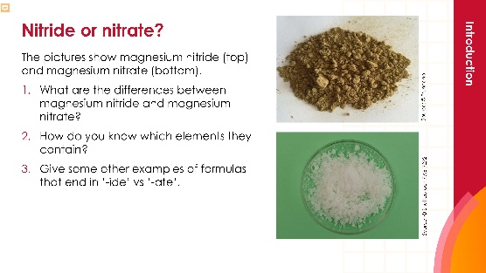 | 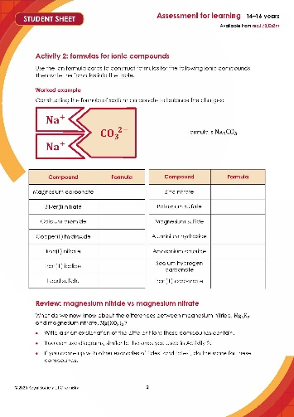 | 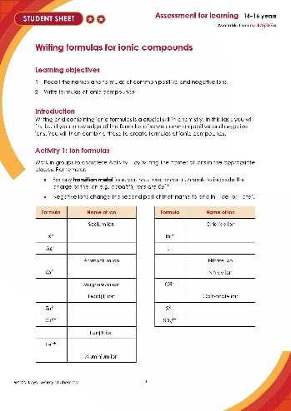
Presentation: slides including learning objectives, introductory activity, learner-facing instructions and answers for self-assessment. | Standard sheet (✪): two activities where learners complete the tables by naming ions and writing ionic formulas. | Challenge sheet (✪✪): a more challenging version of activity 1, where learners need to write the symbol for some of the ions.
Learning objectives
- Recall the names and formulas of common positive and negative ions.
- Write formulas of ionic compounds.
During the introduction, you can quickly assess learners’ prior knowledge of ions and ionic formulas, particularly ‘ides’ and ‘ates’.
During Activity 1, you will be able to identify which learners require more support to fill out the formulas. The use of ‘expert’ learners will enable support to cascade.
During Activity 2, use the visual ion cards to provide extra support for learners and allow you to identify misconceptions by asking learners to use the cards to explain their understanding.
Then, ask learners to return to the introduction task to assess the progress made by the class.
Teaching sequence
Introduction (slides 2–4)
- Display the images of magnesium nitride and magnesium nitrate.
- Ask learners the differences between the compounds. Prompt them to go beyond the images, to think about what the names mean. Encourage learners to recall other examples of ‘-ides’ and ‘-ates’ e.g. sulfide, sulfate. Why doesn’t oxygen have ‘oxate’?
- Discuss the difference between the two formulas. Learners may discuss the different elements and how many there are. Guide learners to think about the ions – both contain ${Mg}^{2+}$ ions, but what is different about the negative ion? How does this impact the overall ionic formula?
Activity 1: ion formulas (slides 6–7)
- Organise learners into groups of four and ask them to complete Activity 1 on their student sheets by adding the names of the ions listed. You can give learners the standard student sheet (✪) or the challenge sheet (✪✪).
- When one group believes it has completed this task successfully, check their work. If successful, designate them an ‘expert group’. Authorise these group members to check the work of other groups.
- Allow the checking to cascade.
- Ask learners to self-assess their work using the answers displayed on the screen.
Combining formulas (slides 8–13)
Give each learner a mini-whiteboard. For each of the three examples, ask learners to:
- Write the formulas of the positive and negative ions.
- Write the formulas of the ionic compounds.

Use the shapes to help explain to learners. Emphasise the use of subscript numbers and when brackets are needed.
Activity 2: formulas for ionic compounds (slides 14–15)
- Provide learners with the Ion formula cards (at the end of this sheet). Ask them to:
- Arrange the cards to form the formulas of the ionic compounds on their sheet.
- Write down the formulas of the ionic compounds.
- As before, when one group has finished, check their work using random questions. If five questions are correctly answered, designate them an ‘expert group’. Authorise these group members to check the work of other groups and to designate them as an ‘expert group’.
- Allow the checking to cascade.
- Ask learners to self-assess their work using the answers displayed on the screen.

Note: the student sheet includes the ionic compound sodium hydrogen carbonate, which does not appear on some specifications. Learners should be able to complete the activity by applying the same principals as they have to the other examples but you can choose to replace the ionic compound with an alternative depending on the exam board and specification e.g. ammonium carbonate.
Review (slide 16)
With the whole class, ask learners to:
- Write down the ions contained in magnesium nitride and then magnesium nitrate (review from introduction).
- Compare this with what was discussed at the start of the lesson.
- Ask learners to write a brief explanation of the differences between the formulas of magnesium nitride and magnesium nitrate. Encourage learners to draw diagrams, similar to those used in Activity 2.
- Get learners who completed the extension in the starter to do the same for the ‘ides’ and ‘ates’ they listed.
Commentary
Use the ‘nitrate vs nitride’ introduction to show learners how compounds are different based on their names and formulas, and the importance of ‘ide’ vs ‘ate’ in chemical formulas.

In the two main activities get learners to support and assess each other, while using visual prompts such as ion cards to support their understanding.

By using the task of personal evaluation, asking learners to use the mini whiteboards, as well as returning to the introduction task at the end of the lesson, you will promote learners’ confidence that they can improve.
Scaffolding
Provide learners with the ionic formula of magnesium nitride and magnesium nitrate (slide 3) during the introduction to encourage them to spot the differences in the elements they contain.
For Activity 1, you can give learners the standard sheet (✪), which gives learners the ion formulas, requiring only the names to be completed.
Alternatively, give them the challenge sheet (✪✪), which requires learners to complete a mixture of ion names and their formulas.
For Activity 2, you can decide whether learners need to use the ion cards, based on their understanding of the three whole-class examples.
You can ask learners to create further ionic formulas using the cards as an extension opportunity.
Answers
1. Ion formulas

Formula | Name of ion
$${Na}^{+}$$ | Sodium ion
$$K^{+}$$ | Potassium ion
$${Ag}^{+}$$ | Silver(I) ion
$${NH}_{4}^{ +}$$ | Ammonium ion
$${Ca}^{2+}$$ | Calcium ion
$${Mg}^{2+}$$ | Magnesium ion
$${Pb}^{2+}$$ | Lead(II) ion
$${Zn}^{2+}$$ | Zinc ion
$${Cu}^{2+}$$ | Copper(II) ion
$${Fe}^{2+}$$ | Iron(II) ion
$${Fe}^{3+}$$ | Iron(III) ion
$${Al}^{3+}$$ | Aluminium ion

Formula | Name of ion
$${Cl}^{-}$$ | Chloride ion
$${Br}^{-}$$ | Bromide ion
$$I^{-}$$ | Iodide ion
$${NO}_{3}^{ -}$$ | Nitrate ion
$${\text{N}}^{3-}$$ | Nitride ion
$${OH}^{-}$$ | Hydroxide ion
$${CO}_{3}^{ 2-}$$ | Carbonate ion
$$S^{2-}$$ | Sulfide ion
$${SO}_{4}^{ 2-}$$ | Sulfate ion

2. Formulas for ionic compounds
Compound | Formula
Magnesium carbonate | $$MgCO_{3}$$
Silver(I) nitrate | $$AgNO_{3}$$
Calcium bromide | $$Ca{Br}_{2}$$
Copper(II) hydroxide | $$Cu{(OH)}_{2}$$
Iron(II) nitrate | $$Fe{(NO_{3})}_{2}$$
Iron(III) iodide | $$FeI_{3}$$
Lead sulfate | $$PbSO_{4}$$
Compound | Formula
Zinc nitrate | $$Zn{(NO_{3})}_{2}$$
Potassium sulfate | $$K_{2}SO_{4}$$
Magnesium sulfide | $$MgS$$
Aluminium hydroxide | $$Al{(OH)}_{3}$$
Ammonium chloride | $$NH_{4}Cl$$
Sodium hydrogen carbonate▲ | $${NaHCO}_{3}$$
Iron(III) carbonate | $${Fe}_{2}{(CO_{3})}_{3}$$

▲Sodium hydrogen carbonate appears on the National 5 specification in Scotland. If this compound is not on your specification, then you can edit the cards and student sheet to include an alternative compound e.g. ammonium carbonate.
Review
- Magnesium nitride contains the ions ${Mg}^{2+}$ and ${\text{N}}^{3-}.$
  - ${Mg}^{2+}$ is a magnesium atom that has lost two electrons, giving it a 2+ charge.
  - ${\text{N}}^{3-}$ is a nitrogen atom that has gained three electrons, giving it a 3- charge.
  - The ratio of ions in magnesium nitride is three magnesium ions to every two nitrogen ions, to balance the charge.
- Magnesium nitrate contains the ions ${Mg}^{2+}$ and ${NO}_{3}^{ -}$.
  - ${Mg}^{2+}$ is a magnesium atom that has lost two electrons.
  - ${NO}_{3}^{ -}$ is a polyatomic nitrate ion containing one nitrogen and three oxygen atoms. The additional electron (that is not involved in covalent bonds between nitrogen and oxygen) gives the ion a 1- charge.
  - The ratio of ions in magnesium nitrate is one magnesium ion to every two nitrate ions, to balance the charge.
Magnesium nitride
$${Mg}^{2+}$$
$${Mg}^{2+}$$

$$N^{3-}$$

$$N^{3-}$$
$${Mg}^{2+}$$
Magnesium nitrate
$${Mg}^{2+}$$
$${NO}_{3}^{ -}$$
$${NO}_{3}^{ -}$$

$${Cl}^{-}$$
$${Na}^{+}$$
$$I^{-}$$
$${NO}_{3}^{ -}$$
$${OH}^{-}$$
$${OH}^{-}$$
$${OH}^{-}$$
$${NO}_{3}^{ -}$$
$${NO}_{3}^{ -}$$
$${NO}_{3}^{ -}$$
$$I^{-}$$
$$I^{-}$$
$${NH}_{4}^{ +}$$
$${NH}_{4}^{ +}$$
$${Ag}^{+}$$
$${Ag}^{+}$$
$${Br}^{-}$$
$${Br}^{-}$$
$${Br}^{-}$$
$${Cl}^{-}$$
$$K^{+}$$
$$K^{+}$$
$${Na}^{+}$$
$${Cl}^{-}$$
$${HCO}_{3}^{ -}$$
$${HCO}_{3}^{ -}$$

$$S^{2-}$$

$${CO}_{3}^{ 2-}$$

$${CO}_{3}^{ 2-}$$

$${CO}_{3}^{ 2-}$$
$${HCO}_{3}^{ -}$$
$${Zn}^{2+}$$
$${Fe}^{2+}$$
$${Mg}^{2+}$$
$${Cu}^{2+}$$
$${Pb}^{2+}$$
$${Ca}^{2+}$$
$${Cl}^{-}$$
$${Cl}^{-}$$
$${Al}^{3+}$$
$${Al}^{3+}$$

$${SO}_{4}^{ 2-}$$

$${SO}_{4}^{ 2-}$$

$${SO}_{4}^{ 2-}$$

$$S^{2-}$$

$$S^{2-}$$
$${Fe}^{3+}$$
$${Fe}^{3+}$$
$${Al}^{3+}$$

$${Al}^{3+}$$

v

$$O^{2-}$$

$$O^{2-}$$
$${Mg}^{2+}$$
$${Mg}^{2+}$$

$$N^{3-}$$

$$N^{3-}$$
$${Mg}^{2+}$$

