Dissolved substances in tap water and seawater

The investigation is part of the Nuffield Practical Collection, developed by the Nuffield Foundation and the Royal Society of Chemistry. Delve into a wide range of chemical concepts and processes with this collection of over 200 step-by-step practicals: rsc.li/43bjGql

Learning objectives
- Set up and carry out an evaporation practical.
- Compare the dissolved substances in tap water and seawater.
- Describe what happens to the particles of a substance when it dissolves.
- Explain why it’s important for water to contain dissolved substances.

Learners will successfully set up and carry out the evaporation experiment – meeting LO1. During the teacher demonstration there will be opportunities to discuss LO2–4. LO2 and 4 will be met by answering the teacher demonstration questions and the student worksheet questions.

Introduction

Compare the solids and gases dissolved in tap water and seawater in this class practical and demonstration.

In this experiment, learners evaporate tap water, distilled water and seawater to reveal solid residues. They then observe as the teacher boils the three types of water to release their dissolved gases, which will be collected in a test tube and tested using a glowing splint.

This is a class practical and teacher demonstration. If there is sufficient apparatus, learners could do the three evaporations in parallel. Alternatively, the three types of water could be distributed round the class and the results compared at the end. It takes quite a long time for the water in a beaker to boil, so this should be built into the planning.

The teacher demonstration could be set up while the leaners are waiting for their water to evaporate.

If several of the shortcuts suggested above are used, these experiments could be done in 45 minutes.

Scaffolding

There are two versions of the student worksheet: scaffolded (✪) and unscaffolded (✪✪). The scaffolded sheet offers more support to allow learners to access the questions.

Integrated instructions are available in the Powerpoint presentation.

Technician notes

Read our standard health and safety guidance (rsc.li/3zyJLkx) and carry out a risk assessment before running any live practical.

Equipment

Apparatus

Eye protection: safety glasses to EN166F

For the teacher demonstration
- Round bottomed flask (250 cm³), x 2
- Bung and delivery tube, x 2
- Bunsen burner
- Tripod and gauze, x 2
- Heat resistant mat, x 2
- Stand and clamp, x 2
- Beaker (250 cm³) or a small trough, x 2
- Test tube, x 2

For the class practical
- Glass watch glasses (approximately 7.5 cm diameter), x 3
- Beaker (100 cm³)
- Bunsen burner
- Tripod and gauze
- Heat resistant mat
- Tongs

Chemicals

For the teacher demonstration
- Seawater (400 cm³)

For the class practical
- Seawater (5 cm³)
- Distilled (or deionised) water (5 cm³)

Preparation

If the real thing isn’t available, ‘seawater’ can be made up by dissolving about 35 g of sodium chloride in 1000 cm³ of tap water. This will provide enough for both parts of the experiment. (Note: seawater contains a complex mixture of salts, but this gives a suitable solution for this experiment, resembling seawater in having 3.5% salinity.)
Chemicals supplied for the practical and hazard | Preparation
Seawater (3.5% w/v sodium chloride in water)  Not classified as hazardous  See CLEAPSS Hazcard HC047b  In Scotland follow SSERC advice. | Sodium chloride (solid), $NaCl$(s)  Dissolve about 35 g of sodium chloride in 1000 cm³ of tap water (see CLEAPSS Recipe Sheet RB082).

Safety and hazards

Learners should be able to use a Bunsen burner with confidence and they should be reminded how to handle hot liquids in beakers.

Allow enough time for the equipment to cool down before asking the students to put away their equipment. In case of a burn, cool the burn by immediately irrigating with gently running water for at least 20 minutes and until pain is relieved and heat is no longer felt.

The solid residue on the watch glass can be disposed of in the general waste bin. Remind learners never to eat or drink anything in the lab as they may be tempted to taste the salt.

Method

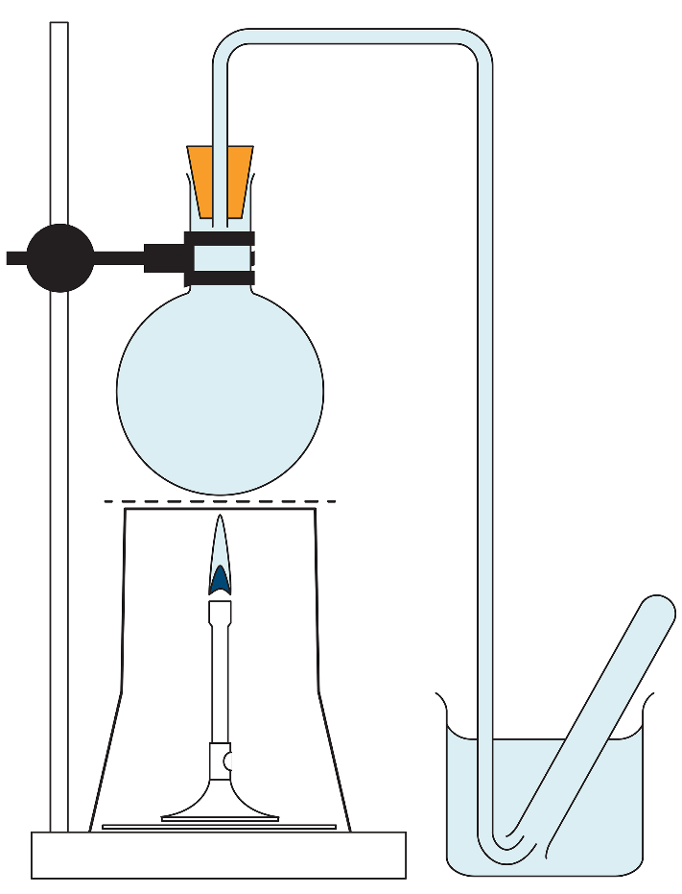
Teacher demonstration
- Fill a round bottomed flask right up to the top with tap water. Insert a bung carrying a delivery tube so that the tube itself becomes completely filled with water (see diagram). If this cannot easily be done, place the bung in the flask while the whole apparatus is immersed in a sink of water.

- Fill a collection test tube with water and place inverted into a beaker of water. Position the other end of the delivery tube under the test tube (see diagram).

- Repeat step 1 and 2 with a flask of seawater.

- Position each flask over a Bunsen burner using a clamp and stand. Heat each flask until bubbles of gas are released from the water and travel into the test tube. Continue until the contents of the flask are boiling. About half a test tube full of gas will be collected in each case, all of which has been displaced from solution by heating.

- Conduct a splint test to demonstrate the presence of oxygen.

Pause-and-think questions

During the demonstration use these questions to engage learners and assess understanding. Alternatively, these questions can be answered later on in the lesson or as a homework activity.
No. | Question | Response
1 | What do you observe when the round bottomed flask is heated? | Bubbles of gas start to appear.
2 | Suggest a reason why the apparatus is completely filled with water at the start of the experiment. | To remove all the air from the equipment at the start of the demonstration.
3 | Name a gas that is collected in the test tube. Give a reason for your answer. | Oxygen – it relit a glowing splint.
4 | How did the results from the tap water experiment compare to those from seawater? | They both produced a similar amount of gas.
5 | Suggest how the gas got into the water. | By diffusion from the air and the plants.
6 | Why is it important for seawater and freshwater to contain dissolved gases? | For aquatic life (plants, fish and other marine animals) to respire.
7 | Predict what you would see if the experiment was repeated with distilled water. Suggest a reason for your answer. | No gas produced because distilled water is a pure liquid.  Or  Less gas produced than with the tap and seawater because although distilled water is a pure substance, when it is poured out, some air will mix and dissolve in it.

Class practical

A full method is provided in the student worksheet. Integrated instructions are available in the Powerpoint presentation.

Teaching notes

Distilled water should contain no dissolved solids, tap water some dissolved solids (those causing ‘hardness’ for example) and seawater more dissolved solids (sodium chloride and other salts). A related experiment describes how to analyse the salts obtained from seawater: rsc.li/4oojpdk

The gas that comes out of both seawater and tap water is air (with a higher percentage of oxygen than normal air, as oxygen is more soluble than nitrogen). The best test available is to show that a glowing splint continues to glow and does not immediately go out when placed in the gas.

The presence of dissolved oxygen in water is vital for fish to survive.

Answers (scaffolded)

Type of water | Observation
Distilled water | No residue
Tap water | Some white residue
Seawater | More white residue

- Distilled water contains no dissolved salts because it is pure.

Seawater tastes salty. It contains sodium chloride and some other salts. It is a mixture/impure.

When sodium chloride dissolves in water, the sodium chloride or solute particles separate and spread throughout the particles of the water or solvent. The white crystals can no longer been seen.

When seawater is boiled the water molecules evaporate, leaving the solid salts behind.

- Calcium and magnesium salts – usually carbonates and sulfates. Other salts include fluorides. There may also be traces of lead salts (from old pipes).

Answers (unscaffolded)
- Completed table as in the scaffolded worksheet answers.

- Tap water contains some dissolved salts. There will be some solids when all the water has been evaporated.
- Distilled water is pure. It will not contain any dissolved salts – so no solids should be left at the end.
- Seawater tastes salty. It has a higher concentration of dissolved salts than tap water. This explains why there is more white residue than the tap water.

- When a substance dissolves in a solvent, the solute particles separate and spread throughout the particles of the solvent until the solute particles can no longer been seen.

- When seawater is heated the water particles gain more kinetic energy, so they start to move more quickly. Eventually they gain enough energy to move into the gas state.

- Calcium and magnesium salts – usually carbonates and sulfates. Other salts include fluorides; there may be traces of lead salts (if old pipes).

- Low concentrations of fluoride prevent tooth decay.

