Particles in motion?

Learning objectives
- Investigate the motion of particles in a gas.
- Use particle theory to explain your observations.

Introduction

You are going to carry out a practical activity to explore the motion of particles in a gas.

You will produce a test tube full of carbon dioxide by reacting calcium carbonate with hydrochloric acid. You will then check to see if diffusion occurs by holding the test tube of carbon dioxide over a test tube of air and vice versa.

Equipment (per group)

Apparatus
- Test tubes, x 3
- Cork
- Delivery tube and bung

Safety equipment
- Eye protection: safety glasses to EN166F

Chemicals
- Limewater 0.02 mol dm^{–3}
- Calcium carbonate
- Hydrochloric acid 0.5 mol dm^{–3}

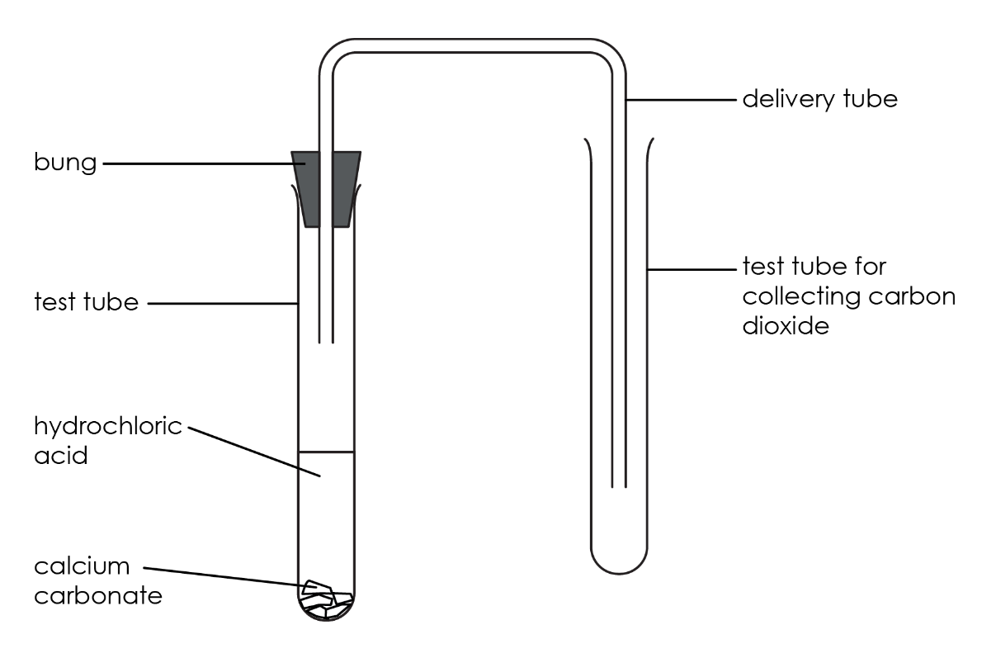
Diagram


Procedure
- Wear safety glasses.
- Set up the apparatus as shown in the diagram.
- Put a spatula of calcium carbonate into the first test tube.
- Add 10 cm³ of hydrochloric acid and quickly replace the bung and delivery tube. Ensure the delivery tube reaches almost to the bottom of the second test tube.
- Allow the carbon dioxide gas to pass into the second test tube for about 1 minute, then remove the delivery tube and cork the test tube.
- Hold the test tube of carbon dioxide gas upside down over a similar test tube containing air.
- Remove the cork and place the tubes mouth-to-mouth.
- After 5 minutes, cork both tubes and test the contents for carbon dioxide (swirl a little limewater round in the test tube). Write down what happens in both tubes.
- Repeat this experiment but this time at step 5 hold the test tube of air upside down over the test tube of carbon dioxide.

Results table
Experiment | Test tube | Observations with limewater
1 | Upper
1 | Lower
2 | Upper
2 | Lower

Questions
- Complete the word equation for the reaction of calcium carbonate with hydrochloric acid.

_________________________ | + | calcium carbonate | $$→$$ | calcium chloride | + | __________ | + | ____________  _____________

- Complete the sentence to state the test for carbon dioxide gas:

Add some ____________________. It will change from ____________________ to ____________________ if carbon dioxide gas is present.

- Which of the four test tubes contained carbon dioxide at the end of the experiment?

__________________________________________________________________________________
- Which is more dense? Circle your answer.

air carbon dioxide

- Concentration is a measure of the number of particles per unit area.

The diagrams show a sample of gas particles at different concentrations.

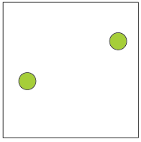 | 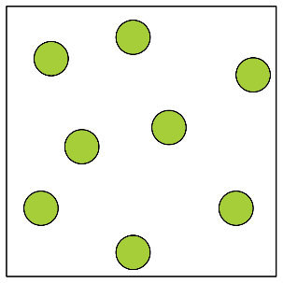 | 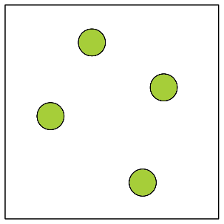 | 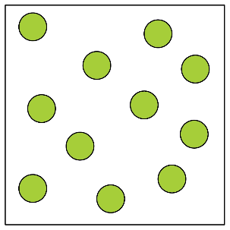
A | B | C | D

List the samples in order from highest concentration to lowest concentration.

________ > ________ > ________ > ________

- Use the words to complete the sentence.

low concentration high movement

Diffusion is the _________________________ of a substance from an area of _________________________ concentration to an area of low _________________________.

- Does this experiment support the idea that the particles of a gas are in motion? Circle your answer.

yes no

Suggest a reason for your answer by completing the sentences.

green liquids gases cloudy

moved jumped air carbon dioxide oxygen

In each experiment, when limewater was added to both test tubes it went ________________. This suggests that the ________________ in the tubes had mixed. To do this the particles of ________________ must have ________________ from one test tube to the other.

