Particles in motion?

This resource is part of our extensive collection of practical chemistry experiments edu.rsc.org/resources/practical

Resource components

Two different levels of student sheet and lesson presentation slides are also available from: rsc.li/3F6wKBt
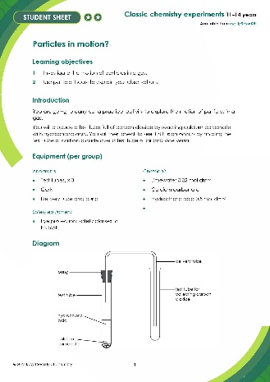 | 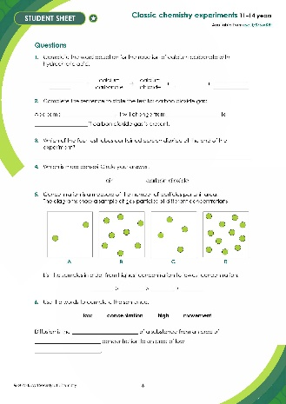 | 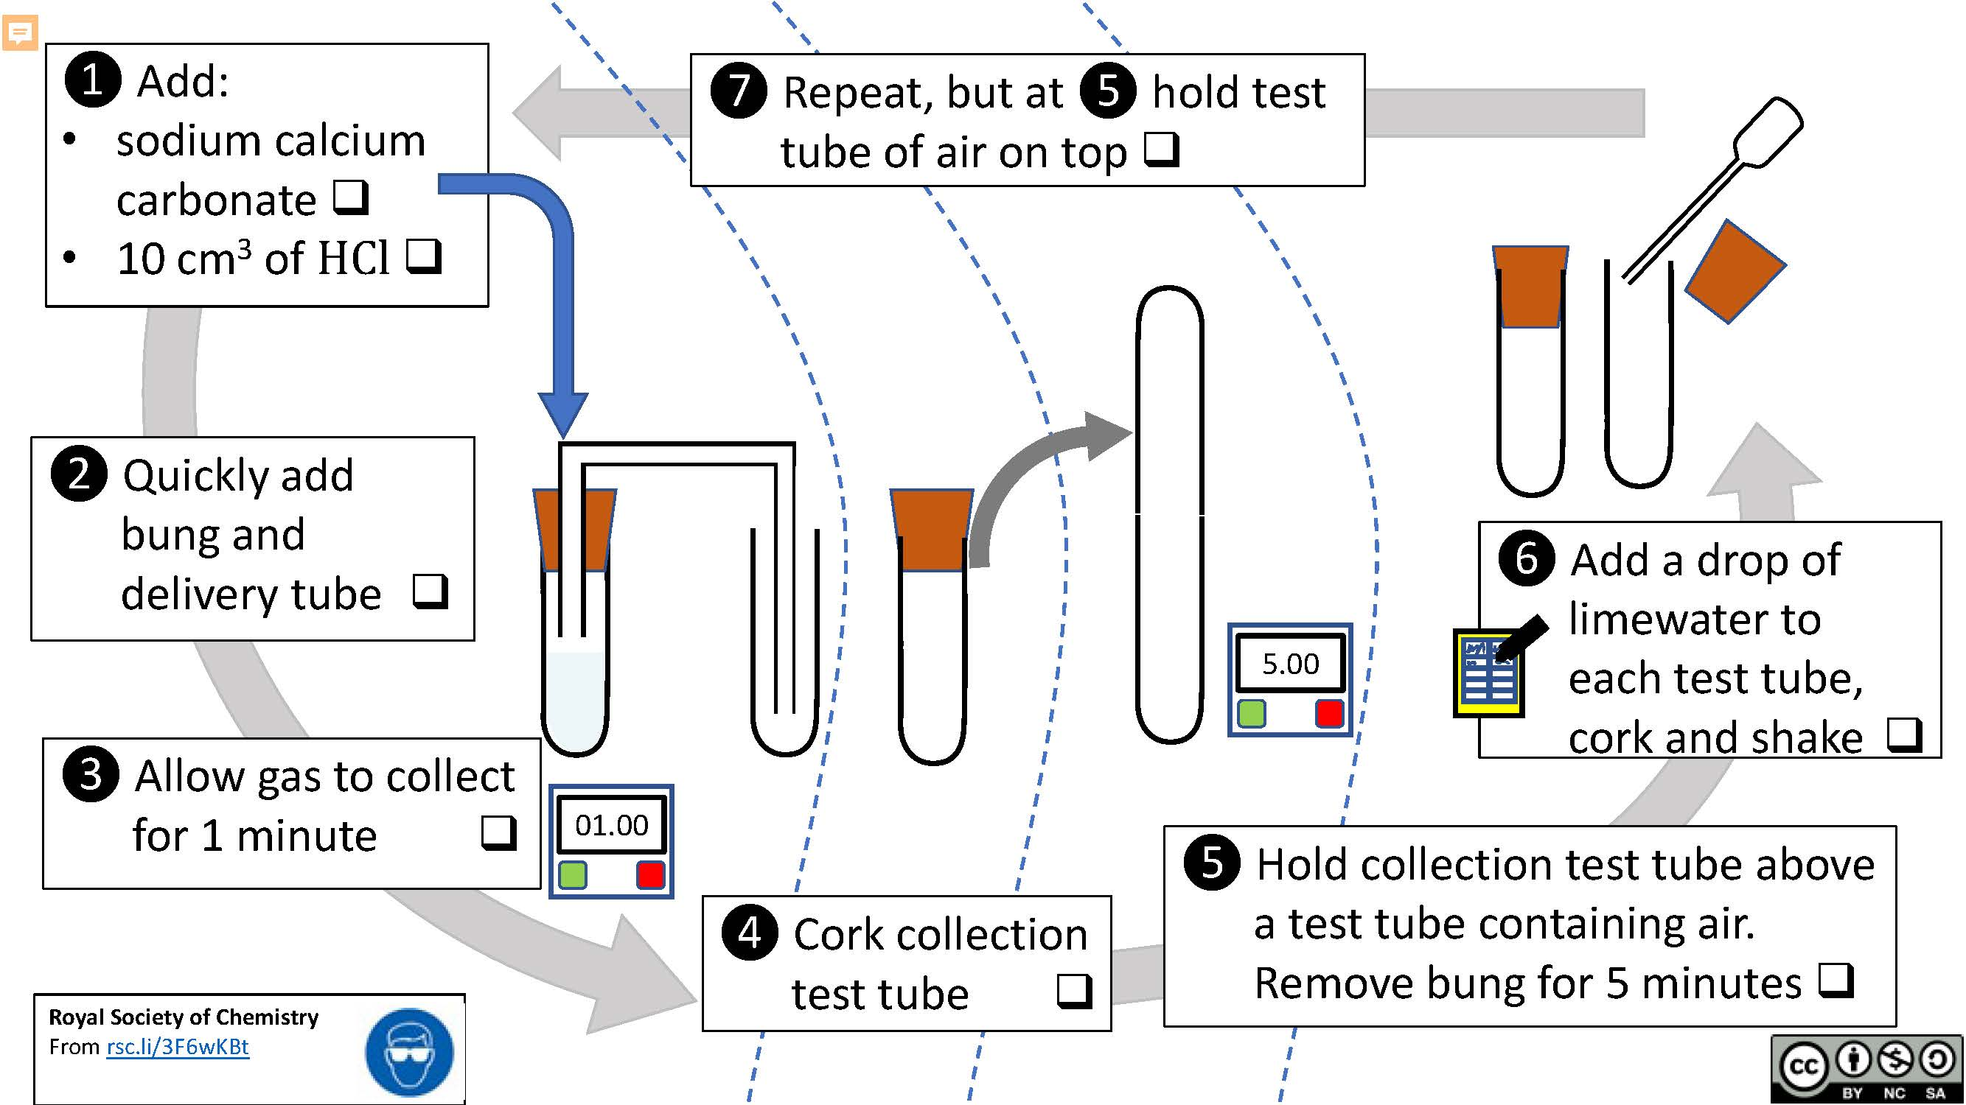
Standard student sheet: a written method, equipment list and diagram followed by questions with free-space for written answers. | Scaffolded student sheet: the same written method, equipment and diagram followed by multiple choice and fill-in-the-gap questions to support learners. | Presentation: lesson slides including starter activities, written method, integrated instructions and follow-up questions

Learning objectives
- Investigate the motion of particles in a gas.
- Use particle theory to explain your observations.

Learning objective one will be met by carrying out the complete practical and watching the optional teacher demonstration of Brownian motion.

Learning objective 2 will be met through small group/whole class discussions as well as answering the questions.

Introduction

Learners produce carbon dioxide by reacting calcium carbonate with hydrochloric acid. They then check to see if diffusion occurs by holding the test tube of carbon dioxide over a test tube of air and vice versa.

Scaffolding

There are two versions of the student worksheet: scaffolded (✪) and unscaffolded (✪✪). The scaffolded sheet offers more support for learners.

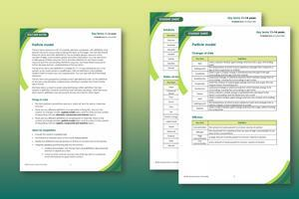
Integrated instructions are available in the PowerPoint presentation. There is also a list of key terms, for both equipment and chemistry. These key terms can be used to check for understanding and to activate previous knowledge at the start of the lesson using a mini whiteboard activity.

Find more support for literacy and vocabulary in our Key Terms support bundle for 11-14 Particle model, available to download from: rsc.li/4cmvSbS

Teaching notes

Particles in motion is an abstract idea. Use familiar images to introduce it, such as the one on slide 2, and to stimulate discussion at the start of the lesson.

Explain that particles in the gas state are in continuous motion. Scientists have built up a body of evidence proving this with a range of different experiments. Ask your learners for examples of evidence for moving particles e.g. dust being blow about in the air or sun shining through a crack in the drawn curtains, showing dust in the air.

You could demonstrate or use a video clip to show Brownian motion in a smoke sample (rsc.li/3I1qVKU), as further evidence of particles in motion, before moving onto the class practical. This video also contains a useful model to show how the particles of a substance in the gas state move. Alternatively Brownian motion may be used to reinforce ideas once the practical is completed.

This experiment enables learners to explore the motion of particles in a gas. The learners generate (and collect) carbon dioxide by mixing calcium carbonate and hydrochloric acid. They then allow the carbon dioxide to diffuse into an empty test tube. Next, learners carry out a chemical test to confirm that carbon dioxide particles have moved into the empty test tube. Learners should then apply their previous learning about particle theory to explain their observations.

This experiment does not prove particulate theory, but it does show that the particles in the gas must be in motion to spread through the air and into the other test tube. If the particles didn’t move, carbon dioxide would not be found in both test tubes.

Technician notes

Read our standard health and safety guidance (rsc.li/3iFPxff) and carry out a risk assessment before running any live practical.

Equipment (per group)

Apparatus
- Test tubes, x 3
- Cork
- Delivery tube and bung

Safety equipment
- Eye protection: safety glasses to EN166F

Chemicals
- Limewater 0.02 mol dm^{–3}
- Calcium carbonate
- Hydrochloric acid 0.5 mol dm^{–3}

Safety, hazards and disposal
- At this concentration hydrochloric acid is not classed as hazardous but use eye protection even when using dilute solutions, see CLEAPSS Hazcard HC047a. Teachers in Scotland should refer to SSERC for guidance.
- Avoid inhaling fumes.
- Neutralise and dilute hydrochloric acid to below 0.1M before disposing via a foul-water drain.

Answers
- Calcium carbonate + hydrochloric acid calcium chloride + water + carbon dioxide.
- Add some limewater. It will change from colourless to cloudy if carbon dioxide gas is present.
- All the test tubes contained carbon dioxide.
- Carbon dioxide
- D, B, C, A
- Diffusion is the movement of a substance from an area of high concentration to an area of low concentration.
- Unscaffolded

Yes. When limewater was added to both test tubes, it went cloudy. This suggests the gases i.e. carbon dioxide from one tube and air from the other tube mixed.

In the first experiment, some of the heavier carbon dioxide molecules moved downwards by diffusion into the test tube containing air.

In the second experiment, some of the heavier carbon dioxide molecules moved upwards by diffusion into the test tube containing air.

Scaffolded

Yes. In each experiment, when limewater was added to both test tubes it went cloudy. This suggests that the gases in the tubes had mixed. To do this the particles of carbon dioxide must have moved from one test tube to the other.

