Solutions

Learning objectives
- Apply the particle model in the context of solutions.
- Use logical reasoning to choose between explanations for observations.

Introduction

A group of students conduct an experiment where they dissolve two solids, separately, in water to produce two solutions. The solids are sodium chloride (table salt) and blue copper(II) sulfate.

They know that all solids, liquids and gases are made of tiny particles.
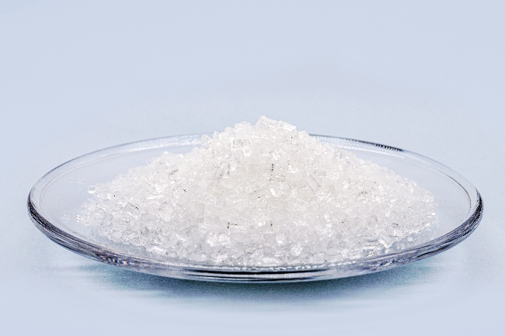 | 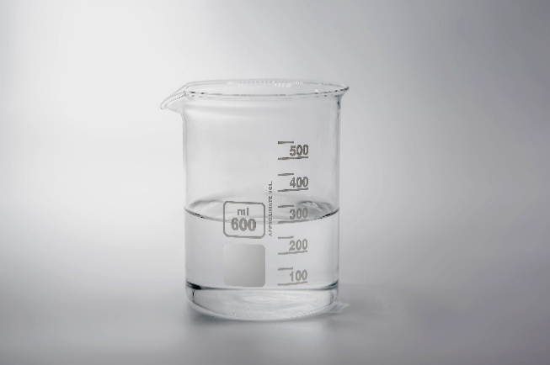
sodium chloride | sodium chloride solution
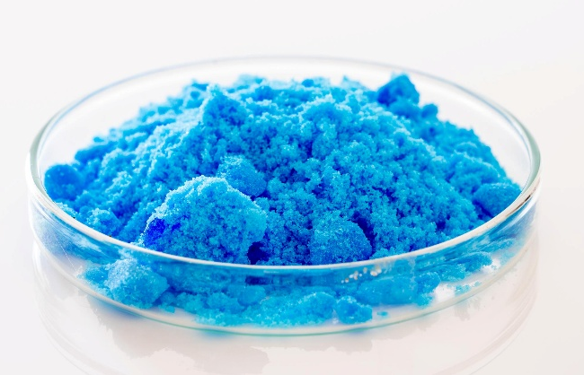 | 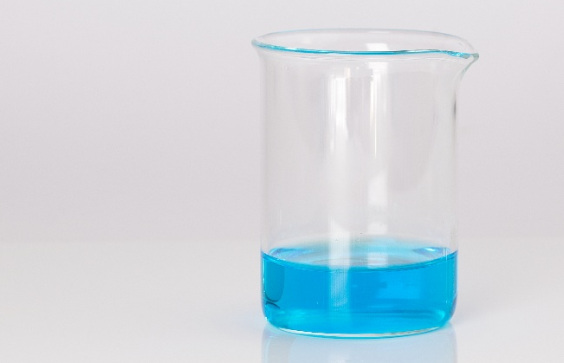
copper(II) sulfate | copper(II) sulfate solution

Images © Shutterstock

Questions
- First, the students discussed what happens when a solution is formed:

- Sam thought that, because the solid disappears, the solid is destroyed and no longer exists
- Ravi noted that the solutions were no longer pure water
- Jo said that the solids must become gases, since you cannot see them and you cannot see gases
- Yara said that the solid cannot be destroyed, because you can get the solid back, if you let the water evaporate
- Alice suggested that the solid breaks up into tiny particles too small to see which is why it disappears
- Tadhg wanted to know why the solid particles would split up in water

- Which of the students (it could be more than one) do you agree with?

__________________________________________________________________________________

__________________________________________________________________________________

__________________________________________________________________________________
- Suggest an answer to Tadhg’s question in terms of the forces of attraction between particles.

__________________________________________________________________________________

__________________________________________________________________________________

__________________________________________________________________________________

__________________________________________________________________________________

__________________________________________________________________________________

__________________________________________________________________________________

__________________________________________________________________________________

__________________________________________________________________________________

__________________________________________________________________________________

- The students noticed that solid copper sulfate is blue, and so is the solution. They also saw that while solid sodium chloride is white, the solution is not.

- Tadhg described the sodium chloride solution as ‘clear’
- Yara said that the sodium chloride was ‘colourless’
- Jo suggested that the tiny particles of copper sulfate must be blue, making both the solid and solution blue
- Alice thought that the copper sulfate was like coloured glass, see-through (transparent), and coloured
- Ravi suggested that the sodium chloride particles were only white when they were grouped together in lumps big enough to see, and colourless when they were spread apart, as in a solution
- Sam said that, if that was true, the copper sulfate particles must be blue all the time
- Arrange the students into the order in which you think their statements showed the most reasoning based on their observations (e.g. If you think Alice made the best contribution to the group’s understanding by good reasoning, put her name at the top of the list).

1. ____________

2. ____________

3. ____________

4. ____________

5. ____________

6. ____________

- Explain your reasons for the order that you decide.

__________________________________________________________________________________

__________________________________________________________________________________

__________________________________________________________________________________

__________________________________________________________________________________

__________________________________________________________________________________

__________________________________________________________________________________

__________________________________________________________________________________
- What colour would you expect copper sulfate gas to be, if it exists?

__________________________________________________________________________________

- The blue copper sulfate crystals that have been discussed so far are more fully called hydrated copper(II) sulfate.

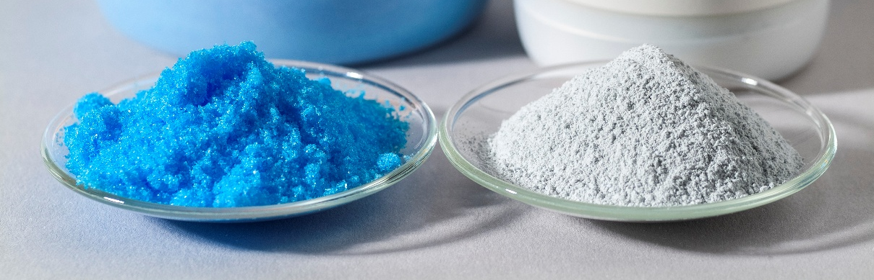
© Science Photo Library

Blue hydrated copper(II) sulfate (left) and the white crystals formed when it is heated (right)

Alice took some of the blue hydrated copper(II) sulfate crystals and heated them strongly in a test tube. Alice saw that the blue crystals changed colour to white, she wrote down that ‘steam’ rose from the test tube. Her thoughts are listed below:
- Sodium chloride crystals have no water since they are already white
- The hydrated copper(II) sulfate contains water
- Coloured compounds will change to white when heated if they lose water
- When it is heated, the blue hydrated copper(II) sulfate loses water
- The white residue is copper sulfate with no water – anhydrous copper(II) sulfate
- The copper(II) sulfate needs water to be blue – without water it is white
- The hydrated copper(II) sulfate changes when it is heated
- Rearrange Alice’s thoughts into a sensible order.

__________________________________________________________________________________
↓

__________________________________________________________________________________
↓

__________________________________________________________________________________
↓

__________________________________________________________________________________
↓

__________________________________________________________________________________
↓

__________________________________________________________________________________
↓

__________________________________________________________________________________

- Alice draws some big conclusions from this single experiment. Which of her conclusions do you think are reasonable? Explain your reasons.

__________________________________________________________________________________

__________________________________________________________________________________

__________________________________________________________________________________

__________________________________________________________________________________

__________________________________________________________________________________

__________________________________________________________________________________

__________________________________________________________________________________

- Which of her conclusions do you think are unreasonable? Explain your reasons.

__________________________________________________________________________________

__________________________________________________________________________________

__________________________________________________________________________________

__________________________________________________________________________________

__________________________________________________________________________________

__________________________________________________________________________________

__________________________________________________________________________________

__________________________________________________________________________________

__________________________________________________________________________________

__________________________________________________________________________________

