What happens when a substance changes state?

This resource is from the Assessment for learning series which can be viewed at: rsc.li/44jTX18. This series contains lesson plans and associated resources to actively involve students in their learning.

Resource components
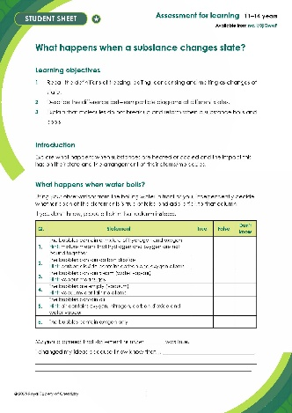 | 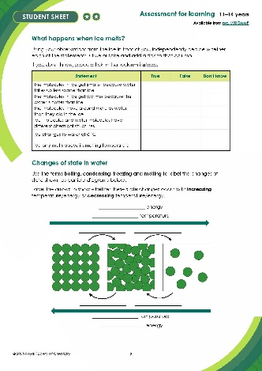 | 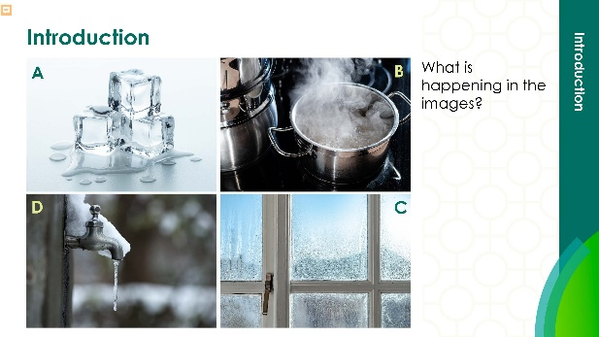
Scaffolded student sheet : true or false questions with hints to support learners | Student sheet : true or false questions to be answered in small groups | Presentation: lesson slides to guide learners through the demonstration, and follow-up questions, including answers for self-assessment

Learning objectives
- Recall the definitions of freezing, boiling and melting as changes of state.
- Describe the difference between particle diagrams at different states.
- Explain that molecules do not break up and reform when a substance boils and cools.

Get learners to work together to determine whether a series of statements are true or false based on their understanding of melting and boiling.

Introduction

In this activity, learners watch a demonstration, then answer questions to probe their misconceptions and to develop scientific understanding about what happens when a substance changes state.

Scaffolding

To support learners further, a scaffolded version () of the student sheet is available, which gives learners hints in the table headings. These will support learners’ working memory as they will elicit prior knowledge discussed in this lesson and previous lessons.

At the end of the unscaffolded () worksheet, there is a challenge task, which asks learners to also label freezing and condensing, and to label an arrow to show increasing and decreasing energy of the particles.

Sequence of activities

Eliciting ideas – oracy activity (slides 2–3)

Collect learners’ ideas about the meanings of freezing, melting, condensing and boiling.

Show learners slide 3, then give them 30 seconds thinking time. Then allow learners to share their ideas in pairs:
- Person 1 presents their ideas on boiling. Person 2 actively listens and responds by agreeing, disagreeing or building on this point
- Person 2 presents their ideas on freezing and the pair repeat the above cycle until they have discussed all four words

Select a few groups to feed back to the class. Write down the ideas/misconceptions learners have and save these for later reference.

Demonstration and activity: stage 1 (slides 4–10)
- Using a Bunsen burner, demonstrate what happens when water boils. Learners should make observations about bubbles and steam being produced as the temperature of the water increases.
- Explain the difference between observations and inferences and then show learners the particle diagrams of the change of state between a liquid and a gas. Then on whiteboards, ask learners to describe what has happened as the substance has changed state from a liquid to a gas.
- Invite learners to work individually on completing the first part of the worksheet.

Activity: stage 2 (slide 11)

Organise learners into groups of four. Circulate and support as groups:
- Discuss their individual responses to the worksheet, working towards a consensus.
- Prepare a response to feed back to the class.
- Elect a spokesperson.

Plenary 1 (slides 12–14)

In a plenary:
- Invite responses from each group.
- Lead learners towards a scientifically correct viewpoint using the graphic on the PowerPoint
- Encourage learners to try and visualise what is happening to the water at a molecular level. (To find out more about this ‘molecular spectacles’ technique see: rsc.li/43Yamaj)
- Ask them to correct their worksheet, if they need to.

Demonstration and activity: stage 3 (slides 15–16)
- Introduce the next task, which is to look at the liquid–solid state change.
- Place a beaker of ice cubes in front of the class/on each table. This can be warmed gently but may also be left at room temperature.
- Invite learners to work individually on completing the second page of the worksheet.

Activity: stage 4 (slide 17)

Reform the groups of four learners. Circulate and support as groups:
- Discuss their individual responses, working towards a consensus.
- Prepare a response to feed back to the class.
- Elect a spokesperson.

Plenary 2 (slides 18–23)

In a plenary:
- Invite responses from each group.
- Show learners slides 19 and 20 to support the development of the concept that intermolecular forces exist between the water molecules in ice.
- Label the changes of state on a particle diagram for water and add an arrow showing the direction in which the state change occurs when the substance is either being heated up or cooled down.
- Reinforce that these terms apply to all substances.

Revisit the introductory discussion (slide 24) and invite learners to discuss how their views have changed. Collect the worksheets.

Commentary

Discussing personal viewpoints with others allows learners to review each other and give feedback. It also allows them to see from other perspectives. Reaching consensus in groups stimulates this process. The teacher-led plenary discussion helps learners whose thinking has not moved forward and gives you an opportunity to assess the extent of any misconceptions in the class. Checking the written feedback on worksheets also gives you an opportunity to deal with misconceptions or confirm correct thinking,

Answers

Answers to the learner activities can be found on the PowerPoint slides: rsc.li/3jiQwwP

Technician notes

In this resource, there is a demonstration of boiling water and a group-based observation where learners can observe ice melting.

Read our standard health and safety guidance (rsc.li/3iFPxff) and carry out a risk assessment before running any live practical.

Equipment

For the demonstration of boiling water:
- Bunsen burner
- Heat-proof mat
- Gauze
- Tripod
- Beaker

For the demonstration of ice melting (per group of 4):
- Beaker

Preparation
- Prepare enough ice for each group of 4 to have a beaker to observe.

Safety and hazards
- Wear safety glasses while using the Bunsen burner
- Risk of burning from Bunsen burner/hot glassware

