Viscosity

Learning objectives
- Compare the viscosity of different liquids by making careful observations.
- Apply your understanding of particles to explain your observations.
- Design an experiment.

Introduction

You are going to measure the times it takes for a bubble to rise through different liquids. This is a way to compare the viscosity of the liquids.

Equipment (per group)

Apparatus
- Stopwatch
- Sealed tubes of different liquids

Chemicals

Choose from:
- water
- cooking oil
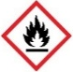
- Washing up liquid
- Ethanol
- Shampoo or bubble bath
- Conditioner

Safety equipment
- Eye protection: safety glasses to EN166F

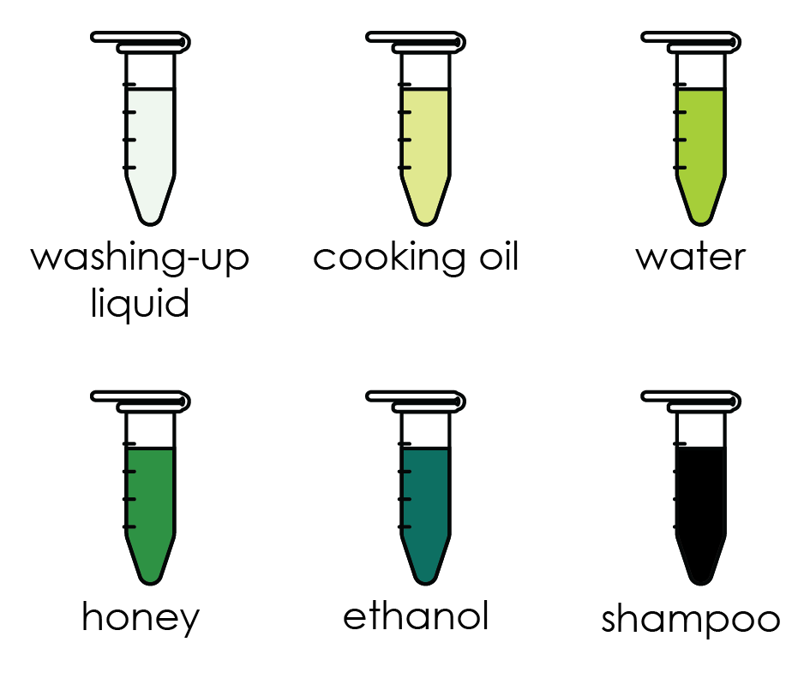
Diagram

Procedure

Take one of the tubes provided.
- Ensure the bubble is at the top and the tube is held vertical.
- Quickly invert the tube and measure the time it takes for the bubble to reach the top.
- Repeat this measurement for all the samples.
- Complete the table provided.

Results
 | Time taken (s)
Liquid | Test 1 | Test 2 | Test 3 | Average time (s)
Water
Cooking oil
Washing-up liquid
Ethanol
Shampoo or bubble bath
Honey

Questions
- State the meaning of the word viscosity.

__________________________________________________________________________________

__________________________________________________________________________________
- Use your results to identify the most viscous liquid? Why did you choose your answer?

Liquid ____________________________________________________________________

Reason ____________________________________________________________________
- Use your results to identify the least viscous liquid? Why did you choose your answer?

Liquid ____________________________________________________________________

Reason ____________________________________________________________________

- Draw a diagram to show how the particles are arranged in cooking oil.

- Describe what happens to the particles when a sample of cooking oil is poured into a frying pan.

__________________________________________________________________________________

__________________________________________________________________________________

__________________________________________________________________________________
- Explain why the viscosity of water is less than the viscosity of bubble bath.

__________________________________________________________________________________

__________________________________________________________________________________

__________________________________________________________________________________

- Predict how the viscosity of honey will change as the temperature of the honey is increased. Suggest a reason for your answer.

__________________________________________________________________________________

__________________________________________________________________________________

__________________________________________________________________________________
- Design an experiment to investigate how the temperature effects the viscosity of a liquid. You should include:
- a prediction
- variables (identify the independent, dependent and control variables)
- equipment list
- method
- results table

