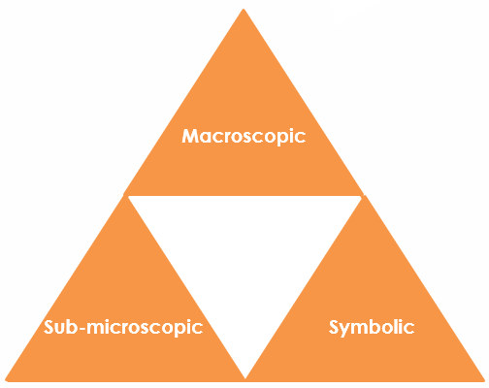
Excess copper oxide: Johnstone’s triangle

Learning objectives
- Explain the changes observed when copper oxide is added (in excess) to sulfuric acid.
- Recognise the compounds represented in the equation.
- Calculate the expected mass of excess copper oxide.

Introduction

When black copper oxide powder is added to sulfuric acid, it reacts to form blue copper sulfate solution. If more and more copper oxide is added, eventually all the sulfuric acid will react. After this point any copper oxide added will be in excess and clearly visible as a black powder in the new blue solution.

Johnstone’s triangle

In chemistry we make sense of the things that we can see by representing what we can’t see using formulas, equations, diagrams and models.

Johnstone’s triangle is a way of thinking about these different concepts as different corners of a triangle:

- Macroscopic – what we can see. Think about the properties we can observe, measure and record.
- Sub-microscopic – smaller than we can see. Think about the particle or atomic level.
- Symbolic – representations. Think about how we represent chemical ideas, including symbols and diagrams.

Being able to connect and move between these three different levels is important for scientific understanding.

Macroscopic – what we can see

Explain the colour change observed when copper oxide is added to warm sulfuric acid.

__________________________________________________________

__________________________________________________________

Explain why a black solid is observed at the bottom.

__________________________________________________________

__________________________________________________________

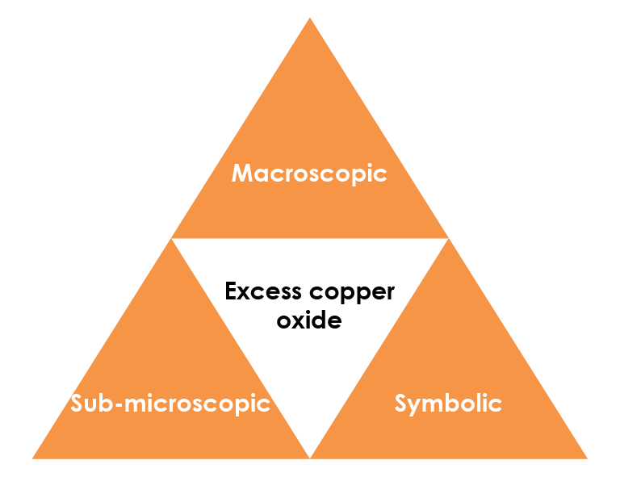

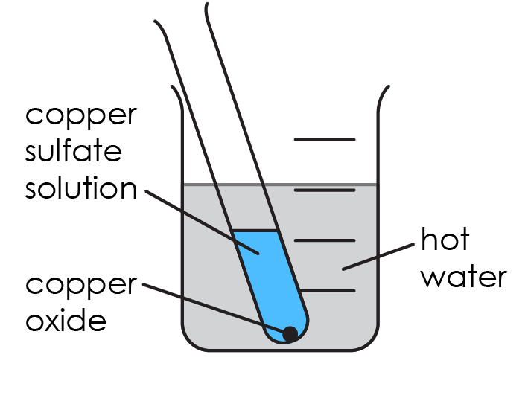

Symbolic – representations

The equation for the reaction between copper oxide and sulfuric acid is:

CuO(s) + $H_{2}{SO}_{4}$(aq) → ${CuSO}_{4}$(aq) + $H_{2}O$(l)

Write the name of the compounds represented by each formula.

CuO(s) ______________________________________________

$H_{2}{SO}_{4}$(aq) ______________________________________________

${CuSO}_{4}$(aq) ______________________________________________

Calculate the relative formula mass of copper oxide.

A_{r} (Cu) = 63.5 A_{r} (O) = 16

___________________________________________________________

___________________________________________________________

Sub-microscopic – smaller than we can see

Use the chemical equation to determine the number of moles of copper oxide that react with 1 mole of the acid.

____________________________________________________________

The boiling tube contains 0.02 moles of sulfuric acid. Determine the number of moles of copper oxide that react with all of the acid.

_____________________________________________________________

Calculate the mass of copper oxide that would react with all the acid.

_____________________________________________________________

_____________________________________________________________

1.8 g of copper oxide powder is added to the sulfuric acid.

Calculate the mass of excess copper oxide.

______________________________________________________________

