Excess copper oxide: Johnstone’s triangle

This resource is from the Johnstone’s triangle series which can be viewed at: rsc.li/43jMfSn. This series helps learners to understand the different ways you need to think in chemistry, building their mental models and understanding.

Learning objectives
- Explain the changes observed when copper oxide is added (in excess) to sulfuric acid.
- Recognise the compounds represented in the equation.
- Calculate the expected mass of excess copper oxide.

How to use Johnstone’s triangle

Use Johnstone’s triangle to develop learners’ thinking about scientific concepts at three different conceptual levels:
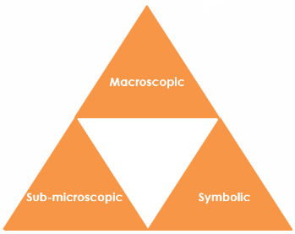
- Macroscopic – what we can see. Think about the properties you can observe, measure and record.
- Sub-microscopic – smaller than we can see. Think about the particle or atomic level.
- Symbolic – representations. Think about how we represent chemical ideas including symbols and diagrams.

For learners to gain a deeper awareness of a topic, they need to understand it at all three levels.

When introducing a topic, don't introduce all three levels of thinking at once. This will overload working memory. Instead complete the triangle over a series of lessons, beginning with the macroscopic level, then symbolic and then sub-microscopic.

The levels are interrelated. For example, learners need visual representation of the sub-microscopic in order to develop mental models of the particle or atomic level.

Find further reading about Johnstone’s triangle and how to use it in your teaching at: rsc.li/49rruZz.

Scaffolding

Share the structure of the triangle with learners prior to use. Tell them why you are using it and how it will help them to develop their understanding. Use an ‘I try, we try, you try’ approach when introducing Johnstone’s triangle for the first time.

More resources

To further develop learner’s thinking in all areas of Johnstone’s triangle, try our Developing understanding of limiting and excess reactants (quantitative) worksheets (rsc.li/4pmKCw8). These include icons in the margin referring to the conceptual level of thinking needed to answer the question.
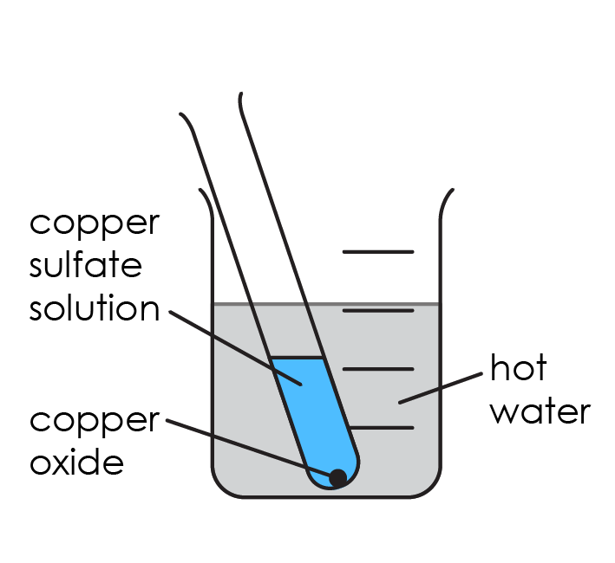
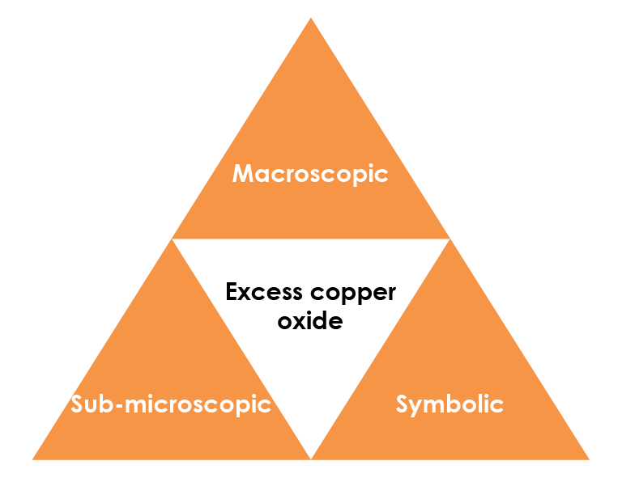

Symbolic – representations

The equation for the reaction between copper oxide and sulfuric acid is:

CuO(s) + $H_{2}{SO}_{4}$(aq) → ${CuSO}_{4}$(aq) + $H_{2}O$(l)

Write the name of the compounds represented by each formula.

CuO(s) copper oxide

$H_{2}{SO}_{4}$(aq) sulfuric acid

${CuSO}_{4}($aq) copper sulfate solution

Calculate the relative formula mass of copper oxide.

A_{r} (Cu) = 63.5 A_{r} (O) = 16

M_{r} (CuO) = 63.5 + 16 = 79.5

Sub-microscopic – smaller than we can see

Use the chemical equation to determine the number of moles of copper oxide that react with 1 mole of the acid.

1 mole

The boiling tube contains 0.02 moles of sulfuric acid. Determine the number of moles of copper oxide that react with all of the acid.

0.02 moles

Calculate the mass of copper oxide that would react with all the acid.

mass = Mr (CuO) x number of moles = 79.5 x 0.02 = 1.59 g

1.8 g of copper oxide powder is added to the sulfuric acid.

Calculate the mass of excess copper oxide.

1.8 - 1.59 = 0.21 g

Macroscopic – what we can see

Explain the colour change observed when copper oxide is added to warm sulfuric acid.

The solution changes from colourless to blue because copper sulfate is formed.

Explain why a black solid is observed at the bottom.

The black solid is unreacted (excess) copper oxide left when there is all the copper sulfate has reacted.

