Practising calculations in chemistry

This resource is from the Assessment for learning series which can be viewed at: rsc.li/44jTX18. The series contains lesson plans and associated resources to actively involve students in their learning.

You can find more resources to prepare, deliver, assess or enrich your teaching of Quantitative chemistry at 14−16 in our topic package: rsc.li/3P4r8Au

Resource components
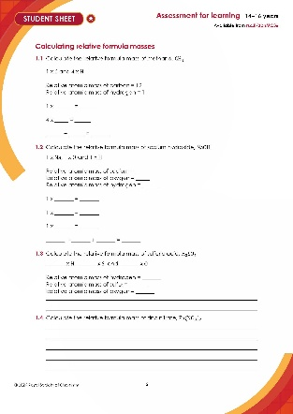 | 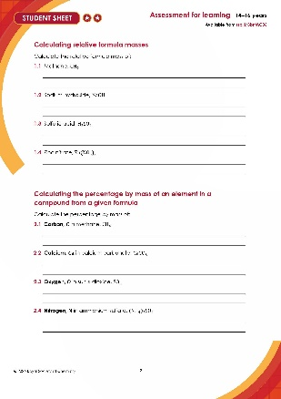 | 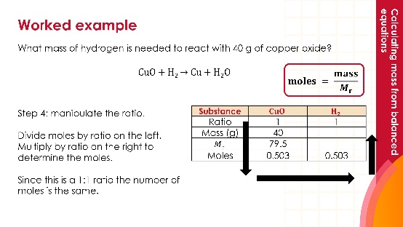
Scaffolded student sheet (µ): a write-on worksheet with support through scaffolding | Unscaffolded student sheet (µµ): a write-on worksheet with calculation questions | Presentation: lesson slides to guide learners through the questions and self-assess the answers

Learning objectives
- Calculate the relative formula mass of a compound given its formula and appropriate relative atomic masses.
- Calculate the percentage by mass of an element from a given formula.
- Calculate masses of reactants and products from balanced equations using the mole equation.

With this activity, enable learners to check and practise simple calculations in chemistry. As groups of learners become ‘expert’, demonstrating their ability to their peers and their teacher, they progressively consolidate the work of other groups.

Use this resource to consolidate and to check on learning. As several different types of calculation are included, you can revisit it over a period of time.

Teaching sequence

Introduction

Introduce learners to quantitative chemistry with this resource, focusing on the use of mathematics to understand and predict chemical reactions. While learners may already be familiar with identifying reactants and products, this topic develops their ability to determine how much of each substance is involved in a reaction.

Learners will calculate the relative formula mass ($M_{r}$) of compounds using atomic masses from the periodic table, and determine the percentage by mass of an element within a compound in order to understand chemical composition. They will then apply this knowledge using balanced equations and the mole equation to calculate the masses of reactants and products in chemical reactions.

By developing these skills, learners will build their confidence in applying mathematical techniques in chemistry and gain a clearer understanding of how quantitative methods make chemistry precise, reliable and relevant to real-world applications.

Activities

The teaching sequence is the same for each learning objective:
- Give a brief introduction to the topic.
- Provide the worked example. You can give this to learners in full afterwards, so they have an example, or ask them to copy this down as you are modelling it.
- Get learners to complete the two checkpoint questions in pairs on mini whiteboards.
- After each question, ask for a show of boards before going through the question with cold-call questioning to the whole class.
- Ask learners to work through the final four calculations independently.

Commentary

Use a checkpoint quiz to remove some of the pressure of moving straight onto independent work, to allow you to determine who needs more support during the independent task, and to determine whether to use the unscaffolded or scaffolded sheet with your learners.

Equipment

For each learner:
- Calculator
- Data table from student sheet (or periodic table)
- Mini whiteboards and pens for checkpoint quizzes

Scaffolding
- Two versions of the worksheet are available: scaffolded (µ) and unscaffolded (µµ). The different sheets are indicated by the number of stars in the header.
- The scaffolded worksheet provides support to learners through backwards fading for calculating relative formula mass and percentage by mass calculations. This is where examples are partially completed and the amount of completion is lowered through each example.
- For calculations of masses of reactants and products from balanced equations using the moles equation, step by step instructions are given.

Answers

Relative formula mass
  - Methane, $CH_{4}$

1 x $C$ and 4 x $H$

Relative atomic mass of carbon = 12

Relative atomic mass of hydrogen = 1

1 x 12 = 12

4 x 1 = 4

12 + 4 = 16

  - Sodium hydroxide, $NaOH$

1 x $Na$, 1 x $O$ and 1 x $H$

Relative atomic mass of sodium = 23

Relative atomic mass of oxygen = 16

Relative atomic mass of hydrogen = 1

1 x 23 = 23

1 x 16 = 16

1 x 1 = 1

23 + 16 + 1 = 40

  - Sulfuric acid, $H_{2}SO_{4}$

2 x $H$, 1 x $S$ and 4 x $O$

Relative atomic mass of hydrogen = 1

Relative atomic mass of sulfur = 32

Relative atomic mass of oxygen = 16

2 x 1 = 2

1 x 32 = 32

4 x 16 = 64

64 + 32 + 2 = 98

  - Zinc nitrate, $Zn{(NO_{3})}_{2}$

1 x $Zn$, 2 x $N$ and 6 x $O$

Relative atomic mass of zinc = 65

Relative atomic mass of nitrogen = 14

Relative atomic mass of oxygen = 16

1 x 65 = 65

2 x 14 = 28

6 x 16 = 96

65 + 28 + 96 = 189

Percentages of elements
  - Carbon, $C$ in methane, $CH_{4}$

1 atom of carbon. Mass of carbon is 12.

Total mass of $CH_{4}$ = 1 x $C$, 4 x $H$ = 12 + (4 x 1) = 16

% by mass = $\frac{12}{16} × 100$ = 75%

  - Calcium, $Ca$ in calcium carbonate, $CaCO_{3}$

1 atom of calcium. Mass of calcium is 40.

Total mass of $CaCO_{3}$ = 1 x $Ca$, 1 x $C$ and 3 x $O$ = 40 + 12 + (3 x 16) = 100

% by mass = $\frac{40}{100} × 100$ = 40%

  - Oxygen, $O$ in sulfur dioxide, $SO_{2}$

2 atoms of oxygen. Mass of oxygen is 2 x 16 = 32.

Total mass of $SO_{2}$ = 1 x $S$, 2 x $O$ = 32 + (2 x16) = 64

% by mass = $\frac{32}{64} × 100$ = 50%

  - Nitrogen, $N$ in ammonium sulfate, ${(NH_{4})}_{2}SO_{4}$

2 atoms of nitrogen. Mass of nitrogen is 2 x 14 = 28.

Total mass of ${(NH_{4})}_{2}SO_{4}$ = 2 x $N$, 8 x $H$, 1 x $S$ and 4 x $O$ = (2 x 14) + (8 x 1) + 32 + (4 x16) = 132

% by mass = $\frac{28}{132} × 100$ = 21.2%

Masses of reactants and products

For each of the questions below, learners must follow the following steps:

Step 1: Fill out the table with the information from the question. On the left write the formula for the substance that you know the mass of. On the right, write the formula of the substance you need to find the mass of. The balancing number tells you the ratio.

Step 2: Work out the relative formula mass of the substance on the left.

Step 3: Work out the moles of the substance on the left using $moles= \frac{mass}{M_{r}}$

Step 4: Manipulate the ratio. Divide moles by ratio on the left and times by ratio on the right to determine the moles.

Step 5: Work out the relative formula mass of the substance on the right.

Step 6: Work out mass using the rearranged mole equation $mass= moles ×M_{r}$

Substance | $$CaCO_{3}$$ | $$CaO$$
Ratio | 1 | 1
Mass (g) | 10 | 5.6
M_{r} | 100 | 56
Moles | 0.1 | 0.1

Substance | $$S$$ | $$SO_{2}$$
Ratio | 1 | 1
Mass (g) | 2.4 | 4.8
M_{r} | 32 | 64
Moles | 0.075 | 0.075

Substance | $$CuO$$ | $$C$$
Ratio | 2 | 1
Mass (g) | 8 | 0.6
M_{r} | 79.5 | 12
Moles | 0.1 | 0.05

Substance | $$Fe$$ | $${Fe}_{2}O_{3}$$
Ratio | 2 | 1
Mass (g) | 112 | 160
M_{r} | 56 | 160
Moles | 2 | 1

