Symbols and formulas

This resource is part of the Structure strips series of resources, designed to support literacy in science teaching. More resources in this series can be found at: rsc.li/4aXYgzt

Learning objectives
- Understand why chemists communicate using symbols and formulas.

Success criteria: this can be shown in the response to the extension question or through verbal questioning. Ask learners to read through the introduction to the activity as a class to reinforce this objective.
- Use the periodic table to find the symbols for elements.

Success criteria: responses to prompts 1 and 2 of the structure strip.
- Understand how subscript numbers indicate the number of atoms in a formula including where there are brackets present.

Success criteria: responses to prompts 3−5 of the structure strip.
- Write independently about symbols and formulas, using provided key words.

Success criteria: overall approach to the activity and extension question and use of support resources.

Introduction

Chemicals have different names in different languages. If English is your first language, you might recognise sulfuric acid in Romanian, but perhaps you would not recognise it in Polish unless you speak that language.

Polish | kwas siarkowy
Romanian | acid sulfuric

Scientists use symbols and formulas as one way of overcoming language barriers when communicating their science.

Chemical formulas contain chemical symbols (for example, H) and may also have subscript numbers (numbers which are smaller and lower than the letters, for example $H_{2}$).
Learners need to learn the rules of how symbols and formulas work. This knowledge will be very useful for the rest of their science education.

How to use structure strips

Structure strips are a type of scaffolding you can use to support learners to retrieve information independently. Use them to take an overview at the start of a topic, to activate prior knowledge, or to summarise learning at the end of a teaching topic. Visit rsc.li/3EszCfr for more ideas on how to use structure strips with your learners.

Structure strips have sections containing prompts, sized to suggest the amount that learners must write. Ask learners to glue the strips into the margin of an exercise book and write their answers next to the sections, in full sentences or in bullet points. When learners have finished using the structure strip, they will have an A4 page set of notes and examples.

Scaffolding
- Encourage learners to use the suggested key words in their answers. These link with our corresponding key terms support resources for Elements, compounds and mixtures (rsc.li/42AcGmK)
- To further support learners, include additional prompts in the structure strip. If learners are struggling to engage with the task, supply them with sentence starters created from the example answers.
- As learners grow in confidence, ask them to attempt the extension task first and then use the structure strip to improve or self-assess their attempt.

Metacognition

This resource supports learners to develop their metacognitive skills in three key areas.
- Planning: the strips provide scaffolding to plan the written response. Learners will decide where to gather information from (textbooks, own notes, revision websites). Ask learners: is the source of information you are using reliable?
- Monitoring: learners are prompted by the questions in the structure strip and can check their own answer against the prompts. Ask learners: have you covered all of the prompts in the space provided? Do you need to change anything to complete the task?
- Evaluation: learners can self-assess or ask a peer to check their work against the answers. Ask learners: did you achieve what you meant to achieve? What will you do differently another time?

Example answers

Example answers for the structure strip are on page 3. Learners can write the answers as bullet points or prose.
Structure strip  Symbols and formulas | Example answer
Write three examples of chemical symbols that are a capital letter and write the names of the elements they represent. | Any suitable chemical symbols and names. Look out for correct spelling of element names and the symbols being clearly capital letters.  For example, S sulfur, C carbon, H hydrogen.  Guidance note: provide a periodic table for learners to refer to. For example, the RSC’s interactive periodic table: periodic-table.rsc.org. This will also be helpful for assessing their answers.
Write three examples of chemical symbols that are a capital letter and a lower-case letter and write the names of the elements they represent. | Any suitable chemical symbols and names. Look out for the symbols being clearly capital letters and lower-case letters as it is common for learners to make mistakes here.  For example, Fe iron, Mg magnesium, He helium.
Oxygen has two forms, O₂ which is in the air we breathe, and O₃ which is called ozone. Explain how the formulas show these are: a) the same element and b) in different forms. | - These formulas show that they are the same element because they only contain one chemical symbol, O for oxygen.  - The subscript numbers show that the molecules are made up of different numbers of atoms of the element – two in oxygen and three in ozone.
Using $CaF_{2}$, explain how to use subscript numbers in formulas to work out the number of each atom. | The subscript numbers multiply the atom immediately to the left of the number. So, in $CaF_{2}$ the 2 applies to the F. In other words, there are two fluorine atoms. It does not apply to the Ca, so it is formed from two fluorine atoms and only one calcium atom.
Using $Mg(OH)_{2}$, explain how to work out the number of atoms of an element in a formula when there are brackets present. | Brackets in a formula mean that the subscript number multiplies everything in the brackets to the left of the number. So, in $Mg(OH)_{2}$the 2 multiplies both the O and the H in the brackets but not the Mg.  So ${Mg(OH)}_{2}$ is formed from two oxygen atoms, two hydrogen atoms and one magnesium atom in this formula.

Extension question

Get learners to answer the question after they have attempted the structure strip. The structure strip activates the required knowledge which learners then apply to the question.

Consider reframing the context of this question to one your learners are more familiar with, to empower them to unlock their existing science capital. Visit rsc.li/40FAMLP for more information.
Learners will benefit from discussion with a partner or participating in class discussion before they begin this task. Support learners to visualise their ideas by supplying chemical modelling kits like Molymods, or counters.

Example answer to extension question

Magnesium and its compounds

Scientists use chemical formulas to communicate clearly. Formulas contain chemical symbols and subscript numbers.

Magnesium – Mg. The formula is just the chemical symbol.
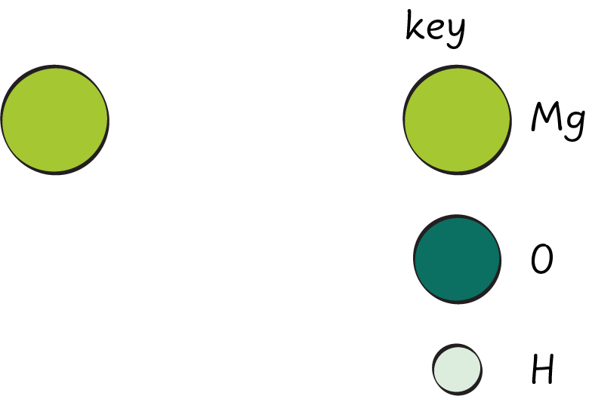

Magnesium oxide – MgO. There are no numbers in the formula, so it is only made up of one of each atom.



Magnesium hydroxide – Mg(OH)₂. The number 2 multiplies everything in the brackets to the left so there are 2 atoms of oxygen and of hydrogen. 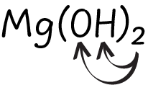

The 2 does not multiply the Mg so there is only one atom of magnesium in the formula.



