Chromatography
This resource is part of the Structure strips series of resources, designed to support literacy in science teaching. More resources in this series can be found at: rsc.li/4aXYgzt.

Learning objectives
- Construct and interpret diagrams of the apparatus used for chromatography experiments.
- Describe how you can tell that a sample is a mixture from its chromatogram.
- Explain why samples travel different distances in chromatography experiments.

Introduction

Chromatography is a useful separation technique based on chemicals’ solubilities – in other words, how well chemicals dissolve in particular solvents. In the pharmaceutical industry, chromatography is used to check the purity of medicines. In the food and drink industry, it is used to detect contaminants in batches of produce. And forensic scientists use chromatography to detect the presence of tiny amounts of chemicals in crime scene samples, such as hair or soil.

There are many different types of chromatography, but paper chromatography is the technique you focus on at school, and it’s the type of chromatography we’ll discuss in this structure strip.

If possible, get learners to carry out a chromatography experiment before attempting this structure strip. Look at the paper chromatography practical video for more information (rsc.li/3MSQltm).

How to use structure strips

Structure strips are a type of scaffolding you can use to support learners to retrieve information independently. Use them to take an overview at the start of a topic, to activate prior knowledge, or to summarise learning at the end of a teaching topic. For more ideas on how to use structure strips with your learners, visit rsc.li/3EszCfr.

Structure strips have sections containing prompts, sized to suggest the amount that learners must write. Ask learners to glue the strips into the margin of an exercise book and write their answers next to the sections, in full sentences or in bullet points. When learners have finished using the structure strip, they will have an A4 page set of notes and examples.

Scaffolding
- Encourage learners to use the suggested key words in their answers. These link with our key terms support resources for Elements, compounds and mixtures (rsc.li/4j5xfyj and rsc.li/42AcGmK).
- To further support learners, include additional prompts in the structure strip. If learners are struggling to engage with the task, supply them with sentence starters created from the example answers.
- As learners grow in confidence, ask them to attempt the extension question first and then use the structure strip to improve or self-assess their answer.

Metacognition

This resource supports learners to develop their metacognitive skills in three key areas.
- Planning: the strips provide scaffolding to plan the written response. Learners will decide where to gather information from (textbooks, own notes, revision websites). Ask learners: is the source of information you are using reliable?
- Monitoring: learners are prompted by the questions in the structure strip and can check their own answer against the prompts. Ask learners: have you covered all of the prompts in the space provided? Do you need to change anything to complete the task?
- Evaluation: learners can self-assess or ask a peer to check their work against the answers. Ask learners: did you achieve what you meant to achieve? What will you do differently another time?

Example answers

Example answers for the structure strip are on page 3. Learners can write the answers as bullet points or prose.

Structure strip  Chromatography | Example answer
Draw a labelled diagram of an apparatus set up for paper chromatography.  Describe two key things about the origin line for the experiment to be successful. | 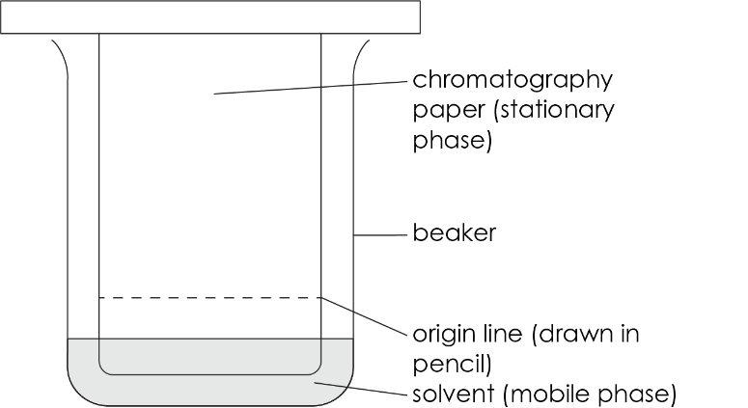  - The origin line must be drawn in pencil.  - The solvent/mobile phase should be below the origin line at the start of the experiment.
Explain the terms:  - mobile phase  - stationary phase  and give a common example of each. | The mobile phase is the solvent which carries the samples up the chromatogram. In school experiments this is usually water.  The stationary phase is the support material that the samples are placed on. In school experiments this is usually chromatography paper.
How does a chromatogram show there is more than one substance in a mixture? | A chromatogram would show two or more spots vertically up from where the sample spot was placed on the origin.
Explain how chromatography works to separate the substances in a mixture. | Chromatography works because substances have different solubilities. Substances that are very soluble in the mobile phase travel far up the chromatogram (and have a large $R_{f}$). Less soluble substances stay further down the chromatogram (and have a smaller $R_{f}$).
Give the formula for calculating $R_{f}$and describe how to use a chromatogram to determine $R_{f}.$  (Use a diagram if needed). | $R_{f}$ = distance from the origin line to the spot / distance from the origin line to the solvent front  $R_{f}$ values are always less than 1.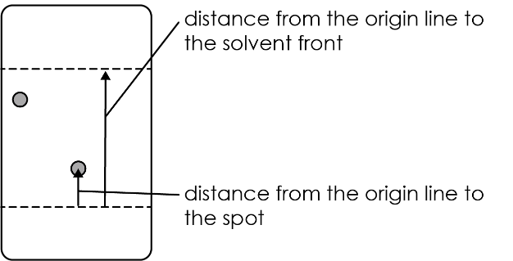

Extended answer question

Get learners to answer the question after they have attempted the structure strip. The structure strip activates the required knowledge which learners then apply to the question.

Consider reframing the context of this question to one your learners are more familiar with, to empower them to unlock their existing science capital. Read our article about targeting science capital (rsc.li/40FAMLP).

Example answer to extended answer question

Error 1: the origin line is drawn in pen.
Reason: the ink from the pen would be soluble in the mobile phase and move up the chromatogram, obscuring the real results.
Improvement: draw the origin line in pencil.

Error 2: the solvent is above the origin line at the start of the experiment.
Reason: this would wash the samples off from the origin line.
Improvement: make sure the solvent is below the origin at the start of the experiment.

