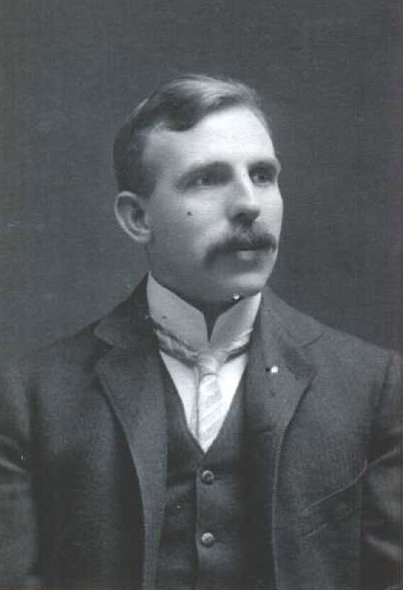

Ernest Rutherford

(Reproduced with kind permission from http://en.wikipedia.org/)

