Kallium and plumbate

Name ………………………………

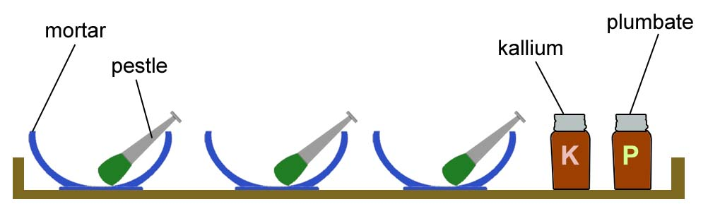

What you do
- Find the mass of the tray and everything on the tray.
- Put the kallium in one mortar.
- Put the plumbate in another mortar.
- Use the pestle to grind the kallium.
- Use another pestle to grind the plumbate.
- Write down what happens to each substance.
- Tip the kallium and plumbate into the third bowl.
- Use the pestle to grind the two substances together.
- Write down what happens.
- Find the mass of the tray and everything on the tray again.

Write what happens
When the kallium is ground up:

When the plumbate is ground up:

When the two substances are ground up together:

The mass of the equipment before: __________ g mass after: ___________ g

Questions

- Did a chemical reaction happen in any of the bowls? Yes / No

If Yes, show which: Kallium Plumbate Kallium and Plumbate

- How do you know if a chemical reaction happened?

- In your group, agree what the rules are for telling when a chemical reaction has happened.

The rules are …

