Hydrogen bonds
Making slime Answer: Structure of slime

Gross structure
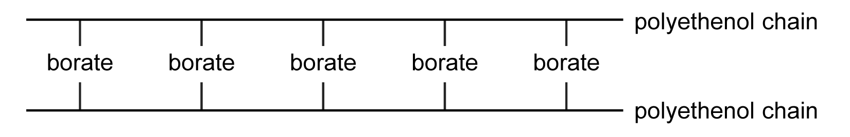

Full structure
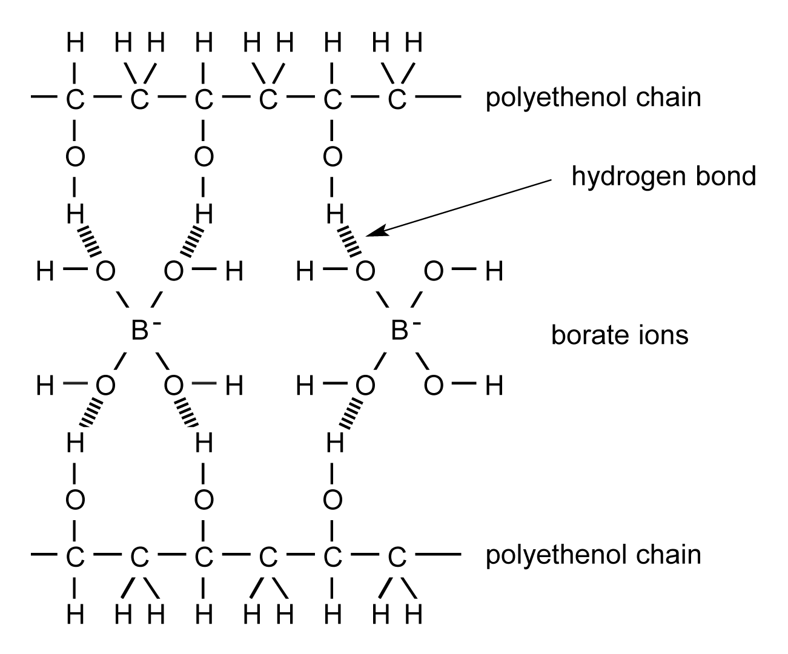

Repeating unit | Monomers
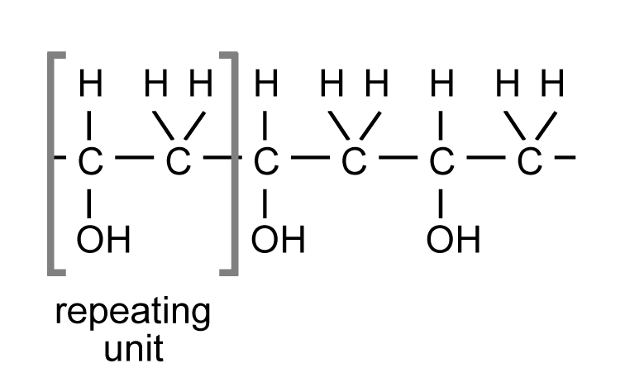 | ethenol  CH₂CHOH. | 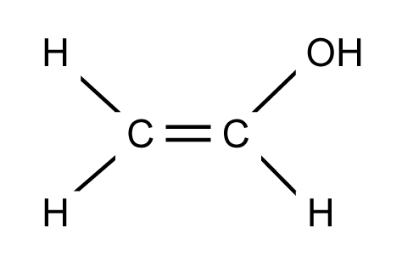
 | borate  B(OH)₄⁻ | 