What sank the Kursk?

On Saturday, 12th August, 2000, one of the world’s most advanced and secret submarines, the Kursk, sank to the bottom of the sea with no survivors. At the time, the Kursk was on a naval exercise carrying a crew of 118 sailors. The Kursk was the pride of the Russian navy. Larger than two jumbo jets and built with two titanium hulls, one inside the other, the Kursk could carry 30 torpedoes, each fitted with a nuclear warhead. The Kursk was capable of remaining at sea for up to six months. Internally, the Kursk was divided into nine watertight compartments and was believed to be unsinkable. The sinking of the Kursk caused great embarrassment to the Russian nation. The cause of the accident was initially a mystery.

Shortly before the submarine was reported as lost, the seismic recording station called ARCES in northern Norway recorded two explosions. The data generated are presented here for you to analyse.

When and where did the Kursk sink?

Two events were recorded at ARCES at around 0730 on Saturday, 12th August 2000. At this time, the Kursk was on naval exercises in the region. UK and US ships and submarines were also thought to be in the area making observations. The BBC first reported an accident at about the same time.

Reporter | Latitude  / °N | Longitude  / °E | Report time GMT | Richter scale magnitude
BBC | 69.62 | 37.58 | - | -
ARCES | 69.70 | 36.80 | 07.28.27 | 1.5
ARCES | 69.57 | 37.54 | 07.30.42 | 3.5

Table 1

- Use an atlas or electronic map to find out where the events occurred.
- Which is the bigger disturbance?

Initial reports suggested that there had been an accident with a nuclear submarine. The Russians reported that the Kursk had collided with another submarine.

The seismic data gives clues as to what happened. Seismic data is collected all the time, recording earthquakes and other events such as explosions that cause the ground to move.

- Use Figure 1 to work out the time difference between the two events. This should be similar to the data given in Table 1.
- What do you notice about the shapes of the two Kursk signals?
- What does this tell you about the events that caused the signals?
- Why does this make the ‘collision’ theory unlikely?

The next two sets of figures show different types of seismic traces. This helps us find out what type of events happened.

- Use Figures 2 and 3 to work out what type of event happened to sink the Kursk.
- Explain how this confirms your answer to question 6.
We can find out how large the events were in terms of the equivalent number of tonnes of the explosive TNT. Figure 4 is a graph that will convert the Richter magnitude values to yield, that is, tonnes of explosive.

- Find the yield for the two events using the Richter magnitude values from Table 1.
- At the start you read about Kursk’s structure. How might this have affected the size of the events?
- Write a summary explaining what the seismic data suggests happened to the Kursk.

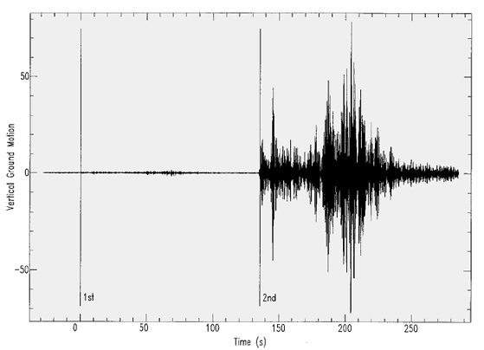

Figure 1. Seismic signals recorded at ARCES.
There is a small signal followed by a much larger one.

(Reproduced with the kind permission of David Bowers and Peter Marshall, www.blacknest.gov.uk)

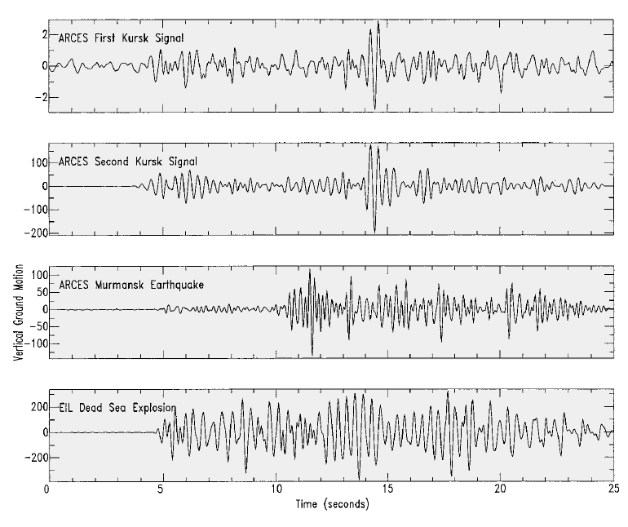

Figure 2. Four seismograms

The top two are from the Kursk. The third is from an earthquake near Murmansk, Russia. The fourth is from an underwater explosion.

(Reproduced with the kind permission of David Bowers and Peter Marshall, www.blacknest.gov.uk)

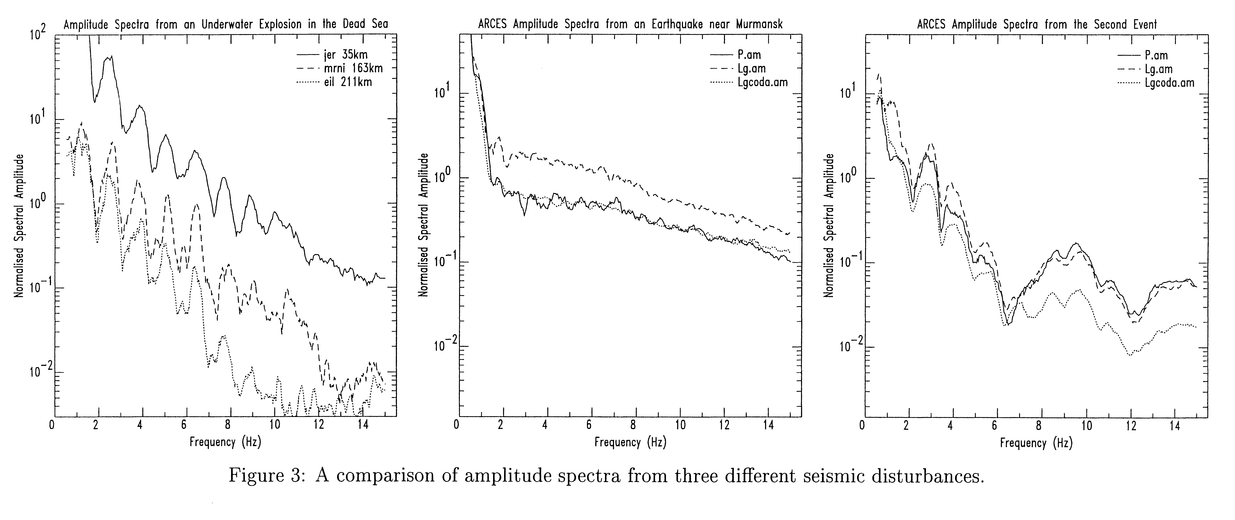

Figure 3. Amplitude spectra from the second Kursk event, the earthquake and the underwater explosion

(Reproduced with the kind permission of David Bowers and Peter Marshall, www.blacknest.gov.uk)

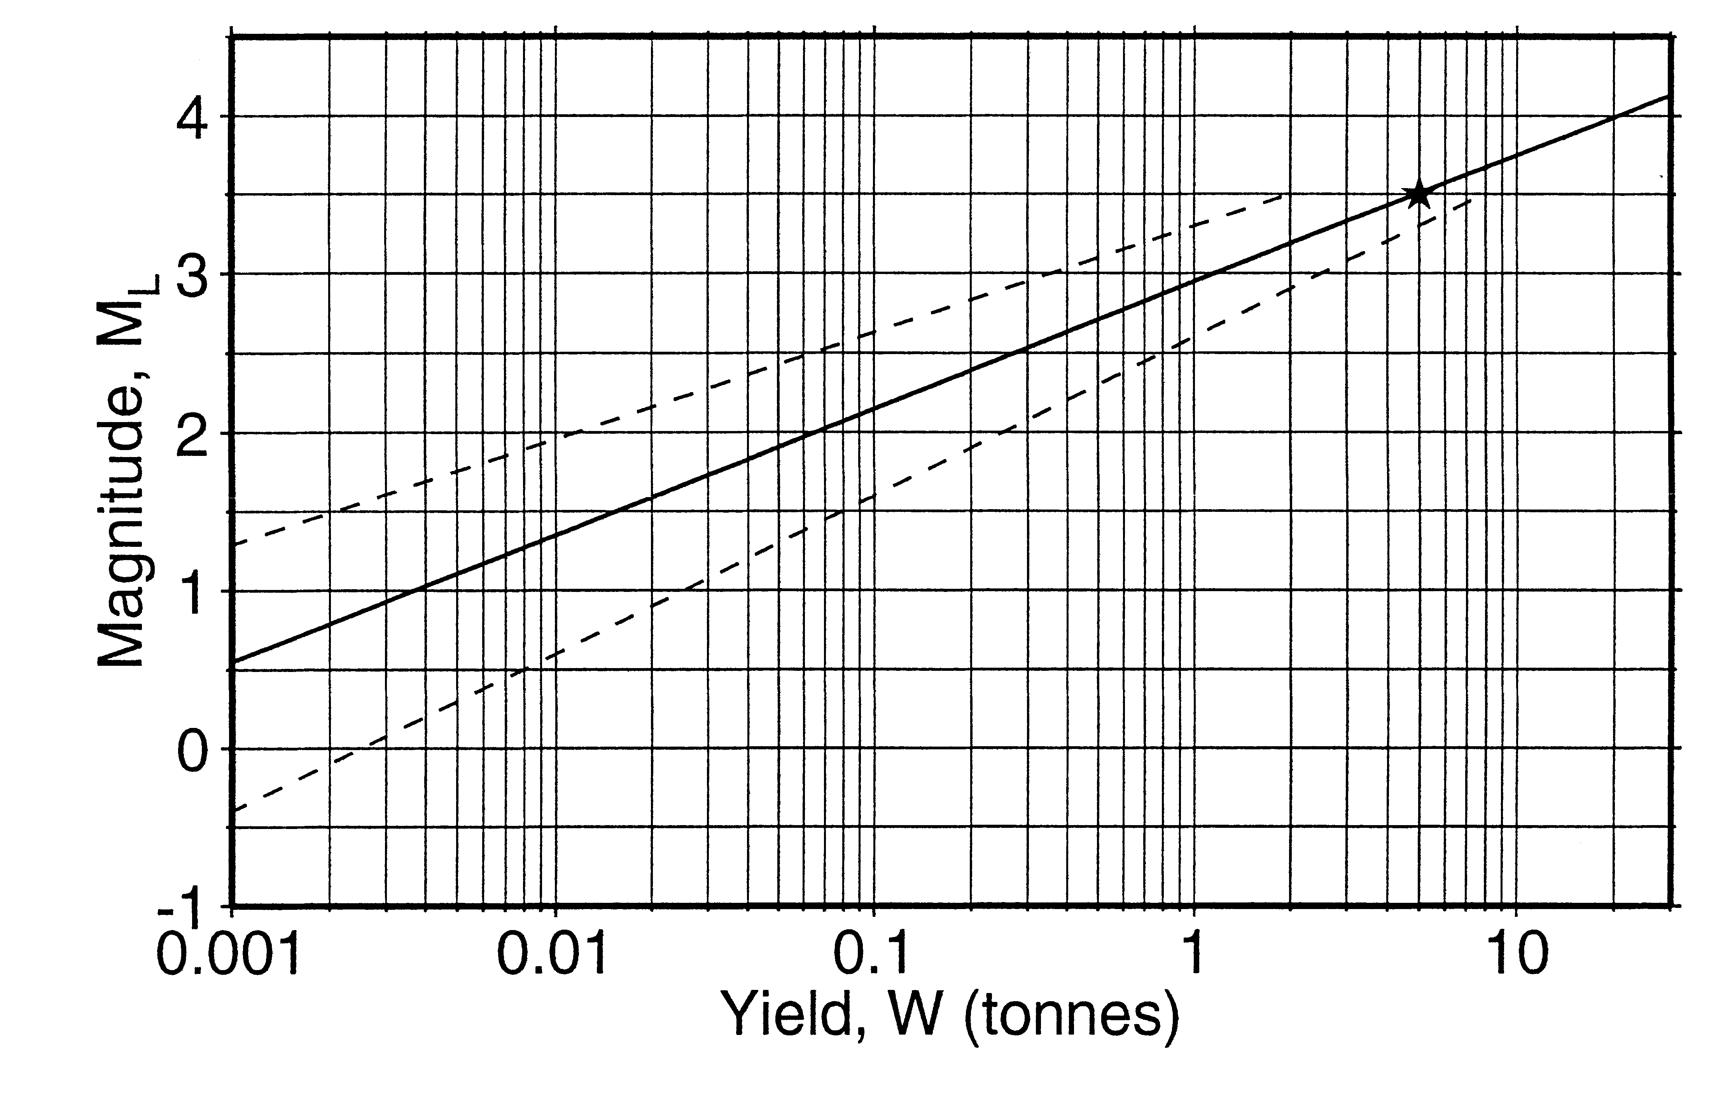
Figure 4. The link between Richter magnitude and explosive yield
The dashed lines indicate the level of uncertainty.
(Reproduced with the kind permission of David Bowers and Peter Marshall, www.blacknest.gov.uk)

