Name:………………………………………………..…. Date:………………………………………………………

Fat in food information table

  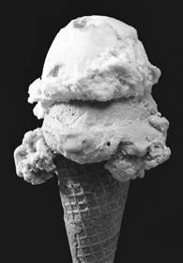
  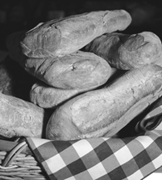
  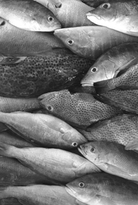
  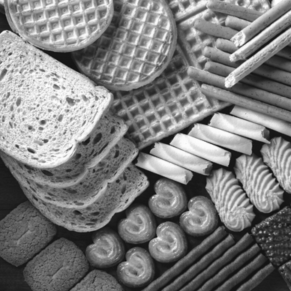
  Food | Total fat %
  Butter | 81.7
  Bacon, fried streaky | 42.2
  Beef, roast | 21.1
  Beef burger | 20.5
  Biscuit, Rich Tea | 16.6
  Biscuit, shortbread | 26.1
  Bread, white | 1.9
  Cake | 16.9
  Cheese, cheddar | 34.9
  Cheese, brie | 26.9
  Chicken, roast | 5.4
  Chocolate, milk | 30.3
  Chocolate, plain | 29.2
  Clotted cream | 63.5
  Egg white | trace
  Egg yolk | 30.5
  Fish, raw cod | 0.7
  Fish, cod in batter, fried | 10.3
  Fish, smoked mackerel | 30.9
  Fish, smoked salmon | 4.5
  Flour, wholemeal | 2.2
  Ice cream, ‘dairy’ | 9.8
  Lamb chop, grilled | 29.0
  Lard | 99.0
  Low fat spread | 40.5
  Margarine | 81.25
  Milk, whole, cow's | 3.9
  Milk, skimmed, cow's | 0.1
  Milk, human | 4.1
  Milk, soya | 1.9
  Nuts, brazils | 68.2
  Oils | 99.9
  Pastry | 40.6
  Peanuts, dry roasted | 49.8
  Pork sausage, grilled | 24.6
  Turkey, roast | 1.4
  