Vitamins
Did you know?
About vitamin C
Vitamin C is the compound ascorbic acid with the molecular formula C₆H₈O₆. The body uses ascorbic acid when making collagen, a protein which helps skin, bone, hair and blood vessels stick together. Ascorbic acid also helps the body absorb iron. We need to take in about 60 mg each day. This is the amount in one glass of fresh orange juice. We can store up to one month's supply of vitamin C, but no more. As we cannot make it in the body, we need to keep a constant supply going. Anyone under stress needs extra vitamin C, because the body will use it up more quickly than in a non-stressed state. Smokers need more vitamin C, because smoking is a 'stress' on the body. Lots of things are said about vitamin C, for example, taking large amounts is supposed to stop us getting colds and it may help us stop getting some types of cancer. Ascorbic acid is found in many fruit juices and some vegetables such as broccoli and potatoes. The compound is easily destroyed, so boiled or treated fruits and vegetables contain much less vitamin C than fresh produce. The structural formula of ascorbic acid is:
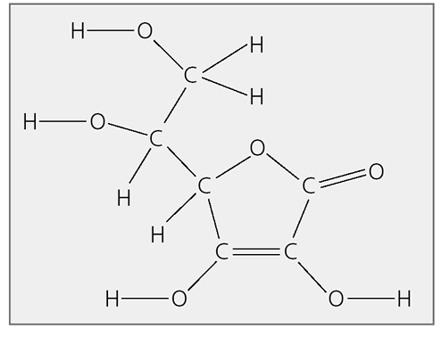
The formula of ascorbic acid was found in 1928 by the Hungarian chemist called Albert Szent-Gyorgyi (who lived from 1893-1986). He used Hungarian paprika, a type of red pepper, for his experiments. Szent-Gyorgyi became a very famous scientist, winning a Nobel Prize in 1937. One of his sayings was, 'Discovery is seeing what everybody else has seen, and thinking what
nobody else has thought.'
Hungarian paprika


