Name:………………………………………………..…. Date:………………………………………………………
What sank the Kursk nuclear submarine?

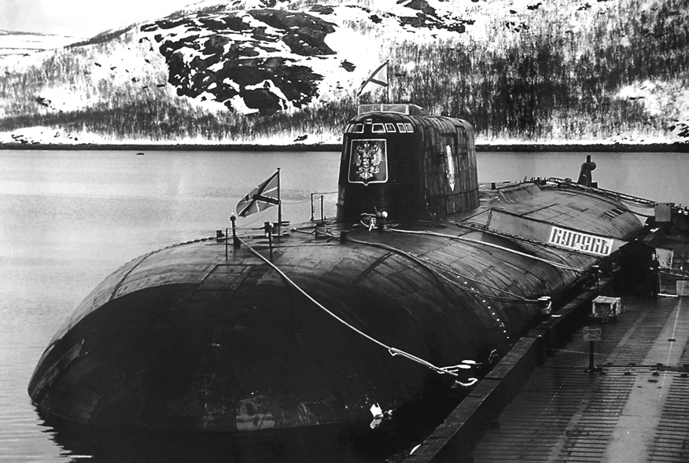
The Kursk submarine
Reproduced with permission from Stephen Atkinson, PA Photos

On Saturday, 12th August 2000 one of the world's largest, most advanced and secret submarines, the Kursk, sank to the bottom of the sea with no survivors. At the time of the accident, the Kursk was on a naval exercise carrying a crew of 118. The Kursk was the pride of the Russian Navy. Longer than two jumbo jets and capable of carrying up to 30 torpedoes fitted with nuclear warheads, the submarine could stay under water for up to six months. The Kursk was built with two titanium hulls, one inside the other, divided into a series of nine watertight compartments. It was thought to be unsinkable. The sinking of the Kursk was a huge disaster and embarrassment for the Russian Navy and Russia. Its cause was initially a mystery.

Analysing the accident

In this unit you can find out how scientists worked out what sank the Kursk.
What you do
You will work as a scientist solving the mystery of 'What sank the Kursk?'. To begin with, you will analyse data recorded at the time the accident happened.
continued on next page



What sank the Kursk nuclear submarine?
continued from previous page

Analysing the accident
At the time of the sinking, the Kursk was taking part in naval exercises. American and British ships and/or submarines were probably in the area as well, making observations. Information about military exercises is kept secret - most of us would never have known about them if the Kursk had not sunk!
The story begins by analysing the signals picked up by a seismic monitoring station at the time the Kursk went missing.
Where and when did the Kursk sink?
The sesimic station called ARCES in northern Norway recorded signals from two events on Saturday morning, 12th August 2000 at around 0730 GMT. The BBC gave its first reports of an accident occurring during Russian naval exercises at about the same time, although the story first appeared in the main news bulletins two days later, on Monday,14th August.
Table 1 shows the information provided about the events.

Reporter | Latitude/°N | Longitude/°E | Report time GMT | Richter scale magnitude
BBC | 69.62 | 37.58. | - | -
ARCES | 69.70 | 36.80 | 07.28.27 | 1.5
ARCES | 69.57 | 37.64 | 07.30.42 | 3.5
Table 1 Location, time and magnitude of seismic disturbances linked to the Kursk accident

Questions
1. Which is the bigger disturbance?
……………………………………………………………………………………………………………….……………………………………………………………………………………………………………….……………………………………………………………………………………………………………….
2. Where did the disturbances occur? Use an atlas to find out.
……………………………………………………………………………………………………………….……………………………………………………………………………………………………………….……………………………………………………………………………………………………………….
continued on next page

What sank the Kursk nuclear submarine?
continued from previous page
3. Use the News timeline worksheet to find out how the disturbances were reported;

- What did the Russians say? ……………………………………………………………………………………………………………….…………………………………………………………………………………………
- What did the BBC/other reporters say? ……………………………………………………………………………………………………………….…………………………………………………………………………………………

