Name:………………………………………………..…. Date:………………………………………………………
What sank the Kursk nuclear submarine?

The Kursk sank to the bottom of the sea, but the cause was not clear. The seismic data gives clues as to what happened. Compare the signals from the Kursk with signals from other sources to work out what might have caused the disturbance. Remember that each type of source produces its own pattern.

What type of seismic disturbance was recorded?
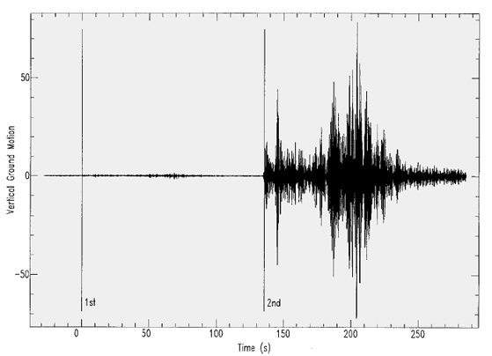 | Figure 1  Seismic signals recorded at ARCES. There is a small signal followed by a much larger one.  Reproduced courtesy of David Bowers and Peter Marshall, AWE Blacknest.
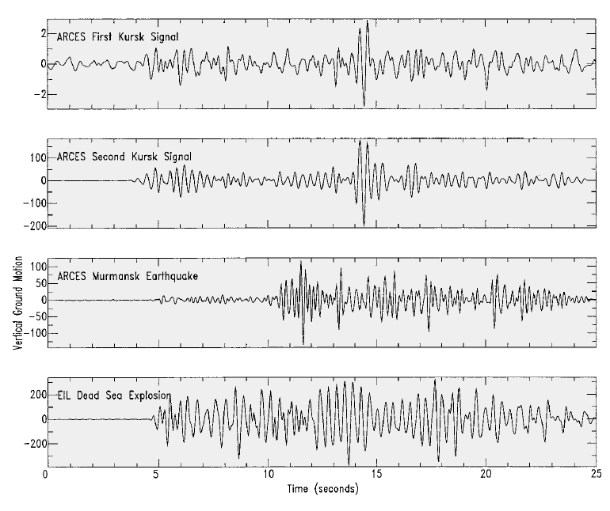 | Figure 2  Four seismograms. The top two are from the Kursk.  The third is from an earthquake which happened near Murmansk, Russia.  The fourth is from an underwater explosion.  Reproduced courtesy of  David Bowers and Peter Marshall, AWE Blacknest.

continued on next page



What sank the Kursk nuclear submarine?

continued from previous page

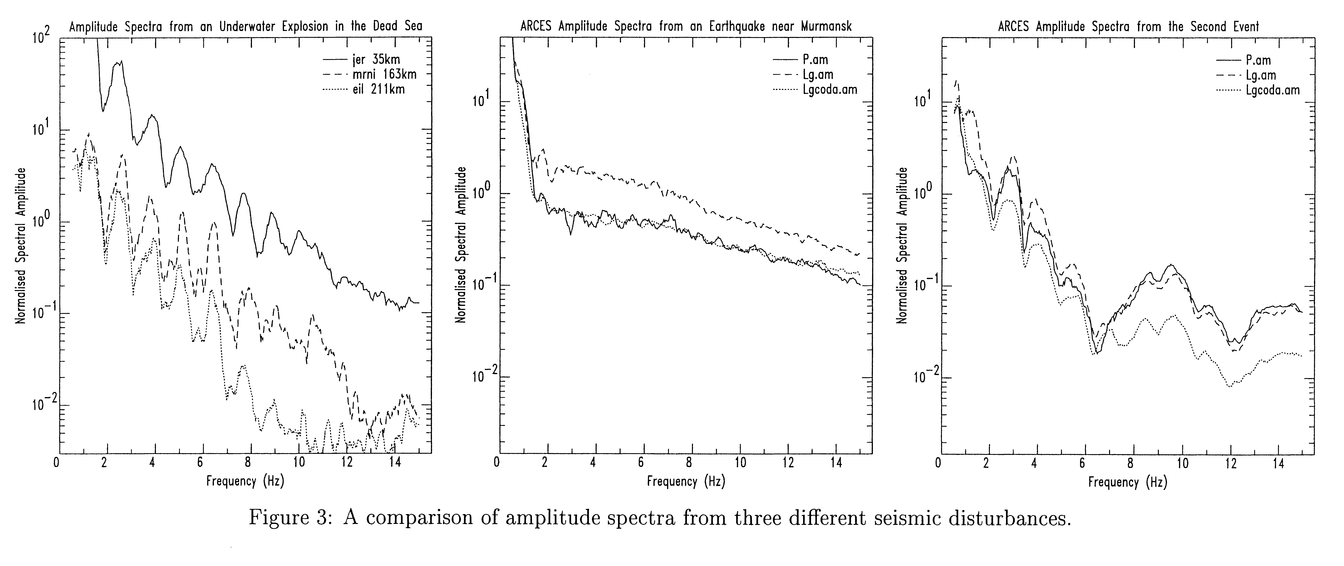Figure 3 Amplitude spectra from the second Kursk event, the earthquake and the underwater explosion
Reproduced courtesy of David Bowers and Peter Marshall, AWE Blacknest.

Questions
1. Use Figure 1 to work out the time interval between the two Kursk events.
……………………………………………………………………………………………………………….……………………………………………………………………………………………………………….……………………………………………………………………………………………………………….
2. Use the vertical axes of Figure 2 to compare the sizes of the Kursk traces.
How big is the second Kursk signal compared with the first one?
……………………………………………………………………………………………………………….……………………………………………………………………………………………………………….……………………………………………………………………………………………………………….
3. What do you notice about the shapes of the two Kursk signals? What could this tell you? ……………………………………………………………………………………………………………….……………………………………………………………………………………………………………….……………………………………………………………………………………………………………….

4. What do Figures 2 and 3 tell you about the cause of the two Kursk disturbances? ……………………………………………………………………………………………………………….……………………………………………………………………………………………………………….……………………………………………………………………………………………………………….

continued on next page

What sank the Kursk nuclear submarine?
continued from previous page

5. What might have caused the first Kursk disturbance?
……………………………………………………………………………………………………………….……………………………………………………………………………………………………………….……………………………………………………………………………………………………………….
6. Use the News timeline worksheet to find the Russian Navy's explanation for the accident. Is this consistent with your interpretation of the seismic data?
……………………………………………………………………………………………………………….……………………………………………………………………………………………………………….……………………………………………………………………………………………………………….
7. Why might the Russians have given the explanation they did?
……………………………………………………………………………………………………………….……………………………………………………………………………………………………………….……………………………………………………………………………………………………………….……………………………………………………………………………………………………………….……………………………………………………………………………………………………………….……………………………………………………………………………………………………………….

How large were the Kursk disturbances?
What you do
Next, use the seismic signals to find out the size of the disturbances in terms of tonnes of the explosive TNT. Figure 4 shows the Richter magnitude values plotted against the 'yield' of TNT which could create a disturbance that size.

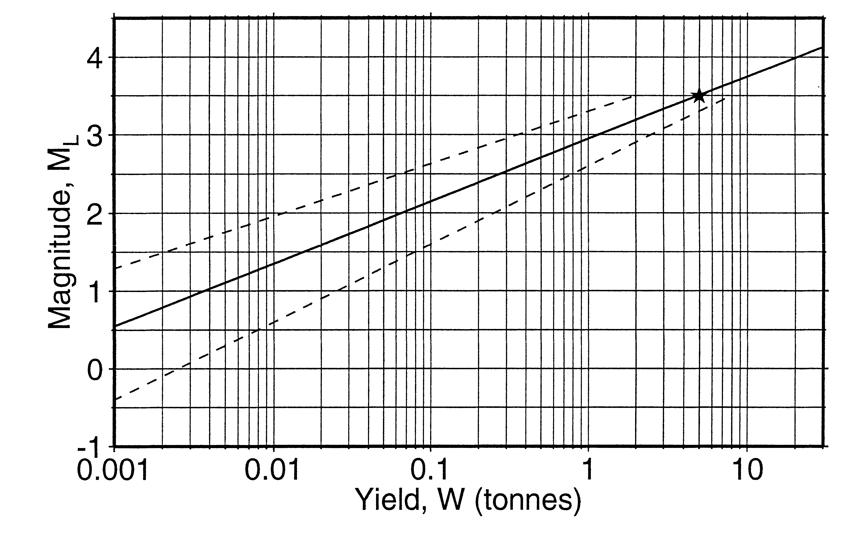 | Figure 4  The link between Richter magnitude and explosive yield. The dashed lines indicate the level of uncertainty.  Reproduced courtesy of David Bowers and Peter Marshall, AWE Blacknest.

continued on next page

What sank the Kursk nuclear submarine?
continued from previous page

Questions
8. Find both the Richter magnitudes from Table 1. Read off the yield equivalents from
Figure 4. Use the dashed lines to show the range of values.
……………………………………………………………………………………………………………….……………………………………………………………………………………………………………….
9. What effect would the submarine's structure have on the seismic signals from an explosion?
……………………………………………………………………………………………………………….……………………………………………………………………………………………………………….………………………………………………………………………………………………………………
10. Given your answer to question 9, are the explosions likely to have been smaller or larger than the yield values? ……………………………………………………………………………………………………………….……………………………………………………………………………………………………………….……………………………………………………………………………………………………………….

Reporter | Latitude/°N | Longitude/°E | Report time GMT | Richter scale magnitude
BBC | 69.62 | 37.58. | - | -
ARCES | 69.70 | 36.80 | 07.28.27 | 1.5
ARCES | 69.57 | 37.64 | 07.30.42 | 3.5
Table 1 Location, time and magnitude of seismic disturbances linked to the Kursk accident

