Name:………………………………………………..…. Date:………………………………………………………
Crystal chemistry
Growing crystals
Experiment and investigation
This experiment describes how to grow a crystal of 'potash alum', aluminium potassium sulfate (AlK(SO₄)₂.12H₂O). From this basic experiment you can try to grow crystals of other substances and carry out investigations on crystal growth.
To get good results, try to be as accurate as possible and to be patient. Beautiful crystals take time to grow!
What you need

For stage 1
- 250 cm³ beaker
- Access to a balance
- Glass rod
- 100 cm³ water
- Eye protection
- Bunsen burner and heatproof mat
- Tripod and gauze
- 20 g aluminium potassium sulfate, plus a few extra grains
- Watch glass
- Clingfilm to seal the beaker, or a screw top jar
- Spatula
- 100 cm³ measuring cylinder

For stage 2
- Thin wire bent into a 'cobra' shape, see diagram
- Hand-lens
- Sewing thread
- Cloth and rubber band to cover the beaker
- 250 cm³ beaker
- Tweezers
- Bunsen burner and heatproof mat
- Tripod and gauze
What you do
Stage 1: making seed crystals
1. Measure 100 cm³ water into the 250 cm³ beaker. Add the 20 g aluminium potassium sulfate.
2. Heat gently, with stirring.
3. Stop heating when the solid has dissolved. This will be at about 50°C.
4. Remove the beaker from the tripod. Cover with the watch-glass and leave to cool.
5. When the solution has reached room temperature, add the extra grains and stir.
6. Cover the beaker again, and leave it for about 48 hours. If possible, stir the solution every now and again. The solution is ready (saturated) when there is no change to the amount of solid at the bottom of the beaker.
continued on next page


Crystal chemistry
continued from previous page
7. Pour a small amount of the solution into a second watch glass. Leave this undisturbed to crystallise.
8. Seal the beaker to prevent evaporation. Save for stage 2.
9. When crystals have formed in the watch glass, examine them with a hand-lens. Describe and draw (or photograph) their shape.

Safety
Wear eye protection. Wash your hands after handling chemicals.
Stage 2: growing large crystals
10. Make a 'cobra' from the wire (see diagram). Your crystal will grow from this.
11. Choose one small crystal from the 'seed' crystals in the watch glass using the tweezers. Tie the crystal to a few centimetres of thread using a slip knot (see diagram). Tie the other end to the hook of the cobra.
12. Remove the seal from the beaker of solution saved from stage 1. Heat the solution until all the solid at the bottom has dissolved. Pour the solution carefully into a clean beaker, trying not to spill any up the sides.
13. Cool the solution to a few degrees above room temperature, stirring to ensure the temperature is constant throughout.
14. Carefully place the cobra into the solution in the beaker. Make sure it is well-covered with solution so no part can stick out as the water evaporates.
15. Cover the top of the beaker with a cloth and a rubber band. This allows slow evaporation and prevents dust from falling into the solution.
16. The crystal should grow to a reasonable size within a couple of days.
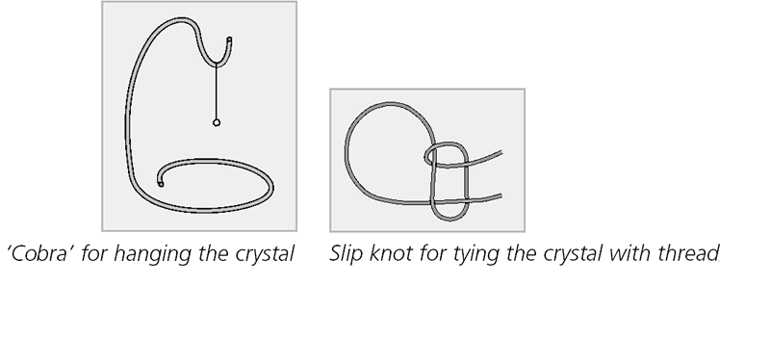
Safety
Wear eye protection. Wash your hands after handling chemicals.

Troubleshooting

- If no crystals formed or there is no growth, the most likely reason is
that the solution was not saturated. Heat the water to a higher temperature and add more solid.

continued on next page

Crystal chemistry
continued from previous page

- Another reason could be that the temperature changed so the solution
stopped being saturated. Heat the water and add more solid to
get a saturated solution. Make sure the beaker is kept at a constant temperature.
- Thirdly, crystals may not grow due to humidity changes, as this affects evaporation rates. Try to find a cool, dry place to leave the solution. Alternatively, try growing the crystal in a sealed jar. To do this, at step 12, heat the solution and add 4 g more potassium aluminium sulfate. Stir until it has dissolved. Pour the solution into a jar which can be sealed with a secure lid. Suspend the crystal from a thread supported on a cardboard disc which will sit tightly across the jar. This system still requires a constant temperature, but humidity changes are avoided.

Questions
1. What is a saturated solution? ……………………………………………………………………………………………………………….……………………………………………………………………………………………………………….……………………………………………………………………………………………………………….……………………………………………………………………………………………………………….
2. What is a supersaturated solution? ……………………………………………………………………………………………………………….……………………………………………………………………………………………………………….……………………………………………………………………………………………………………….……………………………………………………………………………………………………………….
3. Why must the solution be super-saturated to grow crystals? ……………………………………………………………………………………………………………….……………………………………………………………………………………………………………….……………………………………………………………………………………………………………….……………………………………………………………………………………………………………….
4. What is happening as the solution cools? ……………………………………………………………………………………………………………….……………………………………………………………………………………………………………….……………………………………………………………………………………………………………….……………………………………………………………………………………………………………….
5. Why is it important to keep the apparatus clean while growing crystals? ……………………………………………………………………………………………………………….……………………………………………………………………………………………………………….……………………………………………………………………………………………………………….……………………………………………………………………………………………………………….
continued on next page

Crystal chemistry
continued from previous page

Extension experiments
Here is a list of substances from which crystals can be grown:-
- Disodium tetraborate ('Borax', Na₂B₄O₇.10H₂O) (Dust/powder is irritant)
- Potassium sodium tartrate ('Rochelle salt', KNaC₄H₄O₆.4H₂O)
- Copper(II) sulfate (CuSO₄.5H₂O) (Harmful)
- Magnesium sulfate ('Epsom salts', MgSO₄.7H₂O)
- Sucrose ('sugar', C₁₁H₂₂O6).
Investigate
- What happens if solutions of two different substances are mixed and
then left to grow crystals? Does this change if the solids or solutions are mixed?
- What happens to the crystals if the solution is placed at different
temperatures?
- What factors affect the rate of crystallisation?
- What conditions are needed to make the 'perfect' crystal?

