Alcohols: teacher guidance
This resource forms part of the Review my learning series from the Royal Society of Chemistry. The worksheets assess learner’s understanding of content from common 11–14 and 14–16 curriculums. They can be used to identify knowledge gaps and misconceptions once that part of the curriculum has been taught.
The Alcohols worksheets cover the following topics:
- alcohols as a homologous series
- the general formula and functional group of alcohols
- the structural and displayed formulas of alcohols
- combustion reactions of alcohols
- reactions of alcohols with sodium metal and with oxidising agents
- fermentation.
If learners successfully answer questions on these topics, they can attempt the extension questions. These cover more on fermentation and ask learners to interpret a graph of solubility against the number of carbon atoms per molecule.
Scaffolding
Level 1 (*) is a scaffolded worksheet which supports learners in a variety of ways, such as selecting words from a word bank, providing answer options to choose from or completed examples. Level 2 (**) is a partially scaffolded worksheet with a reduced level of support, such as partially completed sentences or a wider range of answer options to select from. Level 3 (***) is an unscaffolded worksheet in which most of the tasks involve answering questions with a minimum of prompts.
Metacognition
The ‘What do I understand?’ page is common to all levels of worksheet and can be used both to identify areas needing whole class attention and as an indicator for learners to help guide their revision.
Below you will find model answers for each level and guidance on learners’ misconceptions. Learners can use the model answers to self- or peer assess.
When to use
The worksheets can be used in a variety of ways:
- To assess learners’ knowledge at the beginning or end of a period of teaching. Match the level of the worksheet to the support needs of learners.
- To assess knowledge during a period of teaching and once learners have completed the relevant topic.
- As part of revision.
- As a refresher exercise for teachers or non-subject specialists.
There is also scope for the level of the worksheets used to be increased as learners progress through their curriculum.
Further support
For more resources to support teaching of this topic and address any misconceptions identified, go to rsc.li/3VhTgRn.

Answers

Alcohols: knowledge check
- (Level 1, 2 and 3)
A  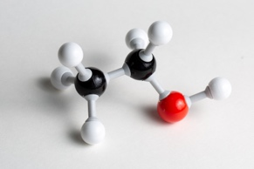 | B  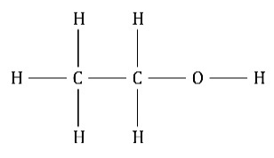 | C  CH₃CH₂OH | D  C₂H₅OH
ball and stick model | displayed structural formula | condensed structural formula | molecular formula
Guidance: Learners need to be able to recognise molecular, condensed structural and displayed structural formulas and understand how they relate to each other. Because of the common use of the term alcohol, learners often consider ethanol to be the only alcohol, or ethanol to be an alternative term for an alcohol.
- (Level 1, 2 and 3)
Name | Molecular formula | Condensed structural formula | Displayed structural formula
methanol | CH₃OH | CH₃OH | 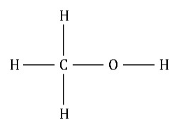
ethanol | C₂H₅OH | CH₃CH₂OH | 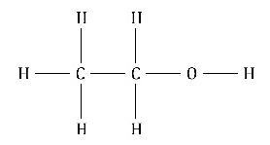
propan-1-ol | C₃H₇OH | CH₃CH₂CH₂OH | 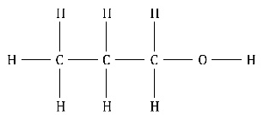
butan-1- ol | C₄H₉OH | CH₃CH₂CH₂CH₂OH | 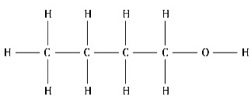
Guidance: See guidance for question 1.1.
- (Level 1, 2 and 3)
–OH; C_{n}H_{2n + 1}OH; –ol; numbers; physical
Guidance: Learners often omit the number in names of alcohols with three or more carbon atoms in their molecules. For example, propanol is used rather than propan-1-ol or propan-2-ol. Others will assume the functional group –OH is the same as the OH– ion and therefore that alcohols have similar properties to bases.
- (Level 1, 2 and 3)
chemical; combustion; 3; 2; 3; hydrogen; oxidised; C₂H₅OH; ethanoic acid
Guidance: Many learners find balancing equations difficult. They need to know how [O] is used to represent the oxidising agent in equations representing organic reactions. Learners will find potassium manganate(VII) referred to by its old name, potassium permanganate, online.
The definition of an alcohol as being an organic compound with an –OH group can also be applied to carboxylic acids, which is confusing for learners.

Alcohols: test myself
- (Level 1)
decan-1-ol
(Level 2 and 3)
decan-1-ol and propan-2-ol
Guidance: Learners do not need to know the name decan-1-ol but should recognise an alcohol from its suffix.
- (Level 1, 2 and 3)
C₅H₁₁OH
Guidance: Learners should be able to substitute into the general formula.
- (Level 1, 2 and 3)
butanoic acid
Guidance: Learners should recognise the common suffix of the reactant and product, but they also need to know that carboxylic acid names end in –oic.
- (Level 1, 2 and 3)
CH₃CH₂CH₂OH + 2[O] → CH₃CH₂COOH + H₂O
Guidance: See guidance for question 1.4.
- (Level 1, 2 and 3)
2C₃H₇OH + 9O₂ → 6CO₂ + 8H₂O
Guidance: Many learners find balancing equations difficult. Some will alter formulas or insert numbers into the middle of a formula in order to balance an equation.
- (Level 1, 2 and 3)
steam
Guidance: Using molecular models to represent this reaction may help some learners to better understand the process.
- (Level 1, 2 and 3)
  - fermentation
Guidance: Some learners will answer distillation or fractional distillation to this question. Fractional distillation is used to later concentrate the ethanol solution produced from fermentation.
  - The conditions are:
- temperature between 25 and 35 °C
- addition of sugar solution
- addition of yeast
Guidance: Water is an essential part of the fermentation process and needs to be included in answers, either as water or as sugar/glucose solution.
- (Level 1, 2 and 3)
  - fractional distillation
Guidance: See guidance for question 2.7(a).
  - Ethanol and water can be separated because they have different boiling points.
Guidance: Learners can revisit the fractional distillation of crude oil to help their understanding.

Alcohols: feeling confident?
- (Level 1, 2 and 3)
limewater
oil layer
yeast and glucose solution

The enzymes in yeast act as a catalyst and convert glucose into ethanol and carbon dioxide. The gas produced bubbles through the limewater and turns it milky. The equation for the reaction is:
C₆H₁₂O₆ → 2C₂H₅OH + 2CO₂
Guidance: Enzymes are the biological catalysts in the fermentation process. A common related error when discussing conditions of temperature for fermentation is that enzymes are killed at higher temperatures; enzymes are protein molecules and are never alive.
- (Level 1, 2 and 3)
  - butan-1-ol
  - 2.5 g pentan-1-ol dissolves in 100 g water
  - As the number of carbon atoms per molecule increases, the solubility of the alcohol decreases.
  - I would expect to see two separate layers of liquid form because the
decan-1-ol does not dissolve. Decan-1-ol contains 10 carbon atoms and the graph shows that the solubility of decan-1-ol would therefore be lower than 0.1 g per 100 g water.
Guidance: This question can be extended to explain the reasons for the solubility trends in alcohols, if required by the specification.

Alcohols: what do I understand?
Mini-topic | Assessed via:
I know that alcohols are a homologous series. | 1.2, 1.3
I can identify the functional group and the molecular and general formulae of alcohols. | 1.1, 1.2, 1.3, 2.2
I can draw the structural and displayed formulas of alcohols. | 1.2
I understand how alcohols are named. | 2.1
I can describe the combustion reactions of alcohols. | 1.4, 2.5
I can describe the reactions of alcohols with sodium metal and with oxidising agents. | 1.4, 2.2, 2.3
I can describe how ethanol is produced industrially. | 2.6
I can describe the process of fermentation. | 2.7, 2.8
Feeling confident? topics | Assessed via:
I can describe a fermentation reaction and complete the equation. | 3.1, 3.2
I can describe the solubility of alcohols. | 3.2

