Metallic structure and bonding
- The diagram shows how metal atoms bond together to form a metal solid.

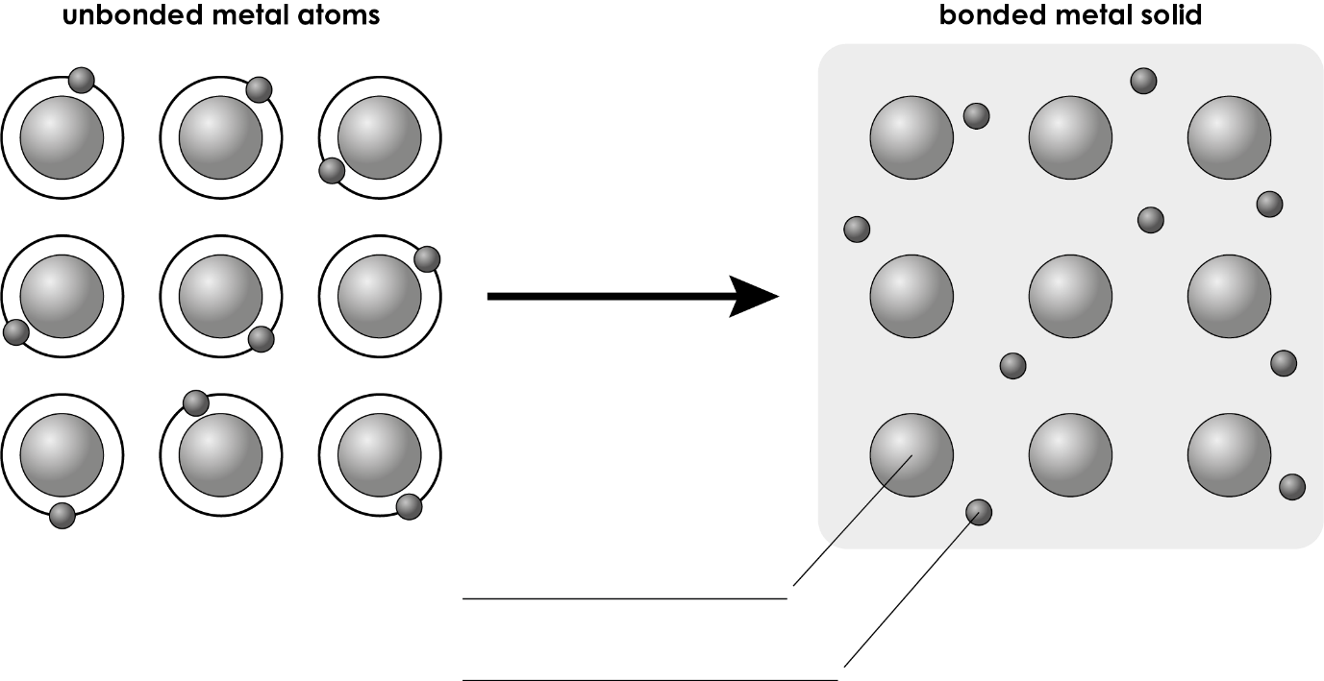
  - Label the diagram to show:
- a metal ion
- a delocalised electron.

(2 marks)
  - Which of these substances has metallic bonding? Circle the correct answer.

A carbon

B copper

C copper sulfate

D oxygen

(1 mark)
  - State what charge the following particles have in a bonded metal.
- metal ions

_________________________________________________________________________________ (1 mark)
- delocalised electrons

_________________________________________________________________________________ (1 mark)

  - Name the force of attraction between the metal ions and the delocalised electrons in a metal.

_____________________________________________________________________________________ (1 mark)
  - Which of these statements is correct? Circle the correct answer.

A Delocalised electrons are free to move through the metal structure.

B Delocalised electrons are arranged in a regular pattern.

C Delocalised electrons are positively charged.

D Delocalised electrons are found in the outer shells of atoms.

(1 mark)
  - The image represents the metal ions in a metal.

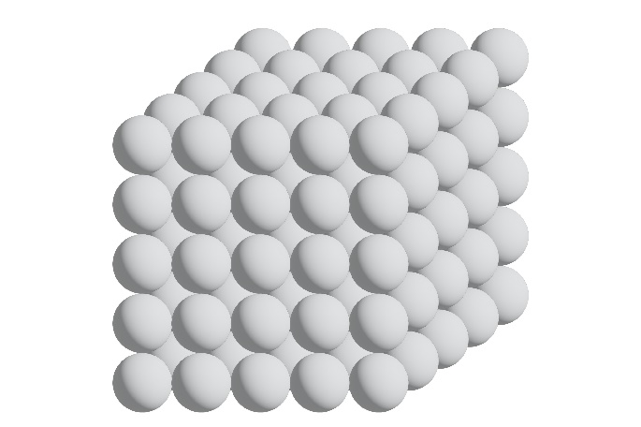

Which is the correct name for this type of structure? Circle the correct answer.

A giant covalent structure

B giant metallic structure

C ionic lattice

D simple molecule

(1 mark)

- Match each of the physical properties of copper to the correct explanation by drawing a line between them.

Physical property |  | Explanation
High melting point of 1083°C |  | Delocalised electrons move through the metal and carry the electric charge.
Good electrical conductor |  | Delocalised electrons move through the metal and transfer heat energy.
Good conductor of heat |  | Layers of metal ions slide over each other.
Is malleable  (can be hammered into shape without breaking) |  | Large amounts of heat energy are needed to break the strong metallic bonds.

(2 marks)
- These diagrams represent the particles in a pure metal and in an alloy.

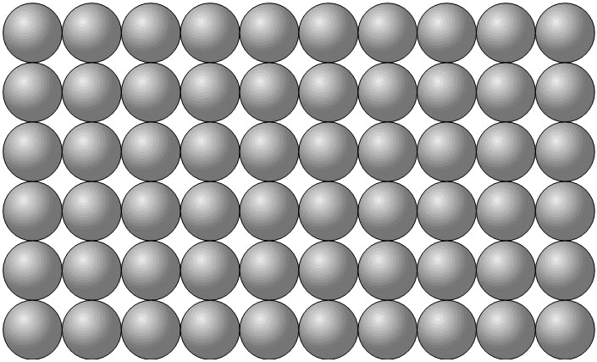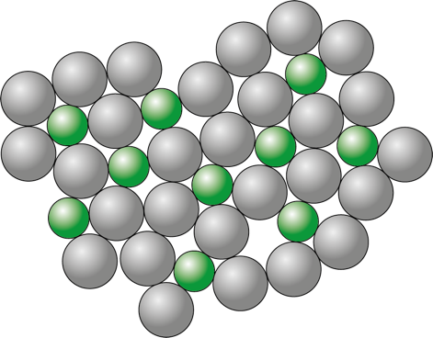
  - Which of these statements is correct? Circle the correct answer.

A An alloy is a mixture of non-metals.

B An alloy is a mixture of a metal and one or more other element(s).

C An alloy is a compound containing only one metal.

D An alloy is a compound with ionic bonding.

(1 mark)

  - Describe what will happen when a force is applied horizontally to the:
- layers of ions in a pure metal

(1 mark)
- ions in an alloy

(1 mark)
  - Use the words below to complete the sentences. You do not have to use all the words.

harder softer regular irregular

more less particles soft

Pure metals are too __________________ for many uses. Alloys are __________________ than pure metals. An alloy has different sized __________________ . This disrupts the __________________ arrangement of particles in the metal and stops the layers of particles from rolling over each other.

(4 marks)

[Total: 17 marks]


Which question(s) did you get wrong? Why?

What will you do next time you’re asked a similar question?

