Rate of evaporation

Learning objectives
- Carry out an investigation into the rate of evaporation of propanone.
- Make and record observations.
- Use particle theory to explain your results.

Introduction

Evaporation is the conversion of liquid to vapour without the boiling point necessarily being reached. In this experiment, you will measure and compare the time taken for a drop of propanone to evaporate under a number of different conditions.

Equipment

Apparatus
- Safety glasses
- Microscope slides, x2 or 3
- Warm water
- Dropper pipette
- Timer

Chemicals
- Propanone (DANGER: highly flammable, irritant) – a few cm³
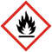

Method
- Before you start, predict which conditions will lead to:
- the fastest rate of evaporation.
- the slowest rate of evaporation.
- Put a drop of propanone onto a microscope slide and time how long it takes to evaporate.
- Change the conditions according to the next row in the results table, repeat the experiment and record the time taken for each one.

Conditions

The conditions can be changed as shown below:
Conditions |  | How achieved
Temperature | Warm | Warm slide in hands and hold on a flat palm. Or place the slide in warm water then dry it.
Temperature | Cool | Room temperature. Or keep the slides in a fridge, cool box or between two bags of cooling gel.
Spread | Spread out | Spread the drop of propanone on the slide with a matchstick.
Spread | Unspread | Drop to be left as one drop on the slide.
Air flow | Air flow | Blow across drop, fan with book or use a hair dryer on a cool setting.
Air flow | No air flow | No air flow provided.

Results table
Conditions |  |  | Evaporation time (s)
Warm? | Spread out? | Air movement? | Evaporation time (s)

Questions
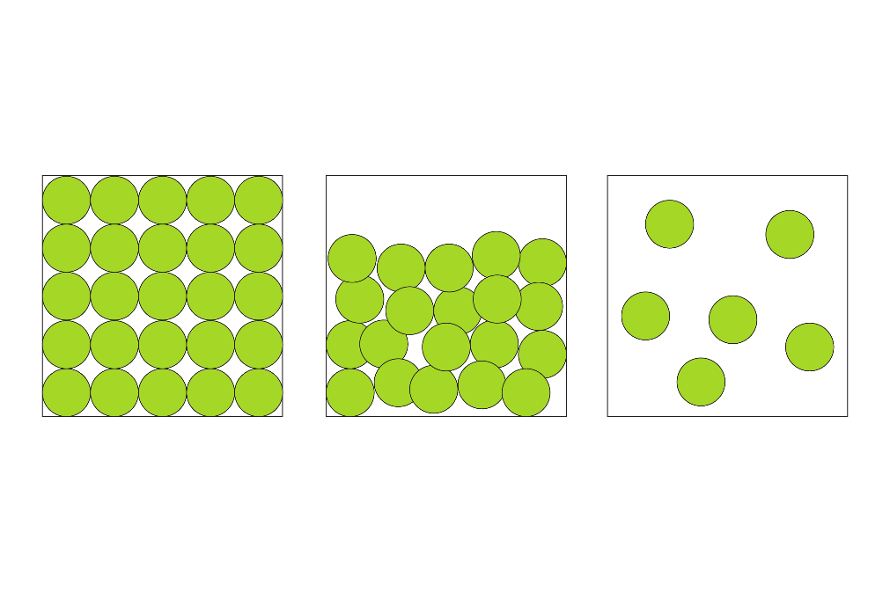
- Label the particle diagram to show how the particles rearrange during evaporation.

____________________ ____________________

- Draw a line to match the variables to their description:

Control variable(s) |  | Experimental conditions  (e.g. temperature, air flow, spread)
Dependent variable(s) |  | Equipment and chemicals  (e.g. microscope slide, propanone, volume of drop)
Independent variable(s) |  | Time taken

- Draw a bar chart of your results on the axes provided:
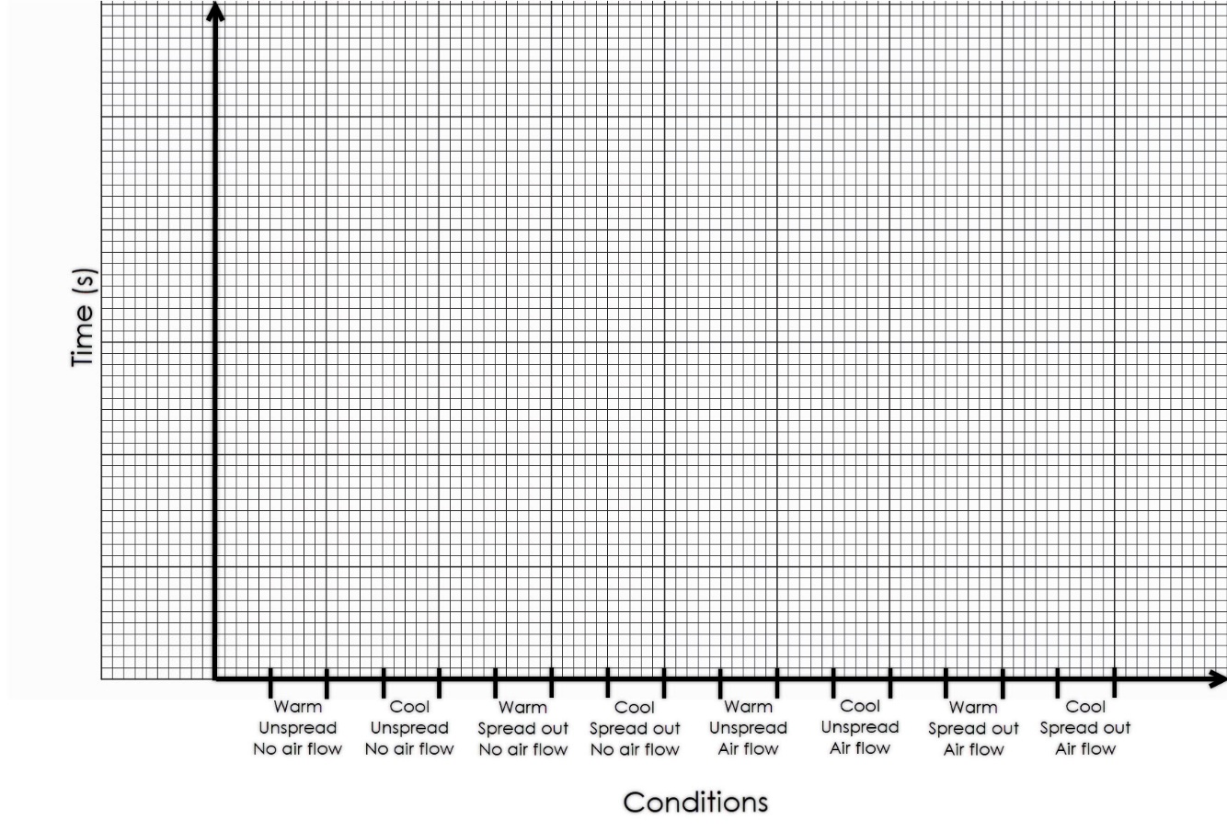
- List the conditions in order, from those taking the shortest time to evaporate to those taking the longest time to evaporate.
Evaporation time | Conditions
Shortest
Longest

- Use your results to help complete the following sentences. Choose the correct words from the list.

increases decreases greater fewer
more less higher lower faster slower
- The rate of evaporation increases when the temperature ______________________. This is because the particles have ______________________ kinetic energy.
- The rate of evaporation increases when there is ______________________ air movement. This is because the air that is saturated with propanone moves away and is replaced with air that can hold ______________________ vapour.
- When the drop spreads out, the rate of evaporation ______________________. This is because ______________________ particles are at the surface and so are more likely to escape.
- Complete the sentences to explain why it takes less time for the washing to dry on a sunny, windy day than on a dull, calm day. Use words from the list above.

On a sunny day, the temperature will be ________________ than on a dull day so the water particles will have ________________ kinetic energy.

On a windy day, there will be ________________ air flow over the water particles than on a calm day so the air that is saturated with water vapour is replaced by air able to hold ________________ water vapour.

Therefore, the water particles on the clothes on a sunny, windy day will move around ________________ and collide ________________ frequently, than those on a dull, calm day so they are ________________ likely to have enough energy to escape into the gas state (or evaporate), and the clothes dry ________________.

