Rate of evaporation

Learning objectives
- Carry out an investigation into the rate of evaporation of propanone.
- Make and record observations.
- Use particle theory to explain your results.

Introduction

Evaporation is the conversion of liquid to vapour without the boiling point necessarily being reached. In this experiment, you will measure and compare the time taken for a drop of propanone to evaporate under a number of different conditions.

Equipment

Apparatus
- Safety glasses
- Microscope slides, x 2 or 3
- Warm water
- Dropper pipette
- Timer

Chemicals
- Propanone (DANGER: highly flammable, irritant) – a few cm³

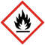

Method
- Decide which conditions to investigate and prepare your results table by adding a tick or a cross in each column. Change only one condition at a time, keeping all of the other conditions the same.
- Before you start, predict which conditions will lead to:
- the fastest rate of evaporation.
- the slowest rate of evaporation.
- Put a drop of propanone onto a microscope slide and time how long it takes to evaporate.
- Change the conditions according to the table, repeat the experiment and record the time taken for each one.

Conditions

The conditions can be changed as shown below:
Conditions |  | How achieved
Temperature | Warm | Warm slide in hands and hold on a flat palm. Or place the slide in warm water then dry it.
Temperature | Cool | Room temperature. Or keep the slides in a fridge, cool box or between two bags of cooling gel.
Spread | Spread out | Spread the drop of propanone on the slide with a matchstick.
Spread | Unspread | Drop left as one drop on the slide.
Air flow | Air flow | Blow across drop, fan with book or use a hair dryer on a cool setting.
Air flow | No air flow | No air flow provided.

Results table
Conditions |  |  | Evaporation time (s)
Warm? | Spread out? | Air movement? | Evaporation time (s)

Questions
- Draw a particle diagram to show how the particles rearrange during evaporation.

- For your investigation state the following:
- the control variable(s) _________________________________________________
- the dependent variable(s) _________________________________________________
- the independent variable(s) _________________________________________________

- Draw a bar chart of your results.
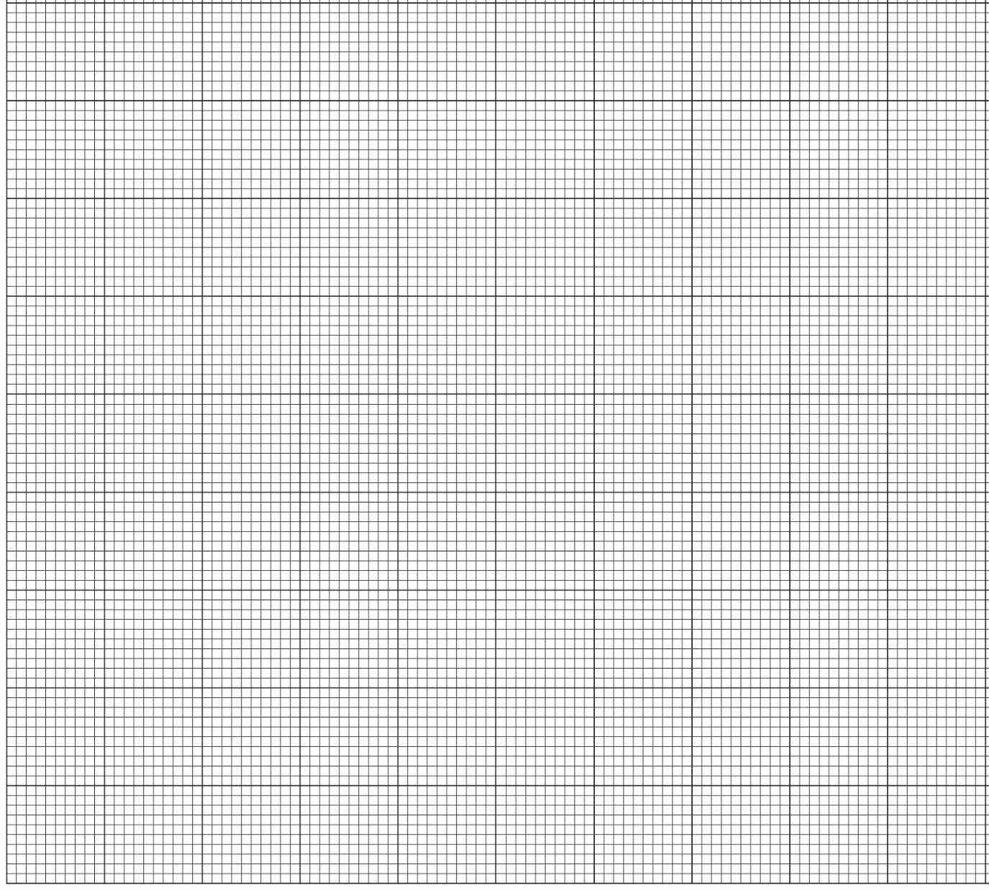
- List the conditions, in order, from those taking the shortest time to evaporate to those taking the longest time to evaporate.
Evaporation time | Conditions
Shortest
Longest

- Use your results to answer the following questions. Suggest a reason for your answer.
- Which condition resulted in the fastest rate of evaporation?

__________________________________________________________________________________

Reason: _________________________________________________________________________

__________________________________________________________________________________

__________________________________________________________________________________
- Which condition resulted in the slowest rate of evaporation?

__________________________________________________________________________________

Reason: _________________________________________________________________________

__________________________________________________________________________________

__________________________________________________________________________________

- Explain why it takes less time for the washing to dry on a sunny, windy day than on a dull, calm day.

__________________________________________________________________________________

__________________________________________________________________________________

__________________________________________________________________________________

__________________________________________________________________________________

__________________________________________________________________________________

__________________________________________________________________________________

