Rate of evaporation

This investigation is part of the Nuffield Practical Collection, developed by the Nuffield Foundation and the Royal Society of Chemistry. Delve into a wide range of chemical concepts and processes with this collection of over 200 step-by-step practicals: rsc.li/43bjGql

Learning objectives
- Carry out an investigation into the rate of evaporation of propanone.
- Make and record observations.
- Use particle theory to explain your results.

Success criteria

Learners will have successfully carried out the investigation meeting the first learning objective (LO1) and produced a results table (LO2). By completing the tasks and correctly answering the questions on the student worksheets, LO1–3 will be met.

Introduction

Use this class practical to measure and compare the rate of evaporation of propanone under different conditions.

Evaporation is the conversion of liquid to vapour without the boiling point necessarily being reached. In this experiment, learners measure and compare the time taken for a drop of propanone to evaporate under a number of different conditions.

Propanone is highly flammable – ensure that there are no sources of ignition nearby. Learners could be asked to devise their own experiment, in which case teachers must check the plans before practical work starts, or they could be told how to vary the conditions and exactly what to do. See the sample results table from the student sheet available for download from: rsc.li/3F8qgWx.

Scaffolding

There are two versions of the student worksheet.

The scaffolded sheet (✪) offers more support including a ready drawn results table and a bar chart with labelled axes. Teachers may decide that different groups should use different experimental conditions and then pool the results or limit the number of conditions used in the investigation.

The unscaffolded sheet (✪✪) offers the opportunity for learners to make their own decisions about which conditions to use in the investigation and how to present their results. The additional questions are unscaffolded.

Technician notes

Read our standard health and safety guidance (rsc.li/3zyJLkx) and carry out a risk assessment before running any live practical.

Equipment

Apparatus
- Eye protection: safety glasses to EN166F
- Microscope slides, x 2 or 3
- Warm water
- Dropper pipette
- Timer

Chemicals
- Propanone (DANGER: highly flammable, irritant) – a few cm³

Preparation
Chemicals supplied for the practical | Preparation
Propanone (acetone), $C_{3}H_{6}O(l)$  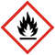  DANGER  - Highly flammable liquid and vapour  - Causes serious eye irritation  - May cause drowsiness or dizziness  - Repeated exposure may cause skin dryness and cracking  See CLEAPSS Hazcard HC085a  In Scotland, refer to SSERC for safety advice. | Dispense in a small bottle/container with a screw top and only give out a small amount.  Label the bottle with the name of the chemical and the hazard signs/warnings.

Safety and hazards
- Check that the microscope slides are undamaged and that they do not have sharp edges.
- Keep the bottles of propanone closed when not in use to avoid evaporation.
- Review the risk assessment for your chosen method to warm and cool the microscope slides.
- The microscope slides can be rinsed and dried after use.

Method

A full method is provided in the student worksheet.

Teaching notes

Learners should be able to observe that warmth, spreading out the drop and air flow all increase the rate at which it evaporates.

Liquids evaporate below their boiling point. This is because as the particles move around and collide – some have more energy than others allowing them to escape from the rest of the liquid as vapour. This results in the overall energy of the liquid (and therefore its temperature) decreasing.

This experiment lends itself well to being a planning exercise or alternatively there are some sample results tables available.

Answers (scaffolded)
- Liquid, gas

- Control variable(s) – equipment and chemicals

Dependent variable(s) – time taken

Independent variable(s) – experimental conditions

- Correctly drawn bar chart on supplied axes. Look for the following criteria:
- Bars are equally spaced (the space between the bars should be the same as the width of the bars).
- Bars are not touching.
- The intervals on the y-axis are equal (e.g. 0, 2, 4, 6, 8, etc).
- The sides of the bars are straight (drawn with a ruler).
- The height of the bars corresponds to the correct time (+/- half a square).
- List will be dependent on actual conditions used.

Warm, spread out drop with air flow will give the quicker times.

Cool, as an unspread drop and with no air flow will give the longer times.

- (a) increases

(b) greater/higher/more, more

(c) increases, more

- Higher, more, greater, decreases, more, faster, more, more, faster

Answers (unscaffolded)
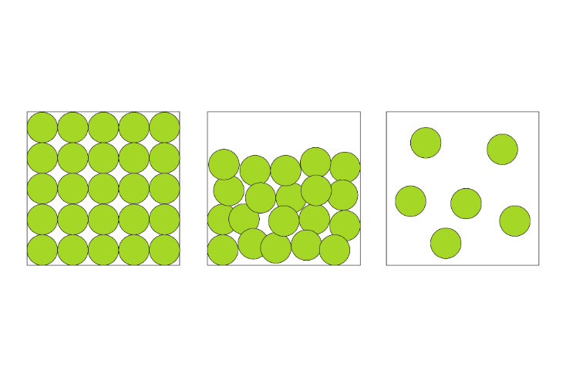

In both diagrams:
- All particles are the same size and colour.
- Particles are irregularly arranged.

In the liquid:
- Particles are touching and overlapping.

In the gas:
- Particles are not touching.

- Control variable(s) – equipment and chemicals

Dependent variable(s) – time taken

Independent variable(s) – experimental conditions

- Correctly drawn bar chart. Look for the following criteria:
- The independent variables (conditions) are on the x-axis (horizontal).
- The dependent variable (time) is on the y-axis (vertical).
- Axes are labelled, with units on the y-axis.
- Bars are equally spaced (the space between the bars should be the same as the width of the bars).
- Bars are not touching.
- The intervals on the y-axis are equal (e.g. 0, 2, 4, 6, 8, etc).
- The sides of the bars are straight (drawn with a ruler).
- The height of the bars corresponds to the correct time (+/- half a square).
- List will be dependent on actual conditions used.

Warm, spread out drop with air flow will give the quicker times.

Cool, as a single drop and with no air flow will give the longer times.

- Answers will depend on actual experimental results.

Condition | Reason
Higher temperature | The particles have more kinetic energy. This means that as the particles move around and collide, they are more likely to have enough energy to escape into the gas state and so the rate of evaporation is faster.
More spread out on the surface | There are more particles at the surface and so more escape into the gas state.
Had a flow of air over them | The air that is saturated with propanone moves away and is replaced with air able to hold more propanone vapour (keeping a high concentration gradient between the liquid and the air).

Condition | Reason
Lower temperature | The particles have less kinetic energy. This means that as the particles move around and collide, they are less likely to have enough energy to escape into the gas state and so the rate of evaporation is slower.
In a single drop | There are less particles at the surface and so less escape into the gas state.
No air flow | The air that above the propanone does not move away so it becomes saturated until eventually it can’t hold any more vapour; slowing down the rate of evaporation until it eventually stops.

- The answer should include the following points:

Cause | Effect
On a sunny day, the temperature will be higher than on a dull day ... | ... so, the water particles will have more kinetic energy.
On a windy day, there will be greater air flow over the water particles than on a calm day ... | … so the air that is saturated with water vapour is replaced by air able to hold more water vapour.
Therefore, the water particles on the clothes on a sunny, windy day will move around faster and collide more frequently, than those on a dull, calm day ... | ... so, they are more likely to have enough energy to escape into the gas state (or evaporate), and the clothes dry faster.

