Experiments with particles

Learning objectives
- Predict how the volume will change when two substances are mixed together.
- Make careful observations.
- Apply your knowledge of particles to explain your observations.

Introduction

When materials are added together, they may acquire new properties. When a solid and a liquid are mixed, the solid may or may not dissolve. When two liquids are mixed they may become one liquid or stay separate.

Before you carry out each experiment, make a prediction about what you will observe.

Equipment

Apparatus
- Eye protection: safety glasses to EN166F
- Stirring rod
- Measuring cylinders x 2 (100 cm³)
- Spatula

Chemicals
- Sodium chloride crystals
- Water
- Sand
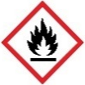
- Dried peas
- Ethanol (DANGER: highly flammable liquid and vapour)

Health and safety
- Always wear eye protection
- Ethanol is flammable, no naked flames or other sources of ignition.

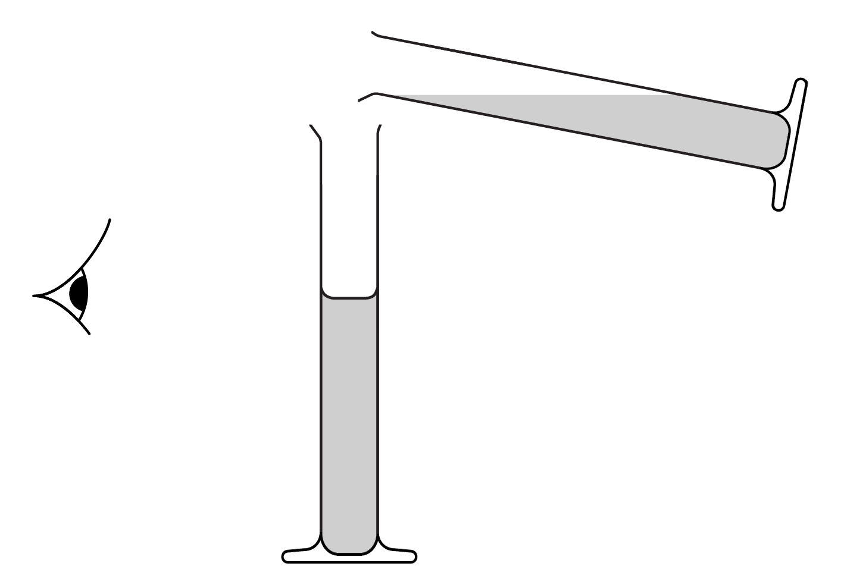
Diagram

Take measurements when eye is level with liquid surface.

Method

Activity 1
- Add approximately 25 cm³ of dried peas and 25 cm³ of sand to separate measuring cylinders. Accurately measure and record the volumes.
- Add contents of one cylinder to the other and shake until the two substances are mixed together.
- Place the measuring cylinder on the bench and gently shake from side to side to allow the mixture to settle.
- Read and record the combined volume.

Activity 2
- Add approximately 25 cm³ of ethanol and 25 cm³ of water to separate measuring cylinders. Accurately measure and record the volumes.
- Add the contents of one cylinder to the other and shake from side to side for 15–30 seconds until the two substances are mixed together, and then leave to stand for 1 minute.
- Read and record the combined volume.

Activity 3
- To the measuring cylinder, add approximately 75 cm³ of water. Accurately measure and record the volume.
- Add spatulas of salt one at a time until salt begins to be left at the bottom of the cylinder, despite continued stirring.
- Read and record the combined volume.

Predictions

Predict what will happen to the volume in each activity. Give a reason for your answer.

Activity 1 prediction: _____________________________________________________________

Reason: _________________________________________________________________________

__________________________________________________________________________________

__________________________________________________________________________________

Activity 2 prediction: _____________________________________________________________

Reason: _________________________________________________________________________

__________________________________________________________________________________

__________________________________________________________________________________

Activity 3 prediction: _____________________________________________________________

Reason: _________________________________________________________________________

__________________________________________________________________________________

__________________________________________________________________________________

Results

Record your results for each activity here.

Questions
- For Activity 1, calculate the difference between the combined volume and total volume of peas and sand.

Suggest a reason for your answer.

______________________________________________________________________________

______________________________________________________________________________

- For Activity 2, calculate the difference between the combined volume and the total volume of alcohol and water.

Suggest a reason for your answer.

______________________________________________________________________________

______________________________________________________________________________

- Draw a particle diagram to show how the particles are arranged in:
- water | - salt crystals | - salt solution

- Suggest a reason for the result observed in Activity 3.

______________________________________________________________________________

______________________________________________________________________________

Extension question

Plan an experiment to show that mass is conserved occurs when dried peas and sand are mixed. Apply your knowledge about particles to explain why mass is conserved.

An experiment to show conservation of mass when dried peas and sand are mixed

Hypothesis

__________________________________________________________________________________

__________________________________________________________________________________

Equipment

______________________________________ ______________________________________

______________________________________ ______________________________________

______________________________________ ______________________________________

______________________________________ ______________________________________

______________________________________ ______________________________________

Method

__________________________________________________________________________________

__________________________________________________________________________________

__________________________________________________________________________________

__________________________________________________________________________________

__________________________________________________________________________________

__________________________________________________________________________________

__________________________________________________________________________________

__________________________________________________________________________________

__________________________________________________________________________________

__________________________________________________________________________________

Results

Explanation

__________________________________________________________________________________

__________________________________________________________________________________

__________________________________________________________________________________

__________________________________________________________________________________

