Structure of the atom: knowledge check
- Label the diagram of the atom using the key words provided.

nucleus shells protons electrons neutrons

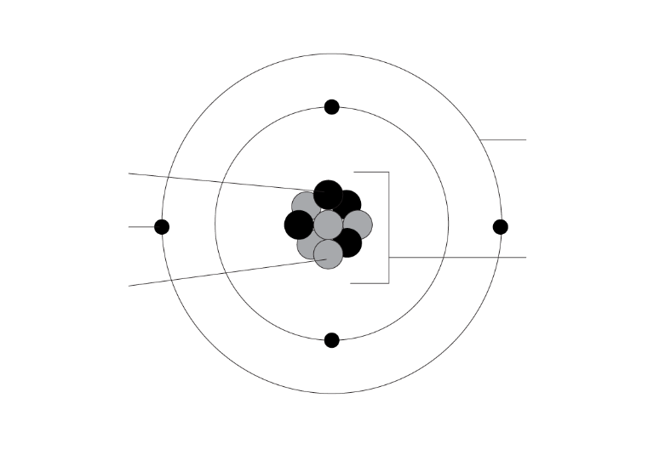
- Complete the sentences using the keywords provided. Words can be used more than once.

nucleus shells protons electrons
neutrons negligible (0.0005) 1

The positive __________________ are found inside the __________________.

The neutral __________________ are found inside the __________________.

The negative __________________ are found in the __________________.

The relative mass of the protons and neutrons is __________________.

The relative mass of an electron is __________________.
- Complete the table using the information from question 1.2:
Name of subatomic particle | Charge | Relative mass | Location

proton

neutron

electron
- The periodic table contain enough information to allow us to work out the numbers of subatomic particles in each atom of the elements. Complete the diagram by filling in the gaps.
Hint: Words can be used more than once or not at all.

atomic mass charge electrons protons neutrons

Name of number |  | Subatomic particles
________________ number  ________________ number | 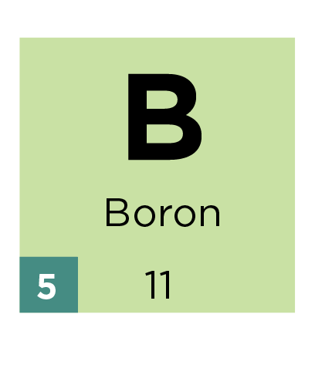 | __________________ and __________________  ______________________
- A neutral atom will have the same number of protons and electrons.

Compete the number of protons, neutrons and electrons in each element below. The first one is done for you.
 | 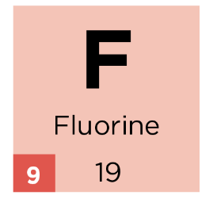 | 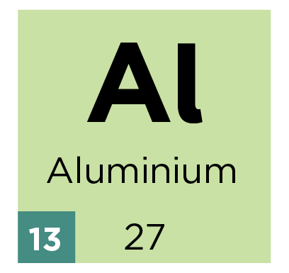 | 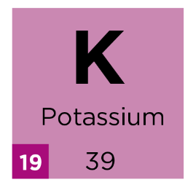
protons: | 9 | __________ | __________
neutrons: | 19 $-$ 9 = 10 | __________ | __________
electrons: | 9 | __________ | __________
- Use the information from question 1.5 to complete the electronic structure for each element in the diagrams below. Write the electron configuration for each atom. The first one is done for you.
 | 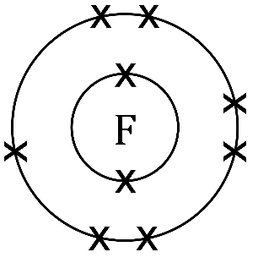 | 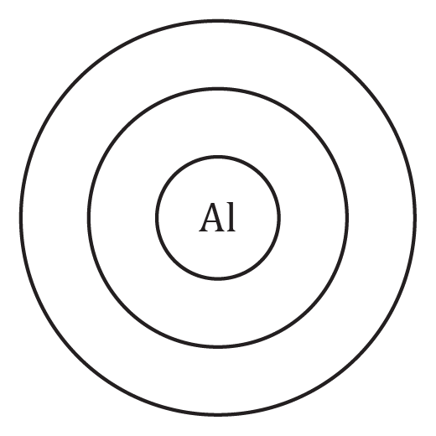 | 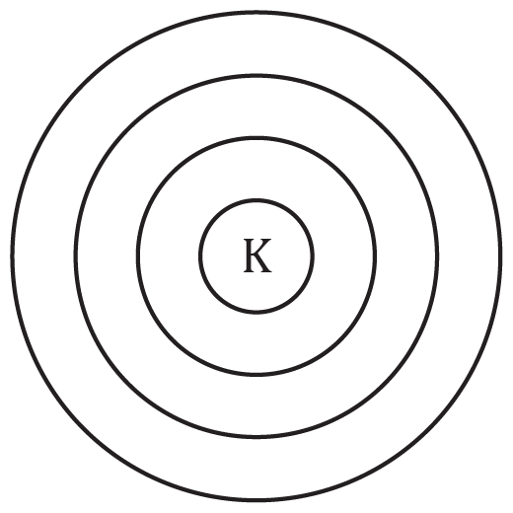
Electron configuration: | 2 , 7 | _____ , _____ , _____ | ____ , ____ , ____ , ____

Structure of the atom: test myself

Choose from the following words to answer questions 2.1 - 2.4. You may use some words more than once or not at all.

nucleus shells proton neutron

electron negative positive neutral
- State the charge of the following subatomic particles:
- proton charge: ________________
- neutron charge: ________________
- electron charge: ________________
- State which particles are found in:
- the nucleus: ______________________________________________________________
- shells/energy levels: ______________________________________________________
- State which subatomic particle can be found by knowing the atomic number

Subatomic particle described by atomic number = _______________
- State which subatomic particles the mass number tells us about.

Subatomic particles described by mass number = ______________and ______________
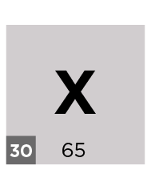
- This is information from the periodic table for element X. Give:

the atomic number = ________

the mass number = ________

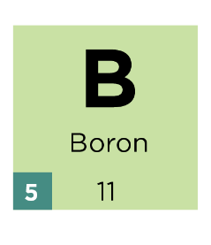
- Using the information given, complete the numbers of protons, neutrons and electrons in boron:

protons = ________

neutrons = ________

electrons = ________
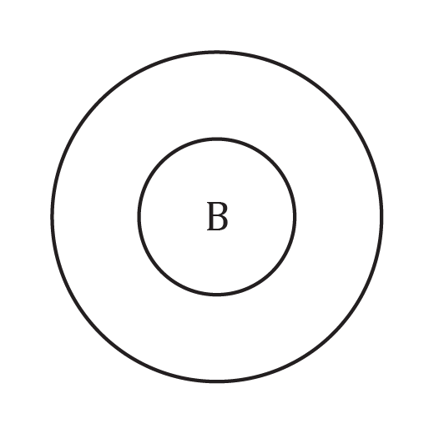
- Using the information from Q2.6, add the electrons in shells for boron to the diagram below.
- Using the information from Q2.7, write the electron configuration for boron.

Electron configuration: _____ , _____
- A neutral atom has 20 protons. Determine the number of electrons it has. Complete the sentences to explain your answer.

Number of electrons = _____

Protons have a __________________ charge. If an atom has 20 protons then it will need to have an __________________ number of electrons in order to be __________________ overall. This is because the __________________ have an equal and opposite __________________ charge to the positive protons. The opposite __________________ cancel out to give a neutral atom.
- A student stated: ‘mass is concentrated in the nucleus of the atom’.
Do you agree or disagree? Complete the sentences to explain your answer.

I ____________________ with the student because protons and ______________________, which are located in the nucleus, each have a relative ______________________ of one. Electrons, which orbit the nucleus, have a mass that is so ______________________ it is considered to be negligible when calculating the mass of an ______________________. The majority of an atom is ______________________.

Structure of the atom: feeling confident?
- Using a periodic table, work out the number of subatomic particles in the atoms below. Add in the electron configuration for the elements indicated.

For the purposes of this table elements are written as follows:
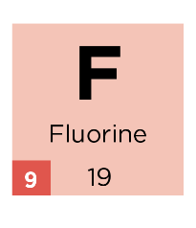
19
$$F$$9
Element | Atomic Number | Mass number | Protons | Electrons | Neutrons | Electron configuration
1  $$H$$  1 |  |  | 1
$$Be$$  4 |  | 9
$$N$$  7 |  |  | 7 |  | 7
24  $$Mg$$  12 | 12
$$P$$  15 |  |  | 15 |  | 16 | 2,8,5
56  $$Fe$$  26 |  | 56 | 26
$$Ag$$ | 47 |  | 47 |  | 61
208
$$Pb$$
82
201  $$Hg$$  80 |  |  |  |  | 122

Structure of the atom: what do I understand?

Think about your answers and confidence level for each mini-topic. Decide whether you understand it well, are unsure, or need more help. Tick the appropriate column.
Mini-topic | I understand  this well | I think I understand this | I need more  help
I can name the subatomic particles.
I can describe the following properties of the subatomic particles:
- charge
- relative mass
- where they are found
I know which particles are described by the:
- atomic number
- mass number
I can use the information from the periodic table to work out the number of protons, neutrons and electrons for a neutral atom.
I can draw the correct number of electrons on the shells of an atom for elements 1–20 on the periodic table.
I can write the electron configuration for an atom of elements 1–20, if I know the number of electrons.
Feeling confident? topics | I understand  this well | I think I understand this | I need more  help
I can use the periodic table to work out the number of subatomic particles for any element.

