Alkenes: knowledge check
- The images show two different ways of representing an ethene molecule.
Use the terms provided to complete the labelling of the two diagrams.
Some terms may be used more than once.
double covalent bond carbon atom hydrogen atom
ball and stick dot and cross
__________________ model  carbon atom  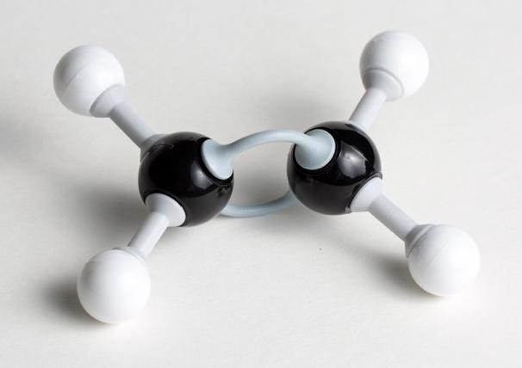  ________________ ________________ | __________________ diagram  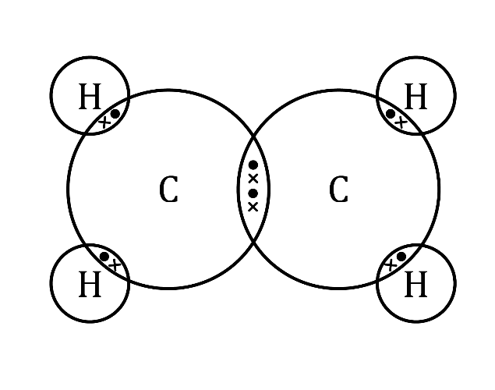  __________________  ______________ double covalent  bond

- Each of the terms listed matches to one of the statements in the table.
C=C $C_{2}H_{4}$ -ene butene three $C_{n}H_{2n}$
Add the correct term into the box provided for each statement. The first has been completed for you.
Suffix used for the names of alkenes | -ene
General formula for the alkenes homologous series
Functional group of alkenes
Number of carbon atoms in a molecule of propene
Name of the alkene containing four carbon atoms
Molecular formula of ethene

- Complete the table using the molecular formulas and displayed formulas provided.
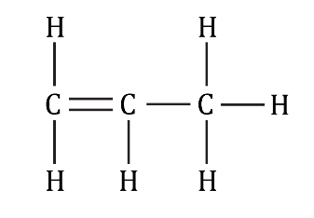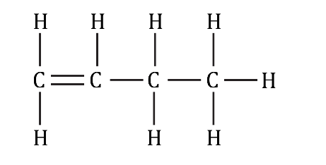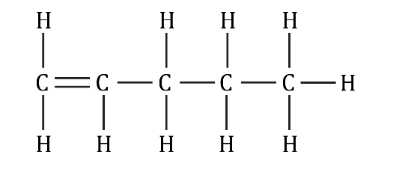
$C_{4}H_{8}$ $C_{3}H_{6}$ $C_{5}H_{10}$
Name | Molecular formula | Displayed formula
ethene | $$C_{2}H_{4}$$ | 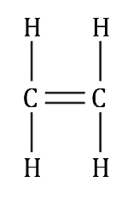
propene
butene
pentene

- Use the words provided to complete the gaps in the sentences.
ethane incomplete ethene C–C
addition more combustion
Like alkanes, alkenes react with oxygen in __________________ reactions.
Unlike alkanes, alkenes tend to combust with smoky flames due to __________________ combustion.
The double C=C bond in alkenes makes them __________________ reactive than alkanes.
Atoms can be added across the C=C bond, so that the C=C bond becomes a __________________ bond. These are called __________________ reactions.
For example, hydrogen gas reacts with ethene to produce __________________, as shown in the equation:
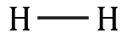
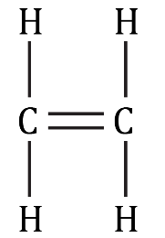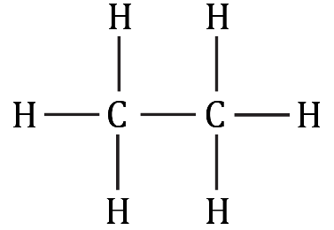
+
→
hydrogen __________________ ethane

Alkenes: test myself
Answer questions 2.1 to 2.7 by circling the correct answer in each question.
- Which compound is an alkene?
propane butane pentene ethane
- What is the molecular formula of the alkene that contains six carbon atoms?

$C_{6}H_{10}$ $C_{6}H_{12}$ $C_{6}H_{14}$ $C_{6}H_{16}$
- Which of the following conditions are required for an addition reaction between ethene and hydrogen?
A nickel catalyst at 150°C
B nickel catalyst at room temperature
C ethane catalyst at room temperature
D ethane catalyst at 150°C
- Chlorine gas reacts with propene in an addition reaction. Which of the images shows the correct displayed formula of the product formed in this reaction?
A  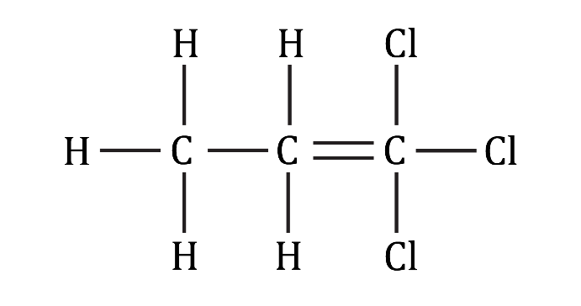 | B  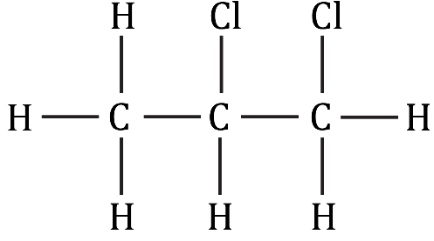
C  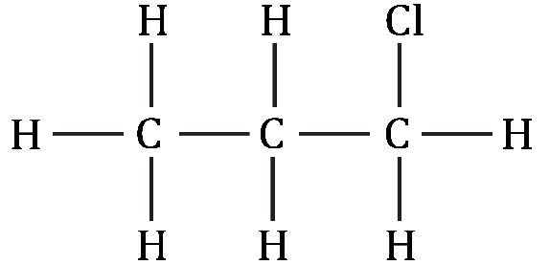 | D  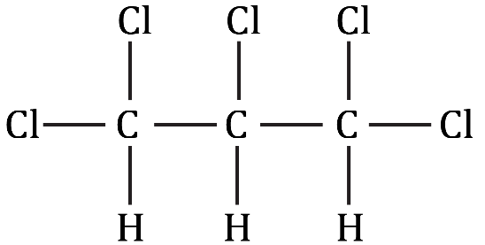
- What is the name of the product formed in question 2.4?
1,1-dichloropentane 1,2-dichloropentane
1,2-dichloropentene 2,2-dichloropentane
- The equation represents ethene reacting with water.
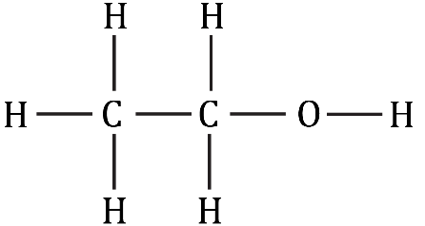
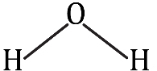
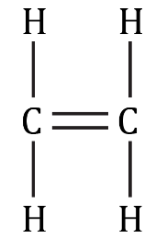
+
→
  - What type of reaction is represented by this equation?
combustion addition substitution reduction
  - What is the name of the product formed in this reaction?
ethanol ethane ethanal ethanoic acid
- What conditions are required when ethene reacts with water?
A 25°C, high pressure and a nickel catalyst
B 300°C, 1 atm and an acid catalyst
C 300°C, high pressure and an acid catalyst
D 100°C, 1 atm and a nickel catalyst
- Use some of the numbers and formulas provided to complete the balanced symbol equation representing the incomplete combustion of propene, C₃H₆. The numbers may be used once, more than once or not at all.
3 $CO_{2}$ 4 $H_{2}O$ OH C
$C_{3}H_{6}$ + ____________ $O_{2}$ → ____________ CO + ____________

Alkenes: feeling confident?
- When ethene gas is bubbled into bromine water, an addition reaction happens and the bromine water turns colourless.
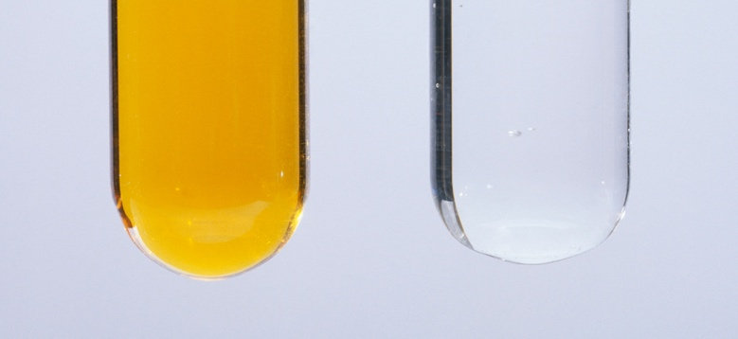
© Andrew Lambert Photography/Science Photo Library

  - Add the displayed formula of the product formed to complete the equation:
Br – Br
+
→
  - Name the product formed in this reaction.

- Describe and explain what happens when alkanes, such as ethane, are added to bromine water. The first sentence has been started to help you.

Alkanes __________________ decolourise bromine water because ______________

Alkenes: what do I understand?
Think about your answers and confidence level for each mini-topic. Decide whether you understand it well, are unsure or need more help. Tick the appropriate column.
Mini-topic | I understand  this well | I think I understand this | I need more  help
I can describe alkenes as a homologous series.
I can identify the general formula and functional group of alkenes.
I can write molecular formulae and draw displayed formulae of alkenes.
I can describe and write equations to represent the combustion reactions of alkenes.
I can describe the addition reactions of alkenes with hydrogen, water and halogens.
I can state the conditions needed for the addition reactions of alkenes.
Feeling confident? topics | I understand  this well | I think I understand this | I need more  help
I can write an equation to represent the decolourisation of bromine water.
I can explain why alkanes do not decolourise bromine water.

