Mass and dissolving
- Sugar and water

Some water was placed in a beaker and its mass was measured using a balance. The mass of beaker and water was 200 grams. Then, 10 grams of sugar were weighed out. The sugar was added to the water and sank to the bottom. After 10 minutes, the sugar could not be seen.
- Fill in the spaces to show what you think the mass of the beaker and its contents would be when the sugar was first added, and then after it could no longer be seen.

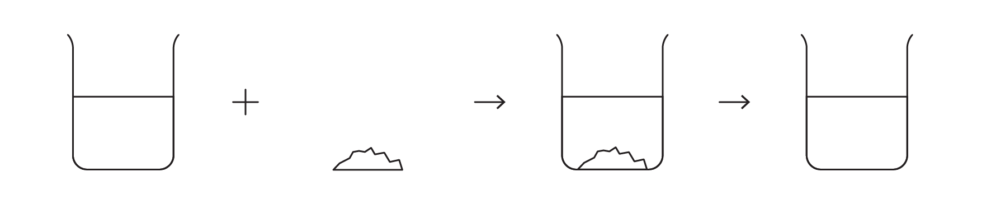
200 g | 10 g | ________ g | ________ g

- Where did the sugar go? Explain your answer.

__________________________________________________________________________________

__________________________________________________________________________________

__________________________________________________________________________________
- Salt and water

Some water was placed in a beaker and its mass was measured using a balance. The mass of beaker and water was 150 grams. Then, 10 grams of salt were measured out. The salt was added to the water and sank to the bottom. After 10 minutes, the salt could not be seen.
- Fill in the spaces to show what you think the mass of the beaker and its contents would be when the salt was first added, and then after the salt could no longer be seen.
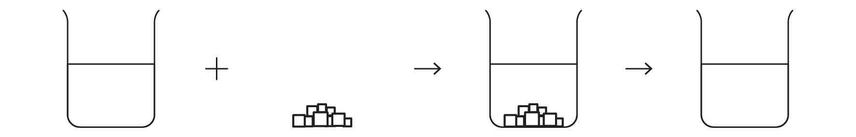
150 g | 10 g | ________ g | ________ g
- Where did the salt go? Explain your answer.

__________________________________________________________________________________

__________________________________________________________________________________

__________________________________________________________________________________
- Copper sulfate and water

Some water was placed in a beaker and its mass was measured using a balance. The mass of beaker and water was 250 grams. Then, 5 grams of blue copper sulfate crystals were measured out. The copper sulfate was added to the water and sank to the bottom. After 20 minutes, the copper sulfate could not be seen, but the liquid had turned blue.
- Fill in the spaces to show what you think the mass of the beaker and its contents would be when the copper sulfate was first added, and when it could no longer be seen.
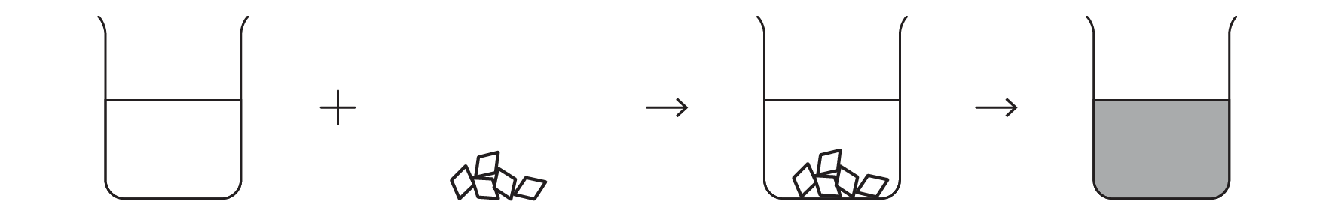
250 g | 5 g | ________ g | ________ g
- Why did the water turn blue?

__________________________________________________________________________________

__________________________________________________________________________________

__________________________________________________________________________________
- Where did the copper sulfate go?

__________________________________________________________________________________

__________________________________________________________________________________

__________________________________________________________________________________
- Particles in sugar and water

The diagrams below represent the particles present at the different stages when sugar is dissolved in water. Not all the particles are shown.
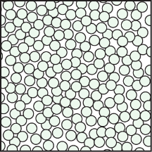 |  | 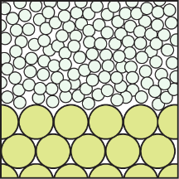 | 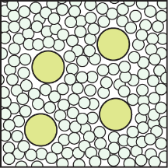

Why does the liquid taste sweet when sugar is added to water?

__________________________________________________________________________________

__________________________________________________________________________________

__________________________________________________________________________________

