Mass and dissolving

This resource is from Chemical misconceptions – prevention, diagnosis and cure, which can be viewed at: rsc.li/456d4fF. This series includes classroom activities you can use to identify and challenge learners’ misconceptions, and help learners construct the chemical concepts required by the curriculum.

How to use this resource

Younger learners may be satisfied with the idea that solutes ‘disappear’ when they dissolve, and learners may not expect the mass of the solute to register in any measurements, even when they appreciate the process of dissolving.

Use this exercise to ask learners to predict the masses of solutions from given masses of solute and solvent, to explain what happens to the solute and the emergent properties of the solution.

Read the chapter Chemical axioms, to find out more about learners’ beliefs in alternative ideas: rsc.li/44mXmJf

When to use? |   Introduce |   Develop |   Revise |   Assess
When to use? | This exercise is primarily aimed at the 11–14 age range, although you can use it to check the understanding of your 14–16 learners.  Use this task as an introductory diagnostic activity before formally teaching about the topic at either level.
Group size? |   Independent |   Small group |   Whole class |   Homework
Group size? | Instruct learners to do the task independently in class so you can identify misconceptions.
Topics assessed? | Conservation of mass during dissolving.
How long? |  |  | 10–15 minutes

Lesson plan also available

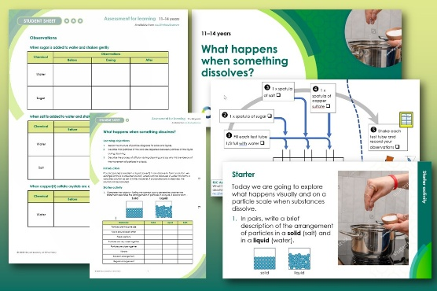
Build a lesson around this resource with our What happens when something dissolves? lesson plan. Ask learners to observe and think about the process of dissolving and use their knowledge of the particle model to explain their observations.

Available to download as part of a complete lesson with presentation slides at: rsc.li/3jwKgBO

Answers

The precise level of an acceptable response depends upon the age and nature of the group.
- Sugar and water
- 210 g, 210 g
- The sugar dissolved – it is still present, but as part of the solution. The molecules of sugar, which are much too small to be seen, are mixed with the molecules of water.

Guidance note: When this exercise was piloted in schools it was found that some learners did not expect mass to be conserved on dissolving (even though most recognised that the solute was still present in some form), and that learners who conserved mass in their responses often had only vague ideas about how the properties of solutions arose.

- Salt and water
- 160 g, 160 g
- The salt dissolved and is now part of the solution. The salt particles are mixed with the water particles in the solution.

Guidance note: If you are using this resource with older learners who have studied ionic bonding, emphasise that the sodium ions and chloride ions are separate in the mixture.

- Copper sulfate and water
- 255 g, 255 g
- The blue colour is a property of the particles in the copper sulfate. The water turned blue as the copper sulfate dissolved to give a solution. The copper sulfate particles are mixed with the water particles. As the copper sulfate particles are spread throughout the solution the whole solution looks blue.
- The copper sulfate dissolved – it is still present, but as part of the solution. The particles of copper sulfate, which are much too small to be seen, are mixed with the molecules of water.

Guidance note: Learners commonly believe that the properties of a substance are due to its particles having that same property (read more about learners’ beliefs in alternative ideas at: rsc.li/44mXmJf). This idea is usually not correct, so although in this case the colour may be seen to be a property of both the particles and the bulk material, emphasise that this is unusual, and that most bulk properties are not shared by the particles.

If learners have studied ionic bonding, emphasise that the copper ions and sulfate ions are separate in the mixture. The colour is due to the hydrated copper(II) ions.

- Particles in sugar and water

The liquid tastes sweet because the molecules of sugar are dissolved in the solution. Sugar has a sweet taste, so the solution tastes sweet because it contains the sugar molecules.

