What happens when something dissolves?

Learning objectives
- Recall the structure of particle diagrams for solids and liquids.
- Describe how particles of the solid are dispersed between particles of the liquid during dissolving.
- Describe the process of diffusion during dissolving and explain why this is evidence of the movement of particles in a liquid.

Introduction

If a solid (solute) is soluble in a liquid (solvent) it can dissolve to form a solution. An example of this is a saltwater solution, where salt has dissolved in water. This forms a colourless solution.

Starter activity

Complete the table by ticking the correct box to determine whether the statement describes the arrangement of particles in a liquid, a solid or both.
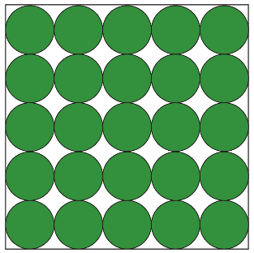 | 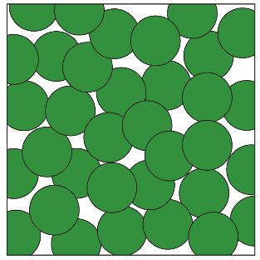
solid | liquid

Statement | Solid | Liquid | Both
Particles are the same size
Particles move around each other
Particles are in fixed positions
Particles are very close together
Particles are close together
Particles vibrate
Particles are in a random arrangement
Particles are in a regular arrangement

Teacher demonstration

Use the table below to record your observations from the demonstration your teacher is performing.

For each step, use the following questions to guide your observations:
- What colour is the substance?
- What state is the substance?
- What has changed since the previous box?
- What could you see but now you can’t?
Chemical | Observations
Chemical | Before | During | After
Water
Potassium manganate

Class practical

You will work in pairs for this practical.

Equipment
- 3 x test tubes
- Test tube rack
- Water
- Spatula
- White card to provide a background
- A pea-size quantity of each of the following:
- salt
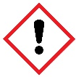
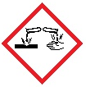

- sugar
- copper(II) sulfate crystals

Safety and hazards
- Wear eye protection – safety glasses.
- Copper(II) sulfate is harmful if swallowed, causes skin irritation and causes serious eye damage.
- Do not remove crystals of hydrated copper(II) sulfate from the laboratory.
- Copper(II) sulfate is very toxic to aquatic life with long lasting effects. Follow instructions for disposal very carefully.

Method
- Fill the test tubes one-third full of water.
- Carefully add the sugar to one test tube.
- Carefully add the salt to the second test tube.
- Carefully add the copper(II) sulfate to the third test tube.
- Shake each test tube gently and observe any changes.

Diagram

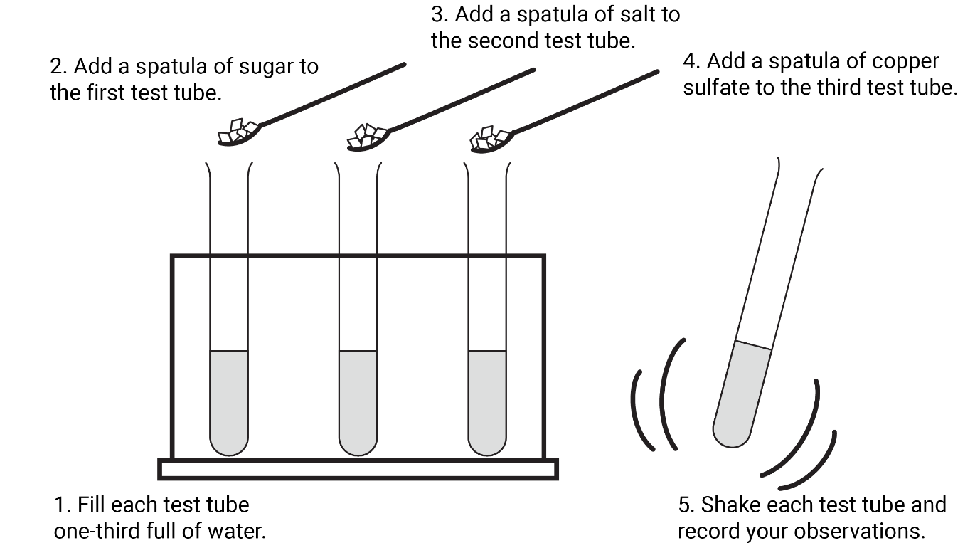

Observations

For each step, use the following questions to guide your observations:
- What colour is the substance?
- What state is the substance?
- What has changed since the previous box?
- What could you see but now you can’t?

When sugar is added to water and shaken gently
Chemical | Observations
Chemical | Before | During | After
Water
Sugar

When salt is added to water and shaken gently
Chemical | Observations
Chemical | Before | During | After
Water
Salt

When copper(II) sulfate crystals are added to water and shaken gently
Chemical | Observations
Chemical | Before | During | After
Water
Copper(II) sulfate

Describing your observations

When salt or sugar is added to water and shaken gently
- Draw particle diagrams to show what happens when a soluble solid (salt or sugar) dissolves in this liquid (water).

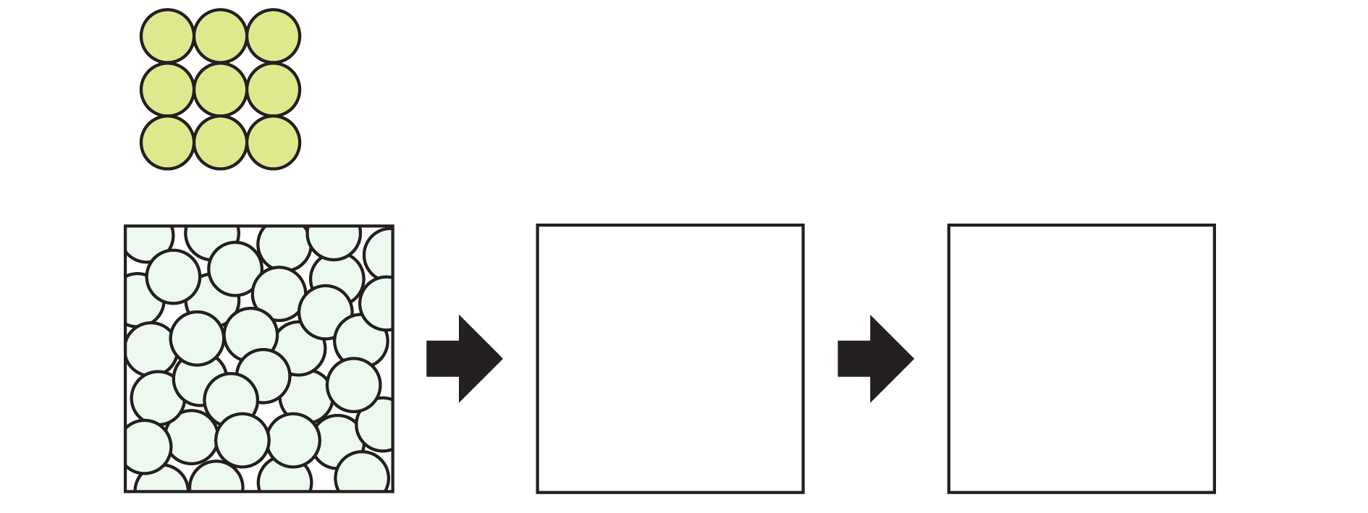
 | This is as you have just added the salt to the water so there is minimal salt dissolved. |  | This is as all the salt has dissolved and has spread through the water.

- Use the words below to complete the sentences to explain your observations from salt and water in terms of particles.

close crystals increase diffusion disperse smaller

particles white water

As a solid, there are enough __________________ of salt packed __________________ together to see them as a __________________ solid.

When salt is added to __________________, the salt particles move apart from each other and __________________ as the water particles move into the spaces between them. This can be seen as the crystals get __________________.

The particles then spread out through the water by __________________. This can be seen as we can no longer see white __________________.

When copper(II) sulfate crystals are added to water and shaken gently
- Choose the correct words to complete the sentences to explain your observations from copper sulfate and water in terms of particles.

blue close decrease diffusion dissolves disperse increase larger liquid solid smaller particles water white

As a __________________, there are enough particles of copper(II) sulfate packed __________________ together to see as __________________ crystals.

When copper(II) sulfate is added to water, the __________________ move apart from each other and __________________. This can be seen through the movement of blue colouring into the water as it __________________ and by the crystals getting __________________.

The particles then spread out through the water by __________________.

This can be __________________ as the solution turns __________________.

