What happens when a substance changes state?

Learning objectives
- Recall the definitions of freezing, boiling and melting as changes of state.
- Describe the difference between particle diagrams at different states.
- Explain that molecules do not break up and reform when a substance boils and cools.

Introduction

Explore what happens when substances are heated or cooled and the impact this has on their state and the arrangement of their atoms/molecules.

What happens when water boils?

Using your observations from the boiling water in front of you, independently decide whether each of the statements is true or false and add a tick to that column.

If you don’t know, place a tick in that column instead.
Statement | True | False | Don’t know
The bubbles contain a mixture of hydrogen and oxygen
The bubbles contain carbon dioxide
The bubbles contain steam (water vapour)
The bubbles are empty (vacuum)
The bubbles contain air
The bubbles contain oxygen only

What happens when ice melts?

Using your observations from the ice in front of you, independently decide whether each of the statements is true or false and add a tick to that column.

If you don’t know, place a tick in that column instead.
Statement | True | False | Don’t know
The molecules in ice get smaller because water takes up less space than ice
The molecules in ice get warmer because the water is hotter than ice
The molecules move around more as water than they did in the ice
Ice molecules and water molecules have different chemical structures
Ice changes to water at 0 °C
Ice only melts above its melting temperature

Changes of state in water

Use the terms boiling, condensing, freezing and melting to label the changes of state shown as particle diagrams below.

Label the arrows to show whether these state changes occur with increasing temperature/energy or decreasing temperature/energy.
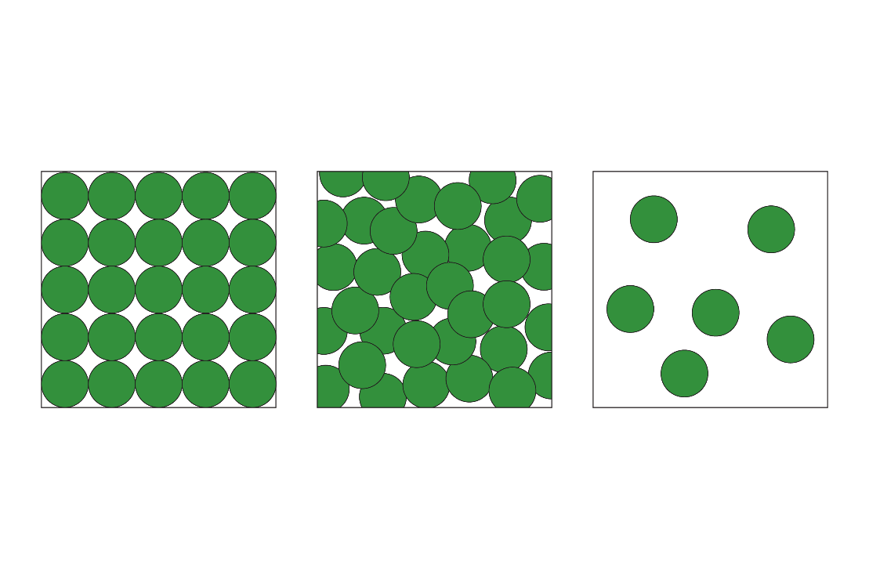
___________________
___________________
___________________
___________________
___________________ energy
___________________ temperature
___________________ temperature
___________________ energy

