Viscosity

Learning objectives
- Compare the viscosity of different liquids by making careful observations.
- Apply your understanding of particles to explain your observations.
- Design an experiment.

Introduction

You are going to measure the times it takes for a bubble to rise through different liquids. This is a way to compare the viscosity of the liquids.

Equipment (per group)

Apparatus
- Stopwatch
- Sealed tubes of different liquids

Chemicals

Choose from:
- water
- cooking oil
- Washing up liquid
- Ethanol 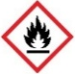
- Shampoo or bubble bath
- Conditioner

Safety equipment
- Eye protection: safety glasses to EN166F

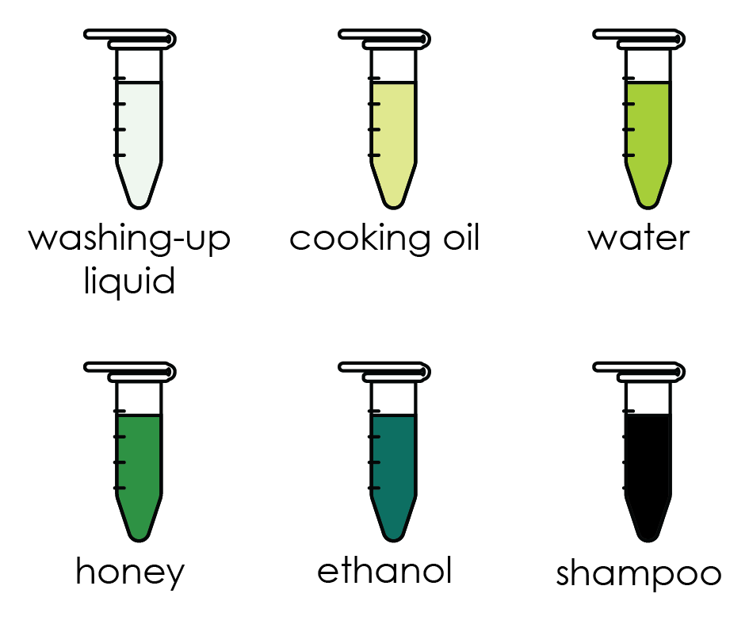
Diagram

Procedure

Take one of the tubes provided.
- Ensure the bubble is at the top and the tube is held vertical.
- Quickly invert the tube and measure the time it takes for the bubble to reach the top.
- Repeat this measurement for all the samples.
- Complete the table provided.

Results
 | Time taken (s)
Liquid | Test 1 | Test 2 | Test 3 | Average time (s)
Water
Cooking oil
Washing-up liquid
Ethanol
Shampoo or bubble bath
Honey

Questions
- State the meaning of the word viscosity.

__________________________________________________________________________________

__________________________________________________________________________________

- Use your results to identify the most viscous liquid. Suggest a reason for your answer.

Liquid ____________________________________________________________________

Reason ____________________________________________________________________

- Use your results to identify the least viscous liquid. Suggest a reason for your answer.

Liquid ____________________________________________________________________

Reason ____________________________________________________________________

- Which diagram shows how the particles are arranged in a sample of cooking oil?
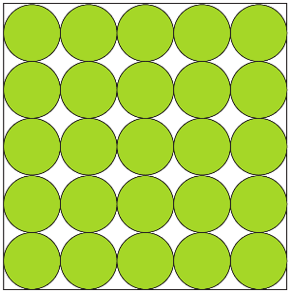 | 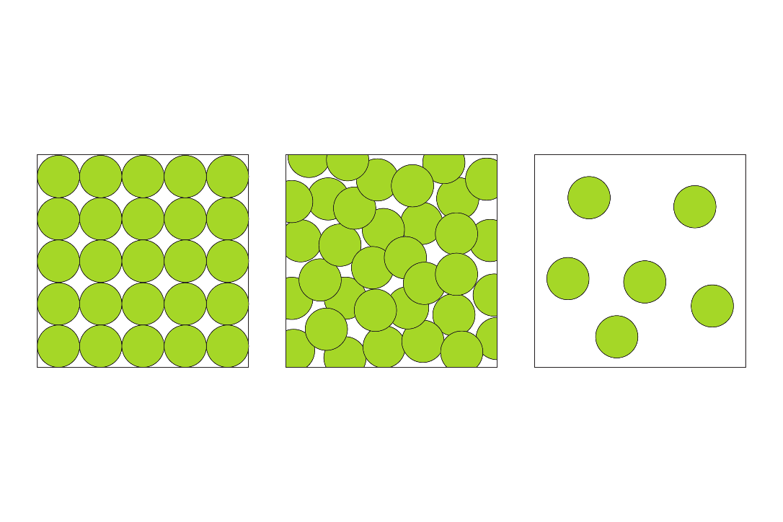
A | B | C

- Complete the sentences to describe what happens to the particles when some cooking oil is poured into a frying pan.

The particles slide ________________________________________________________________

They flow from ___________________________________________________________________

- Choose the correct words to compare the viscosity of water and bubble bath.

Water is less/more viscous than bubble bath because there are less/more forces of attraction within/between the water molecules than those within/between the bubble bath particles. This makes it easier/harder for the water molecules to flow.
- Choose the correct words to complete the sentences to predict how the viscosity of honey will change as the temperature of the honey is increased.

attraction decrease gain increase lose repulsion

The viscosity of honey will ____________________ as the temperature increases. As the particles in the liquid ____________________ more kinetic energy, it will be easier to overcome the forces of ____________________ between the particles.
- Use the structure strip to design an experiment to investigate how the temperature effects the viscosity of a liquid.
Investigating viscosity | Investigating viscosity | Investigating viscosity | Investigating viscosity
Make a prediction. | Make a prediction. | Make a prediction. | Make a prediction.
Which liquid are you going to test? | Which liquid are you going to test? | Which liquid are you going to test? | Which liquid are you going to test?
Identify your variables:  - independent (what you will change)  - dependent (what you will measure)  - control (what you will keep the same) | Identify your variables:  - independent (what you will change)  - dependent (what you will measure)  - control (what you will keep the same) | Identify your variables:  - independent (what you will change)  - dependent (what you will measure)  - control (what you will keep the same) | Identify your variables:  - independent (what you will change)  - dependent (what you will measure)  - control (what you will keep the same)
What equipment will you use? | What equipment will you use? | What equipment will you use? | What equipment will you use?
How will you carry out your experiment?  Write a method. | How will you carry out your experiment?  Write a method. | How will you carry out your experiment?  Write a method. | How will you carry out your experiment?  Write a method.
What will you record?  Draw a results table.  Include spaces for repeat readings. | What will you record?  Draw a results table.  Include spaces for repeat readings. | What will you record?  Draw a results table.  Include spaces for repeat readings. | What will you record?  Draw a results table.  Include spaces for repeat readings.

