Supercooling and the energetics of freezing

This investigation is part of the Nuffield practical collection, developed by the Nuffield Foundation and the Royal Society of Chemistry. Delve into a wide range of chemical concepts and processes with this collection of over 200 step-by-step practicals: rsc.li/43bjGql

Learning objectives
- Make and record observations.
- Interpret a graph.
- Describe the energy changes that take place during a change of state.

Success criteria

Learners will meet LO1 by successfully carrying out the practical and producing a results table. LO2 will be met by answering questions 2 and 3 on the student worksheet and LO3 by answering question 4 on both student sheets, and question 5 on the level 2 sheet.

Introduction

Explore what happens when a liquid is supercooled using sodium thiosulfate in this class practical.

In this experiment, learners melt sodium thiosulfate crystals, before cooling them to a state well below the melting point. The sodium thiosulfate will then exist in a metastable supercooled state. The supercooled liquid will freeze rapidly on the addition of a crystal of sodium thiosulfate or dust particles or on stirring. Learners add a crystal of the solid to seed the crystallisation process and observe temperature changes throughout.

The experiment is best carried out individually or in pairs and takes 20−30 minutes.

Scaffolding

There are two versions of the student worksheet.

Use the level 1 sheet (✪) to offer learners more scaffolding, including a ready-drawn results table and structured questions.

Use the level 2 sheet (✪✪) to allow learners to make their own decisions about how to present their results and give more extended responses to questions.

For a safer alternative, which will also reduce experimental time, boil the hot water used to melt the sodium thiosulfate in a kettle, instead of asking students to set up a Bunsen burner, tripod and gauze.

As an alternative approach, set up a temperature sensor attached to a computer and project a continuous plot onto the screen as the temperature changes are observed. This will allow you to concentrate on LO2 and LO3 through the learner questions.

You can opt to collect some data using the data-logger while learners carry out their own experiment. This provides an opportunity to compare and evaluate the results.

Technician notes

Read our standard health and safety guidance (rsc.li/3zyJLkx) and carry out a risk assessment before running any live practical.

Once the experiment is over, you can easily remove the thermometer by flushing with water (since sodium thiosulfate is water-soluble), or by re-melting the solid. Do not heat the boiling tube directly over a Bunsen flame as at higher temperatures the thiosulfate decomposes and may form toxic products.

Equipment

Apparatus
- Safety glasses
- Boiling tube (this must be very clean)
- Boiling tube holder
- Stirring thermometer, –10 °C to 110°C
(A temperature sensor attached to a computer can be used in place of a thermometer. A continuous plot can then be drawn as the temperature changes occur.)
- Beaker, 100 cm³
- Bunsen burner (or kettle to heat the water)
- Tripod and gauze
- Cotton wool, small tuft to fit boiling tube

Chemicals
- Sodium thiosulfate-5-water, about 20 g
(Currently not classified as hazardous, see CLEAPPS hazcard HC095a. In Scotland, refer to SSERC for safety advice.)

Safety and hazards

Make sure that learners can use a Bunsen burner with confidence and remind them how to handle hot liquids in beakers, as in CLEAPSS student safety sheets SSS092 and SSS095. In Scotland, refer to SSERC for safety advice.

Allow enough time for the equipment to cool down before asking learners to put away their equipment. In case of burns, follow the instructions on the CLEAPSS emergency cards E2a and cool the burn by immediately irrigating with gently running water for at least 20 minutes and until pain is relieved and heat is no longer felt.

Method

The full method is shown on the student sheets and integrated instructions can be found in the presentation.

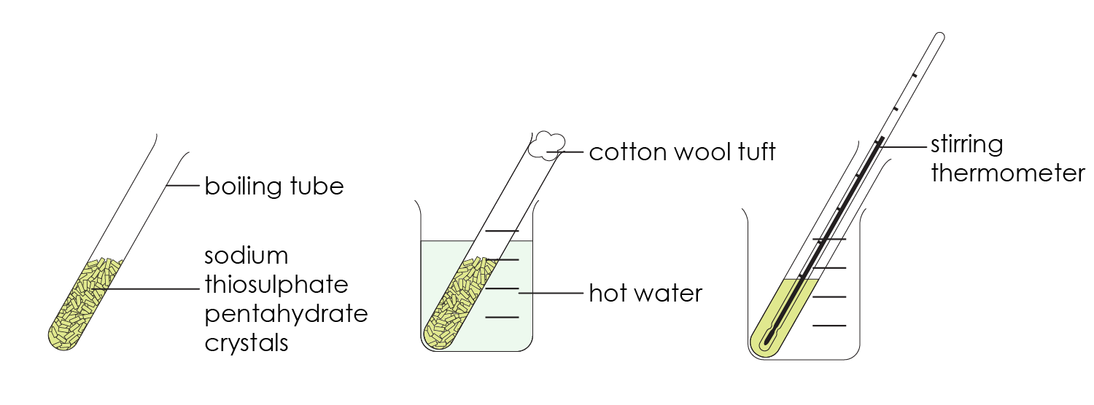

Teaching notes

The temperature changes occurring show a steady fall as the liquid cools. When a crystal is added to the supercooled liquid, the temperature rapidly rises as solidification takes place, confirming this process is exothermic. The solid then cools to room temperature.

All solids exhibit supercooling to a greater or lesser extent, but sodium thiosulfate is particularly prone to exhibiting this metastable condition. It is possible to cool the liquid to a value well below room temperature, but to achieve this involves waiting for more time to elapse, lengthening the experiment considerably.

Carry out an impressive teacher demonstration using cold running water to cool the liquid rapidly to about 5−10°C before adding a crystal to seed the crystallisation process. The boiling tube will warm up rapidly and become hot in the process.

Some vocabulary in this resource, such as metastable, might be unfamiliar to learners and require explanation.

Answers (level 2 sheet)
- (a) Freezing – a substance changes from a liquid to a solid.

(b) Supercooled liquid – when a substance is in the liquid state below its freezing point.

(c) Exothermic – when energy is transferred from the substances to the surroundings (usually in the form of heat).

(d) Crystallisation – the process used to produce solid crystals from a concentrated solution.
- The graph should look similar to this sketch graph. There should be suitable scales and points plotted correctly.

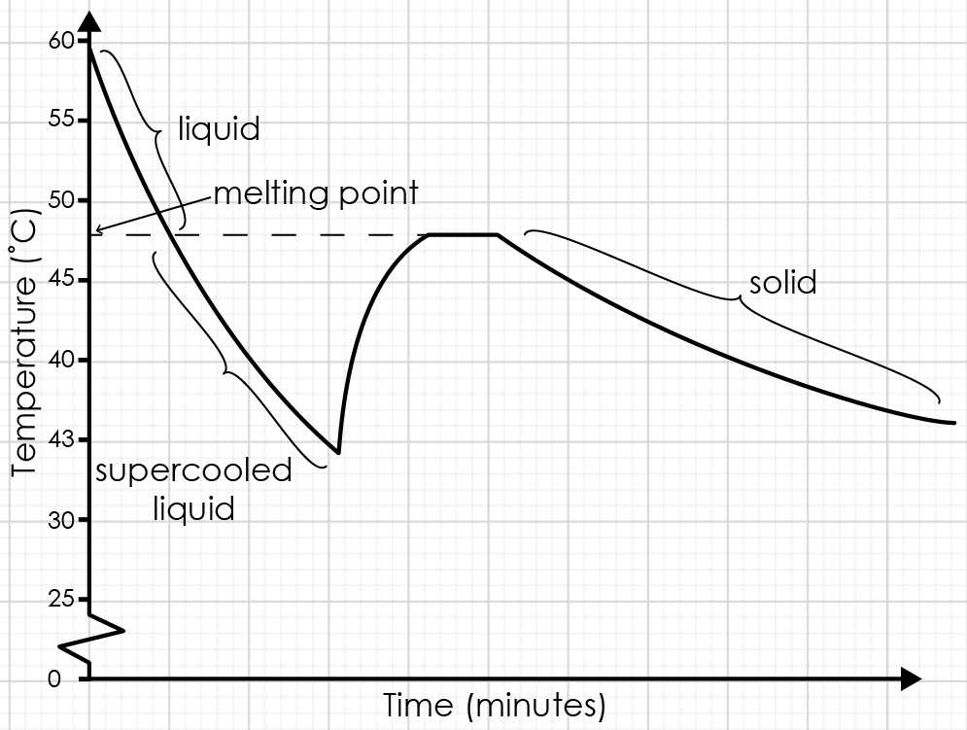

- See annotations on sketch graph above.

- The temperature increased/went up steeply.

As the crystals were formed, the temperature increased rapidly. Heat energy was transferred/released to the surroundings, indicating an exothermic process had taken place.
- The answer should include the following points.


In the liquid state, particles have enough kinetic energy to move freely.

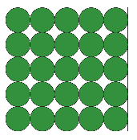

In the solid state, particles only have enough kinetic energy to vibrate around a fixed point.

When a substance changes from the liquid state to the solid state, the excess energy is transferred from the supercooled liquid to the surroundings as heat energy. The temperature increases. The process is exothermic.

Answers (support sheet)

Freezing |  | When a substance is in the liquid state below its freezing point.
Crystallisation |  | The process used to produce solid crystals from a concentrated solution.
Supercooled liquid |  | When energy is transferred from a substance to the surroundings, usually in the form of heat.
Exothermic |  | When a substance changes from a liquid to a solid.

- (a) Crystallisation taking place − D

(b) Liquid sodium thiosulfate − A

(c) Supercooled liquid sodium thiosulfate − B

(d) Solid sodium thiosulfate − E

(e) sodium thiosulfate crystal added − C
- The graph increased/went up steeply.
- The temperature increased as the crystals were formed.

