Electrolysis of brine

Learning objectives
- Safely investigate the electrolysis of brine.
- State and describe your observations for the electrolysis of brine.
- Apply your understanding of electrolysis to explain your observations and the products formed.
- Predict the products formed.

Introduction

In this experiment, you will observe what happens during the electrolysis of brine (sodium chloride solution), using universal indicator to help you follow the reaction that takes place.

Equipment

Apparatus
- Safety glasses
- U-shaped test tube
- Clamp and clamp stand
- Carbon electrodes and electrode holders, x 2
- Electrical leads, x 2
- Power pack (low voltage, DC)
- Beaker, 100 cm³

- Spatula
- Stirring rod

Chemicals
- Sodium chloride (table salt)
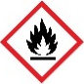
- Universal indicator solution (FLAMMABLE)
- Distilled water

Health and safety

Wear safety glasses throughout, especially when clearing up the experiment.

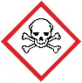
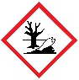
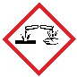
The products of the electrolysis of the salt solution are all more hazardous than the starting materials. One of the products is EXTREMELY FLAMMABLE, a second product is TOXIC and DANGEROUS FOR THE ENVIRONMENT and a third product is CORROSIVE.

Pre-experiment questions
- Circle all the ions found in brine (saturated sodium chloride solution).

${Cu}^{2+}$ $S{O_{4}}^{2-}$ ${Cl}^{-}$ $H^{+}$ ${Mg}^{2+}$ ${OH}^{-}$ ${Na}^{+}$ $F^{-}$

- What colour indicates the presence of an acid and an alkali when using universal indicator? Delete the incorrect words.

Universal indicator, in the presence of an acid, will turn red/purple/green. Universal indicator, in the presence of an alkali, will turn red/purple/green.
- Match the name of the positive and negative electrodes using a line.

anode |  | positive electrode
cathode |  | negative electrode

- Complete the following sentence by deleting the incorrect words.

Universal indicator in the presence of a neutral substance, such as deionised water, will turn red/purple/green.
- Using your answer to Q1, which ions will move to the positive electrode and which ions will move to the negative electrode?
Positive electrode: __________________
Negative electrode: __________________

- During the electrolysis of aqueous solutions, use the following rules to predict which product is formed. Explain your reasoning.

Positive electrode: if a halide ion is present (group 7), molecules of this ion are formed. If none are present, oxygen is formed due to the hydroxide ions.

Negative electrode: if the metal ion is more reactive than hydrogen, hydrogen is produced. If the metal ion is less reactive than hydrogen, the metal is formed.

I predict that product at the positive electrode will be _______________________________

because ________________________________________________________________________.

I predict that product at the negative electrode will be ___________________________

because ________________________________________________________________________.
- Using this information, predict the products at both electrodes and explain your reasoning.

I predict that at the positive electrode (anode) I will see _____________________________

_________________________________________________________________________________.

I predict that at the negative electrode (cathode) I will see ________________________

_________________________________________________________________________________.

Method
- Put about 75 cm³ distilled water into the beaker. Add about two heaped spatulas of sodium chloride.

- Stir until the salt dissolves. Then add several drops of universal indicator solution. Stir to mix thoroughly. You need enough indicator to give the water a reasonable depth of green colour.

- Pour the coloured salt solution into the U-shaped test tube and clamp it as shown in the diagram.

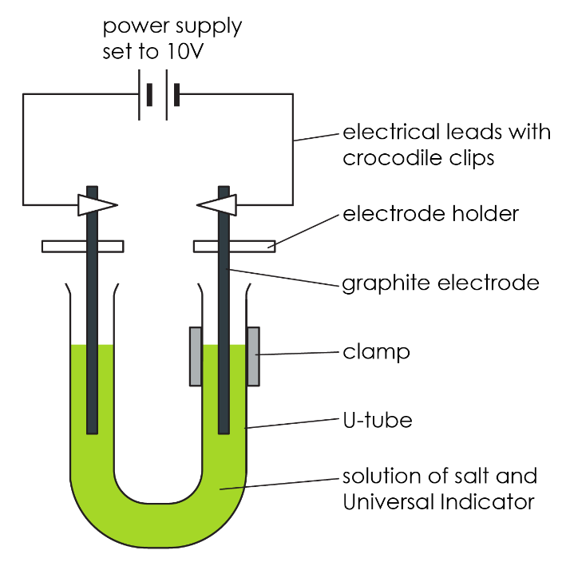

- Wash the carbon electrodes carefully in distilled water and then fix them so that there is about 3 cm of electrode in each side of the U-tube – see diagram. This is most easily done using electrode holders.

- Attach leads to the electrodes and connect them to a power pack set to 10 V (DC).

- Turn on the power pack and observe closely what happens. A piece of white paper held behind the U-tube can help. Make sure the U-tube is kept very still during the experiment.

- Turn off the power as soon as you notice any change at the positive electrode, or when you smell a ‘bleachy, swimming pool’ smell. This will probably take less than five minutes.

Observations

Left electrode: ___________________________________________________________________

Right electrode: __________________________________________________________________

Middle of the U-shaped test tube: _________________________________________________

Further questions – observations and results
- Considering your observations, what is the product formed at the anode? Delete the incorrect words.

The anode is the positive/negative electrode and therefore was the right/left electrode. I know this as we observed bubbles at both electrodes, however the anode turned red/purple initially and was then bleached to colourless. This is due to ${Cl}_{2}$/$H_{2}$/$NaOH$ being produced at this electrode.

- Considering your observations, what is the product formed at the cathode? Delete the incorrect words.

The cathode is the positive/negative electrode and therefore was the right/left electrode. I know this as we observed bubbles at both electrodes, however the cathode turned red/purple. This is due to ${Cl}_{2}$/$H_{2}$/$NaOH$ being produced at this electrode.

- Considering your observations, explain what happened the middle of the U-shaped test tube. Delete the incorrect words.

Initially, the middle of the U-shaped test tube was red/green/purple. However, over time the colour changed to red/green/purple. This is due to the active transport/diffusion of the ions over time.

