Heating copper in air

Learning objectives
- Safely heat copper using a Bunsen burner and record your observations.
- Describe and explain observations from a chemical reaction.
- Write word and symbol equations to represent a chemical reaction.
- Use simple calculations to link mass to reactivity and the availability of oxygen.

Introduction

Many metals can react in the presence of air. This is an example of an oxidation reaction, where the metal reacts with the molecules of oxygen in the air.

Different metals have different reactivities which affects their rate of reaction with oxygen.

Alkali metals, such as sodium and potassium will react almost instantly, but other metals must be heated to increase the rate of reaction.

Copper, like many transition metals, only reacts slowly with oxygen in the air. When heated it forms a layer of black copper oxide on its surface.

Equipment

Apparatus
- Safety glasses
- Bunsen burner
- Heat resistant mat
- Tongs

Chemicals
- Copper foil, 4 cm x 4 cm

Health and safety
- Wear eye protection throughout the experiment

Method
- Fold the copper foil into an envelope as shown in the diagram below.

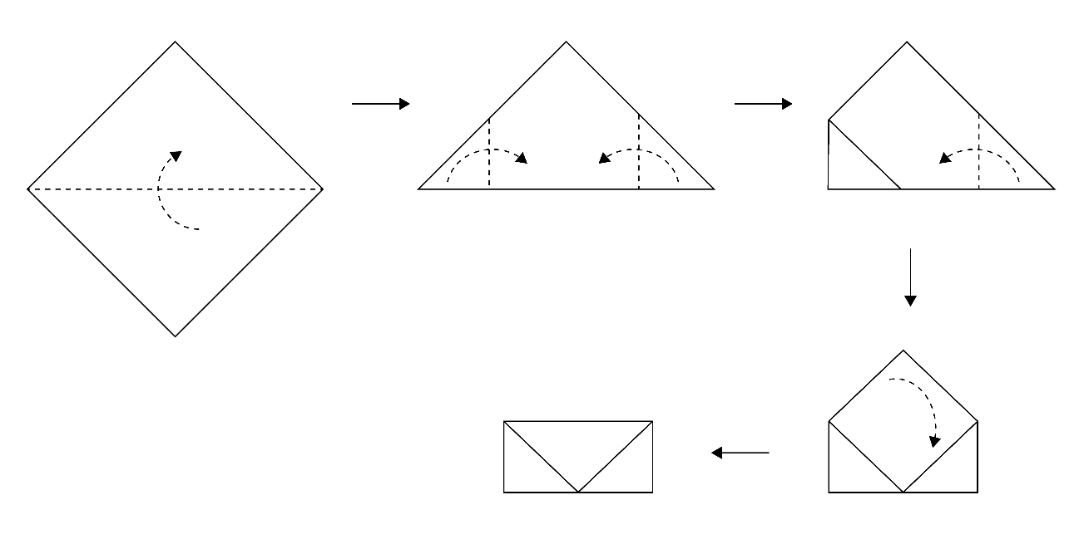
- Wear safety glasses and light the Bunsen burner.
- Hold the envelope in the tongs and heat strongly in the Bunsen flame for five minutes. You will need to have the air hole fully open.
- Place the envelope on the heat resistant mat and allow to cool. This will take a few minutes.
- Open the envelope and compare the inside to the outside surface.

Follow-up questions
- In this experiment, copper ($Cu$) was heated in air to produce copper oxide ($CuO$) on its surface.
- Write a word equation for the reaction.

c__________ + o__________ $→$ __________ __________
- Write a balanced symbol equation for this reaction.

____ $Cu + O_{2} → 2$ ________
- Identify the reactants in this reaction (these are found before the arrow).

__________________________________________________________________________________
- Identify the product in this reaction (this is found after the arrow).

__________________________________________________________________________________
- Describe the observations which show that a chemical reaction has occurred.

__________________________________________________________________________________

__________________________________________________________________________________

__________________________________________________________________________________
- In the practical, the outside of the copper envelope was black in colour. Explain why we saw this.

__________________________________________________________________________________

__________________________________________________________________________________

__________________________________________________________________________________
- In the practical, the inside of the copper envelope was unchanged. Explain why we saw this.
HINT: What wasn’t available to react with the copper?

__________________________________________________________________________________

__________________________________________________________________________________

__________________________________________________________________________________
- For the reaction of copper in air, we used a Bunsen burner, whereas if sodium was reacted in air this wouldn’t be necessary. Choose words to fill in the gaps in the sentences below to explain why we needed a Bunsen burner.

decreases fast high increases low rate slow

Copper has a __________________ reactivity so the __________________ of reaction with oxygen is __________________ at room temperature. Heating it up __________________ the rate of reaction.
- A student measured the mass of the piece of copper before it was heated. It had a mass of 2.5 g. After it was heated, they measured the mass again and it was 2.8 g.
- Name the piece of apparatus used to measure the mass.

__________________________________________________________________________________
- Calculate the change in mass.
HINT: To calculate a change, you must do a subtraction.

__________________________________________________________________________________
- Select the correct answer to describe what has happened to the mass.

The mass increased/decreased/stayed the same.
- Complete the sentence below to explain these results.

carbon dioxide copper copper oxide nitrogen oxygen

______________ molecules from the air have combined with the ______________ in a chemical reaction so are now present as part of _____________ _____________ as a solid on the surface of the copper.
- A student performed a calculation which said that if they heated 5 g of copper in air, they should produce 6.26 g of copper oxide. However, their final mass was only 5.5 g.
- Calculate the expected increase in mass.

__________________________________________________________________________________
- Calculate the actual increase in mass.

__________________________________________________________________________________
- Explain why the mass didn’t increase as much as expected.
HINT: Use the difference you saw between the inside and outside of the copper envelope to help you answer this question.

__________________________________________________________________________________

__________________________________________________________________________________

__________________________________________________________________________________

