Extracting lithium using string

This resource forms part of the elements, compounds and mixtures (14–16) topic package where you will find more resources to embed literacy skills development into your teaching. You can edit all the linked files in this resource to best suit the needs of your learners.

Resource components

Reading comprehension sheet, present the news slides and script are also available from: rsc.li/42tFi0D
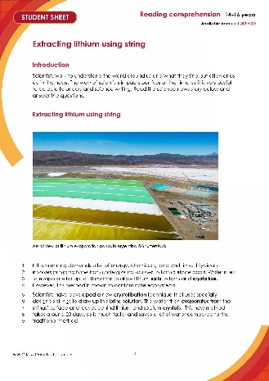 | 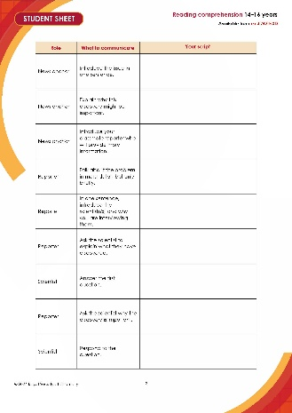 | 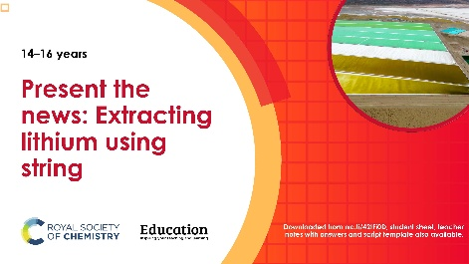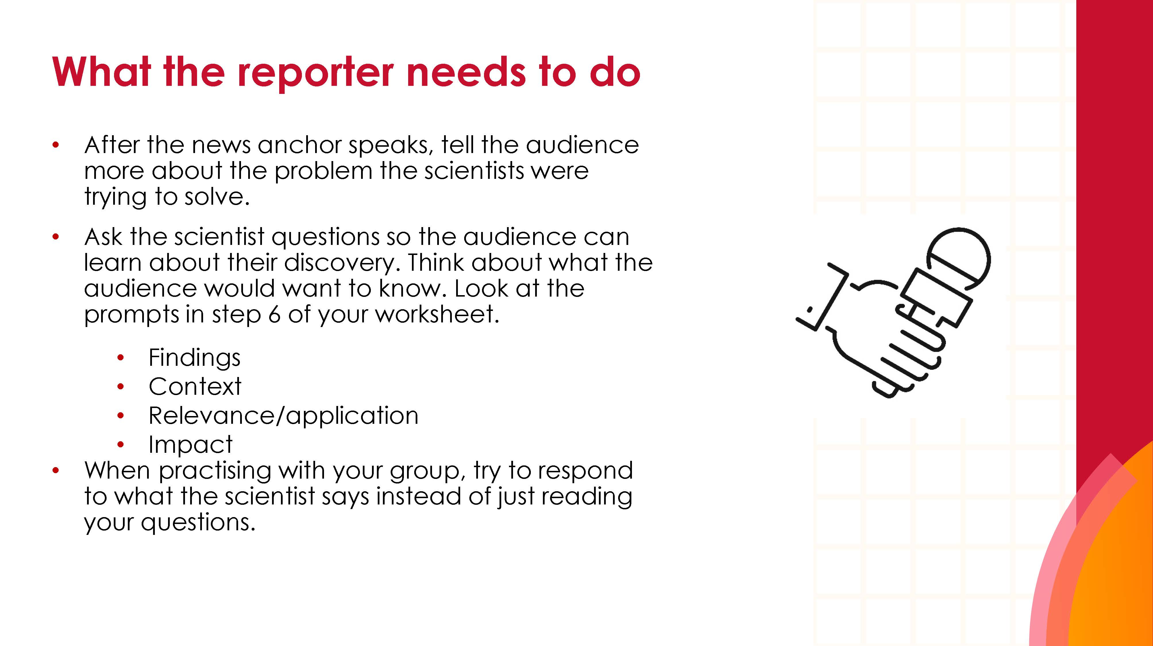
Reading comprehension worksheet: a simplified summary of a research article with comprehension questions and a glossary. | Present the news script: a template groups can write into. | Present the news slides: instructions and hints for a group presentation task.

Learning objectives
- Use active reading strategies to help you understand a science news story.
- Use the glossary to support your understanding of unfamiliar words.
- Know what key information to look for when reading a science news story.
- Understand how people write about science differently depending on their audiences.
- Confidently talk about the science news story, with consideration for your audience.

Questions 1–8 in the student sheet support learning objectives 1 and 2. Question 5 supports learning objective 3. Questions 9–11 support learning objective 4 and the ‘Present the news’ extension task supports learning objective 5.

Introduction

Reading about science is pivotal for understanding the world around us and the events and discoveries that effect our lives. In this reading comprehension, learners will actively engage with a simple text about a research article. Education in Chemistry has collated and distilled a wealth of science research news stories (see rsc.li/4jvfRU0). This reading comprehension resource is based on one of these stories relevant to the elements, compounds and mixtures (14–16) topic includes:

Reading comprehension activity

The story text has line numbers so you can easily direct learners to parts of the text. The line numbers can be disabled, more information on how to do this is available on Microsoft support: bit.ly/4cHKkeW

Model active reading

Before reading, show the headline and ask learners 'what do you think this text is about?' Read all the way through once without interruptions to allow learners to use context clues in the text to support their understanding and problem-solve unfamiliar vocabulary.

Read the text a second time and prompt learners throughout to actively engage with the text. You can ask:
- ‘How would you rephrase what’s just been said?’
- ‘What is this news story about?’
- 'Can you summarise this news story in a sentence?'
- 'Are any words in this text new to you?'

Find more information in: How to teach reading in science.

Consider using playback or recording software, so that learners can listen to the text on a device as they read along.

Question 7 asks learners to write a summary of the news story for their classmates. You can work through this question as a class first, before tasking learners to draw out the required information from the text independently. You can get learners to peer mark the summaries.

Taking it further

For questions 9 and 10, give learners access to a longer, more complex version of the reading comprehension text. Learners will need a printed version to annotate in question 9. See: A fast-track crystallisation technique (rsc.li/3EJf8PW).

Glossary of relevant terms

The glossary is pre-populated with vocabulary from the story that learners may need support with. The Education Endowment Foundation recommends prioritising teaching tier 2 and tier 3 terms, which learners are less likely to hear or read outside of their science lessons. More information on tier 2 and 3 terms can be found on the Education Endowment Foundation website, as well as reports and practical tools: bit.ly/4imgii2

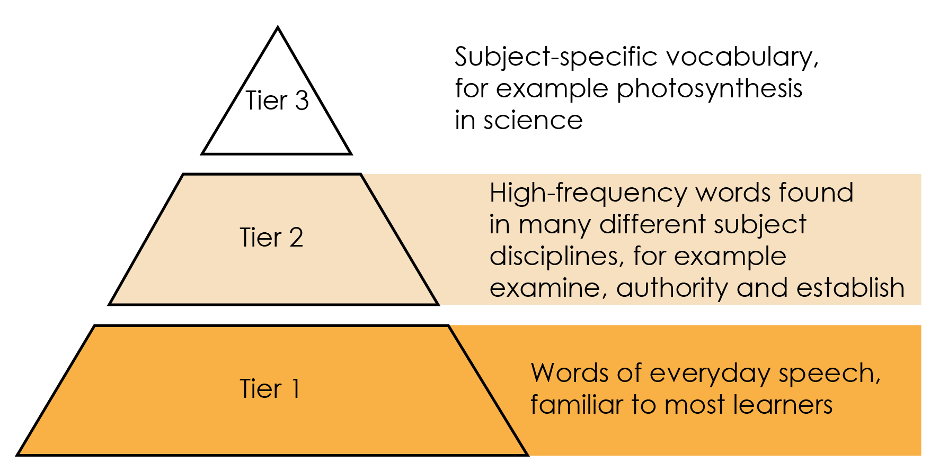

Reproduced with permission from Guilford Press, copyright 2013

Some words in the glossary are key terms and link with our key terms support resources (rsc.li/42tFi0D). For more challenge, remove or edit entries and task learners with researching and then populating the glossary.

Extension task: present the news

Instruct learners to present the science news story they have read as an item in a news programme.

Split learners into groups of three or four and assign each of them one of three roles – news anchor, reporter, or scientist. If there are more than three per group, assign multiple scientists. It’s important that everyone says something during the presentation.
- Project the ‘Present the news’ slides on the board. Explain the task (slide 2) and provide learners with printouts of what each role needs to do (slides 3–5).
- Talk through the slide called ‘What does a good news presentation look like?’ (slide 6).
- Give learners the script template and direct them to prepare, as a group, what they want to say in the presentation. This will firstly involve reading the introduction on the script template, which you can do as a class if necessary. Allow learners about 45 minutes to prepare.
- Revisit the slide called ‘What does a good news presentation look like?’ (slide 6) before inviting the groups to present (allow five minutes per group).
- Direct learners to fill in the feedback sheet on the script template while their classmates are presenting. After all groups have presented, invite reflections and make notes of any learnings for the next speaking and listening activity.

Oracy Cambridge’s ‘Oracy skills framework’ provides more information about speaking and listening skills. For more information, see: bit.ly/4jBaTEG

Metacognition
This resource supports learners to develop their metacognitive skills in three key areas.
Aspect | Ideas for prompts
Plan | - Question 7 provides learners with a series of prompts to scaffold their summary of the science news story.  - The ‘present the news’ script introduction contains questions for learners to ask themselves when planning the presentation, for example about keeping to time.
Monitor | - Ask learners questions when reading the text aloud (see section called ‘model active reading’) to prompt them to monitor their understanding throughout the task.  - The comprehension questions prompt learners to assess how much the active reading strategies help them to understand the text and what other strategies they can employ to aid their understanding.
Evaluate | - Invite feedback on answers to the questions which use the 1–10 scale and collate a reading strategy ‘cheat sheet’ as a class. Revisit this cheat sheet next time you do a reading comprehension activity.  - Use the populated feedback table to reflect as a class on the strengths of the presentations and identify things to work on next time you do a class speaking and listening activity.

Example answers and guidance
- The current method takes 18 months, and it can contaminate the land.
- Learner’s own answer, which may include the following points:

String is placed into brine solution. The water evaporates leaving lithium and sodium crystals on the string.
- Scientific words: lithium, energy, chemicals, evaporate, crystallise, salts, contaminate, ecosystems, crystallisation, technique, crystals.

The point of this exercise is simply to prompt learners to consider which potentially unfamiliar words are specific to science or chemistry, compared to for example connecting words. The list above is an example and there may be variation in answers.
- Any similar definitions to the below, use these definitions to check for accuracy:
- Evaporate – a method of separation used to form solids by heating to remove the solvent from a solution.
- Crystallise – a method of separation used to get crystals of a solid by very slowly evaporating the solvent from a solution.
- Contaminate – to make something less pure or make it poisonous.

Sentences including the terms will vary.

Learners rate how much the glossary is helping them. Do a rough show of hands to gauge confidence and note learners’ responses.

- Ask learners to share what they think is the most important point of the news story.

Look for a good understanding of the key message in the story.

Important words: new crystallisation technique, much faster, saves water, specially designed.

Learners rate how much circling words is helping them. Do a rough show of hands to gauge confidence and note learners’ responses.

- Ask learners to share what they have learned from reading the news article.

Learners rate their confidence explaining the story. Do a rough show of hands to gauge confidence and note learners’ responses. Ask learners to share their strategies for the benefit of the class.

How learners rate the techniques in questions 3 and 4, and their confidence to explain the story, can inform your approach to future reading comprehension activities.

- Indicative answers for summary of story.
- What have the scientists discovered? (Findings)
- How to make lithium crystals using string.
- What was the problem they were trying to solve? (Context)
- The current method takes a long time, using a lot of water, and contaminates ecosystems.
- Why does their discovery matter? (Relevance/application)
- It will help reduce contamination of the land by lithium. It might also be faster and is less water intensive.
- Think about who it matters to, and what impact it could have for them (Impact)
- People who extract lithium and sell it because they can extract the lithium quicker. If the extraction process is quicker, this could mean the cost of production is lower and therefore there could be savings for consumers who purchase lithium-containing products, like batteries.
- If the new process is more environmentally friendly (less contamination and water use), this could be good for the environment and people who live close to/are impacted by lithium mines.
- Warm the salt water in an evaporating basin over a Bunsen burner. The water will evaporate and leave the salt residue behind.

Taking it further
- Learners should highlight the full article in different colours using the prompts below. See the highlighted text below as an example.
- What have the scientists discovered? (Findings)
- What was the problem they were trying to solve (Context)
- Why does their discovery matter? (Relevance/application)
- Think about who it matters to, and what impact it could have for them (Impact)

A fast-track crystallisation technique
Original article by James Urquhart. Adapted by Nina Notman.
Crystallisation tool could help meet global lithium demand and string together a greener future
US researchers have developed a technique that uses an array of strings to significantly speed up the evaporation of lithium salts from brine. This greener approach could help meet growing global demand for the metal, which is needed for electric vehicle batteries and grid storage, as the world moves towards electrification and zero-carbon energy.
The most common way to mine lithium is to pump up brine from underground aquifers to form vast pools on the surface. Millions of litres of water are then left to evaporate for up to 18 months to produce lithium salts. However, such operations are known to contaminate groundwater and harm ecosystems and indigenous communities.
Jason Ren’s group at Princeton University, has devised a rapid crystallisation technique to harvest lithium from both brine and seawater by dangling an array of specially designed strings into the liquids. This approach takes around 20 days, which is nearly 30 times faster than the traditional evaporation method. ‘The process [also] saves a lot of water compared to traditional evaporation approaches,’ says Jason.
A string of successes
The strings are engineered cellulose fibres specially designed in Jason’s lab for this purpose. The fibre cores are water loving, while their surfaces are water repellent. The team spin the fibres into a tight thread before twisting four of the threads together to create the strings.
When the strings are dipped in lithium-containing salt water, the liquid moves up them through capillary action – in the same way as plants suck water up from their roots to their leaves. When the water evaporates from the strings’ surfaces, lithium and sodium ions are left behind. As the evaporation process continues, the salts concentrate to form sodium chloride and lithium chloride crystals.
Importantly, the crystallisation of the sodium and lithium salts occurs at separate points on the strings due to their different solubilities, meaning lithium chloride can be harvested easily without additional processes. The team created a 100-string array showing how the concept can be scaled up.
‘Our process is like putting an evaporation pond on a string, allowing us to obtain lithium harvests with a significantly reduced spatial footprint and with more precise control of the process,’ says Sean Zheng, who is leading the launch of a startup, PureLi, to develop this technology.
‘Using this low-cost and chemical-free approach can easily increase the productivity of current brine lakes by many-folds and potentially quench our thirst for lithium,’ comments Shihong Lin, an environmental engineer at Vanderbilt University, who was not involved in the research.

- Answers will vary, but can include a selection of the following:
- the article is longer
- it contains more details about the discovery and what related research has been done
- it contains quotes from scientists
- it gives examples of why the research was done and where it could be useful
- it has subheadings.

- In the text and annotations look out for an awareness of different writing formats and an appreciation that different audiences have different needs or interests. For example:

- shorter version, links to other interesting articles, key message up front, relevant pictures or video clips;
- longer version, lots of detail, including information on who did the research and maybe their contact information;
- simplifying complicated language, pictures to aid understanding.

Example script for ‘Present the news’
Role | What to communicate | Example script
News anchor | Introduce the issue in one sentence. | Lithium demands are rising as it is used to make electric car batteries.
News anchor | Explain why this discovery might be important. | Scientists have come up with a new way to extract lithium which should reduce the time it takes to extract it.
News anchor | Introduce your classmate reporter who will provide more information. | Our reporter (name of learner) has been investigating.
Reporter | Talk about the problem in more detail, but only briefly. | Lithium extraction currently uses a lot of energy, chemicals, time, water and land.
Reporter | In one sentence, introduce the scientist(/s) and why you are interviewing them. | Here we have (learner name) to tell us about how they are planning to improve the current extraction method.
Reporter | Ask the scientist to explain what they have discovered. | (Learner name) tell us about how you plan to speed up lithium extraction.
Scientist | Answer the first question. | We have developed a new technique that uses specially designed strings to draw up brine. The water then evaporates and leaves lithium crystals behind.
Reporter | Ask the scientist why the discovery is important. | Why is this such an important discovery?
Scientist | Respond to the question. | Well one reason is that it’s potentially much quicker. 20 days compared with 18 months! And there are other benefits too.
Reporter | Ask what difference this research could make to people. | Like what? What difference might this research make to people?
Scientist | Respond to the question. | The new method will lead to less contamination of the land with lithium.
Reporter | Ask how much better the new method is. | That sounds promising. Are there any other benefits to the new method over the current one?
Scientist | Respond to the question. | It should mean we’re using less water, because since the extraction process is much quicker, less will evaporate way.
Reporter | Thank the scientist. | Thank you very much for your time.
Scientist | Acknowledge the thanks. | No problem.
News anchor | Say something in response to what the scientist and the reporter have said, which reflects what your audience might be thinking. Thank the reporter. This will end the presentation. | Thank you to our reporter (learner name) for that report. A great discovery speeding up the extraction of lithium.

Acknowledgements

Vocabulary tier diagram: Beck, Isabel L., Margaret G. McKeown, and Linda Kucan. Bringing Words to Life: Robust Vocabulary Instruction. New York: Guilford Press, 2013.

