Carbon capture from seawater

This resource forms part of the elements, compounds and mixtures (11–14) topic package where you will find more resources to embed literacy skills development into your teaching. You can edit all the linked files in this resource to best suit the needs of your learners.

Resource components

Reading comprehension sheet, present the news slides and script are also available from:
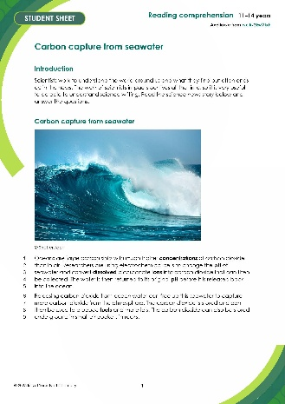 | 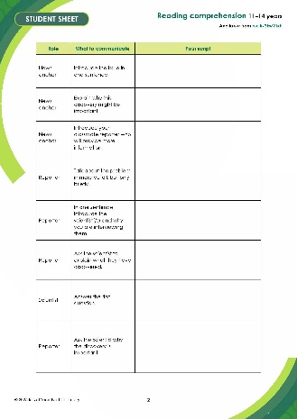 | 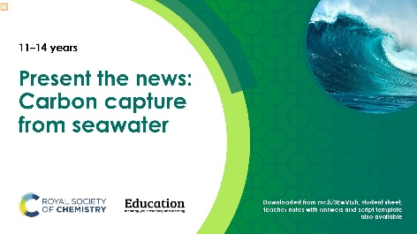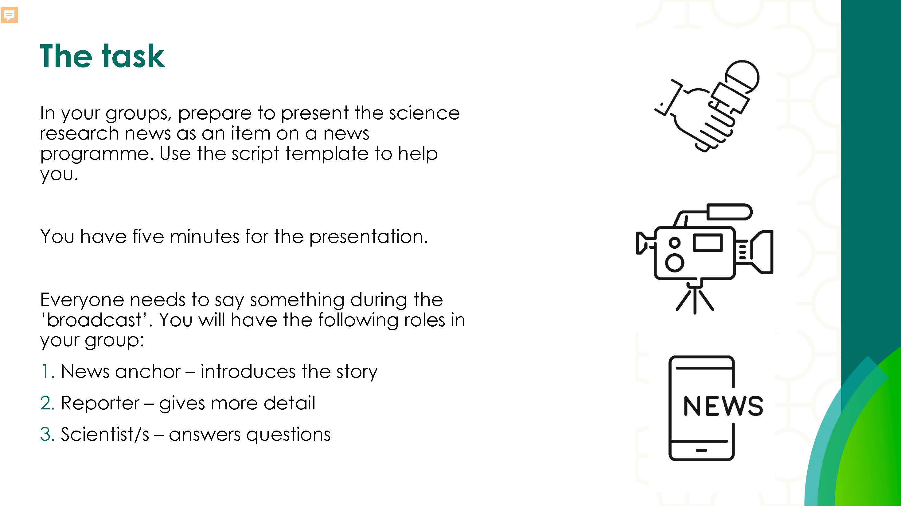
Reading comprehension worksheet: a simplified summary of a research article with comprehension questions and a glossary. | Present the news script: a template groups can write into. | Present the news slides: instructions and hints for a group presentation task.

Learning objectives
- Use active reading strategies to help you understand a science news story.
- Use the glossary to support your understanding of unfamiliar words.
- Know what key information to look for when reading a science news story.
- Understand how people write about science differently depending on their audiences.
- Confidently talk about the science news story, with consideration for your audience.

Questions 1–5 in the student sheet support learning objectives 1 and 2. Question 6 supports learning objective 3. The ‘Take it further’ questions support learning objective 4. And the ‘Present the news’ extension task supports learning objective 5.

Introduction

Reading about science is pivotal for better understanding the world around us and the events and discoveries that effect our lives. In this reading comprehension, learners will actively engage with a simple text about a research article. Education in Chemistry has collated and distilled a wealth of science research news stories (see rsc.li/3YK8xv0). This reading comprehension resource is based on one of these stories relevant to the elements, compounds and mixtures topic.

Reading comprehension activity

The story text has line numbers so you can easily direct learners to parts of the text. The line numbers can be disabled, more information on how to do this is available on Microsoft support: bit.ly/4cHKkeW

Model active reading

Before reading, show the headline and ask learners 'what do you think this text is about?' Read all the way through once without interruptions to allow learners to use context clues in the text to support their understanding and problem-solve unfamiliar vocabulary.

Read the text a second time and prompt learners throughout to actively engage with the text. You can ask:
- ‘How would you rephrase what’s just been said?’
- ‘What is this news story about?’
- 'Can you summarise this news story in a sentence?'
- 'Are any words in this text new to you?'

Find more information in: How to teach reading in science.

Consider using playback or recording software, so that learners can listen to the text on a device as they read along.

Question 6 asks learners to write a summary of the news story for their classmates, using the prompts given. You can work through this question as a class first, before tasking learners to draw out the required information from the text independently. You can get learners to peer mark the summaries.

Taking it further

Give learners access to a longer and more complex version of the reading comprehension text to allow them to answer challenge questions. The longer version of the article, titled Using seawater to reduce our carbon footprint is available to download and print or can be viewed online at: rsc.li/4391bCT. Give learners a printed version to annotate in question 7.

Glossary of relevant terms

The glossary is pre-populated with vocabulary from the story that learners may need support with. The Education Endowment Foundation recommends prioritising teaching tier 2 and tier 3 terms, which learners are less likely to hear or read outside of their science lessons. More information on tier 2 and 3 terms can be found on the Education Endowment Foundation website, as well as reports and practical tools: bit.ly/4imgii2

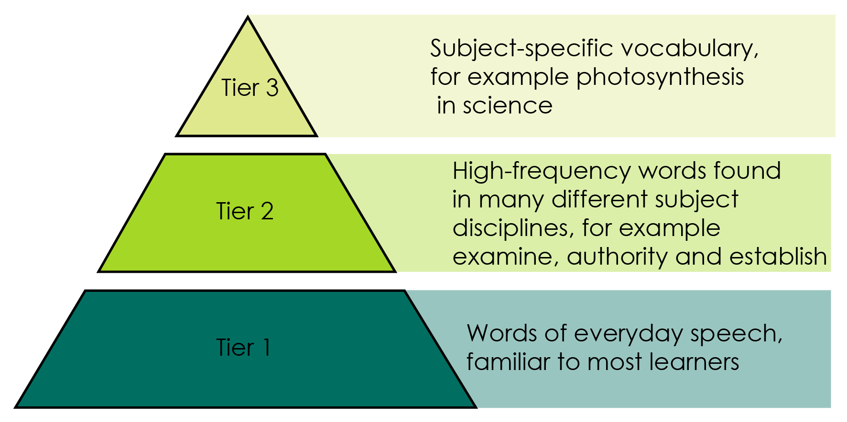

Reproduced with permission from Guilford Press, copyright 2013.

The words listed in bold in the glossary are key terms and link with the key terms support resources (visit: rsc.li/42AcGmK). For more challenge, remove or edit entries and task learners with researching and then populating the glossary.

Extension task: present the news

Instruct learners to present the science news story they have read as an item in a news programme.

Split learners into groups of three or four and assign each of them one of three roles – news anchor, reporter, or scientist. If there are more than three per group, assign multiple scientists. It’s important that everyone says something during the presentation.
- Project the ‘Present the news’ slides on the board. Explain the task (slide 2) and provide learners with printouts of what each role needs to do (slides 3–5).
- Talk through the slide called ‘What does a good news presentation look like?’ (slide 6) before inviting the groups to present (allow five minutes per group).
- Give learners the script template and direct them to prepare, as a group, what they want to say in the presentation. This will firstly involve reading the introduction on the script template, which you can do as a class if necessary. As a rough guide, allow about 45 minutes for learners to prepare.
- Direct learners to fill in the feedback sheet on the script template while their classmates are presenting. After all groups have presented, invite reflections and make notes of any learnings for the next speaking and listening activity.

Oracy Cambridge’s ‘Oracy skills framework’ provides more information about speaking and listening skills. For more information, see: bit.ly/4jBaTEG

Metacognition
This resource supports learners to develop their metacognitive skills in three key areas.
Aspect | Ideas for prompts
Plan | - Question 6 provides learners with a series of prompts to scaffold their summary of the science news story.  - The ‘present the news’ script introduction contains questions for learners to ask themselves when planning the presentation, for example about keeping to time.
Monitor | - Ask learners questions when reading the text aloud (see ‘model active reading’ section) to prompt them to monitor their understanding throughout the task.  - The comprehension questions prompt learners to assess how much the active reading strategies help them to understand the text and what other strategies they can employ to aid their understanding.
Evaluate | - Invite feedback on answers to the questions which use the 1–10 scale and collate a reading strategy ‘cheat sheet’ as a class. Revisit this cheat sheet next time you do a reading comprehension activity.  - Use the feedback sheet to reflect on the strengths of the presentations and identify things to work on next time you do a class speaking and listening activity.

Example answers and guidance
- Any from; burning fossil fuels to generate electricity, driving petrol/diesel cars, deforestation, any other sensible suggestion.
- Carbon dioxide in the atmosphere contributes to the greenhouse effect and can lead to global warming.
- Write down the meaning of the following scientific words from the news story, any other similar definitions. Use these definitions to check for accuracy:
- Dissolved – when a solute is added to a solvent and the solute breaks into much smaller particles and spreads out.
- Fuel – a substance that can transfer useful energy as heat when it is burned.
- Carbon sink – anything that absorbs more carbon from the atmosphere than it releases.

Sentences including the terms will vary.

Learners rate how much the glossary is helping them. Do a show of hands to gauge confidence and note learners’ responses.
- (a) Scientific words: concentration, carbon dioxide, electrochemical, pH, dissolved, bicarbonate, ions, fuels, materials.

The point of this exercise is to prompt learners to consider which potentially unfamiliar words are specific to science or chemistry, compared to, for example, connecting words. The list above is an example and there may be variation in answers.

- Look for a good understanding of the key message in the story. Example answer – free up seawater to capture more carbon dioxide from atmosphere.

Learners rate how much circling words is helping them. Do a show of hands to gauge confidence and note learners’ responses.

Learners rate their confidence explaining the story. Do a show of hands to gauge confidence and note learners’ responses. Ask learners to share their strategies for the benefit of the class.

How learners rate the techniques in questions 3 and 4, and their confidence to explain the story, can inform your approach to future reading comprehension activities.

- Invite learners to share what they’ve learned.

- Indicative answers for summary of story:
- What have the scientists discovered? (Finding)

That carbon dioxide can be removed from sea water by changing its pH and stored in rocks or used to make fuels.
- What was the problem they were trying to solve? (Context)

How to reduce the amount of carbon dioxide in seawater so that the ocean can absorb more carbon dioxide from the atmosphere.
- Why does their discovery matter? (Relevance/application)

It will help reduce the amount of carbon dioxide in the atmosphere which can contribute to climate change and global warming.

The released carbon dioxide can be stored, and/or used to make fuels and materials.
- Think about who it matters to, and what impact it could have for them. (Impact)

It matters to everyone because climate change will affect all aspects of life on earth.

Take it further – example answers
- Learners highlight the full article in different colours using the prompts below. See the highlighted text below as an example.
- What have the scientists discovered? (Finding)
- What was the problem they were trying to solve (Context)
- Why does their discovery matter? (Relevance/application)
- Think about who it matters to, and what impact it could have for them

Using seawater to reduce our carbon footprint
Original article by Rebecca Trager. Adapted by Nina Notman.
New system that uses the Earth’s seawater sink has advantages over existing systems that capture carbon dioxide gas from air
Capturing carbon dioxide (CO₂) from seawater to address climate change could be more efficient and cheaper than existing systems that capture it from ambient air, say engineers in the US. Oceans and other surface waters act as large carbon sinks and have absorbed 30% to 40% of CO₂ emissions from human activities since the industrial revolution began.
Ocean capture
MIT scientists have harnessed electrolysis to separate CO₂ from acidic seawater and lock it away in a new method to reduce our carbon footprint.
Carbon dioxide reacts with seawater to form carbonic acid, which can then dissociate to form bicarbonate (and other) ions. The engineers at the Massachusetts Institute of Technology (MIT) have developed an electrochemical system that converts the bicarbonate ions back into CO₂ gas that can then be collected.
The MIT team’s ocean capture system uses a bismuth electrode that reacts with the chloride ions naturally present in salt water, producing a bismuth compound and protons. These protons increase the acidity of the water, which causes the bicarbonates to break down and reform CO₂. The water is then returned to its original pH before it is released back into the ocean.
Making space
Releasing CO₂ from ocean water in this way enables it to capture more CO₂ from the air. ‘Anthropogenic CO₂ distributes between the ambient air and the ocean water, so removing it from the oceans means there is a drive for more to be absorbed [by the water] and thereby be removed from the air,’ says Alan Hatton, one of the study’s co-authors. ‘The net result of what we do is to remove CO₂ from the environment as a whole,’ he adds.
The team’s ocean capture system could be more efficient than air capture systems because the concentration of dissolved CO₂ in seawater is more than 100 times greater than it is in air, Alan notes. A preliminary cost analysis suggests that this technology would be economically feasible, with costs ranging from $50–$100 (£42–£83) per tonne of CO₂. For comparison, one air capture system was calculated to cost $600 per tonne of CO₂ in 2020.
Finding a purpose
Once the CO₂ is extracted from the seawater, the question becomes what to do with it. Alan believes there are two possibilities: CO₂ can be turned into fuels, chemicals and materials, or it can be permanently sequestered (stored) in rock formations underground. Both these solutions are already in use for CO₂ captured from air.
The MIT engineers are currently patenting their ocean capture system. At first, the idea is to couple the technology with existing infrastructure that already processes seawater, such as desalination plants that remove salt to create drinking water. The team’s end goal is for its system to be deployed as free-standing ocean capture plants around the world.
- Indicative answers:
- The article is longer.
- It contains more details about the discovery and what related research has been done.
- It contains quotes from scientists.
- It gives examples of why the research was being done and where it could be useful.
- It has subheadings.
- Look out for an awareness of different writing formats and an appreciation that different audiences have different needs or interests, For example:
- shorter version, links to other interesting articles, key message up front, relevant pictures or video clips
- longer version, lots of detail, including information on who did the research and maybe their contact information
- simplifying complicated language, pictures to aid understanding.

Example script for Present the news
Role | What to communicate | Example script
News anchor | Introduce the issue in one sentence. | Carbon dioxide in our atmosphere can lead to climate change.
News anchor | Explain why this discovery might be important. | Scientists have come up with a new way to reduce carbon dioxide in the atmosphere.
News anchor | Introduce your classmate reporter who will provide more information. | Our reporter (name of learner) has been investigating.
Reporter | Talk about the problem in more detail, but only briefly. | Carbon dioxide in the atmosphere can lead to climate change and a rise in global temperatures.
Reporter | In one sentence, introduce the scientist(/s) and why you are interviewing them. | Here we have (learner name) to tell us about how they are planning to reduce carbon dioxide levels.
Reporter | Ask the scientist to explain what they have discovered. | (Learner name) tell us about what you have come up with to remove carbon dioxide from the atmosphere.
Scientist | Answer the first question. | We have found a way to change the pH of seawater, which allows carbon dioxide dissolved in the water to be collected.
Reporter | Ask the scientist why the discovery is important. | Why is this an important discovery?
Scientist | Respond to the question. | If we remove carbon dioxide from the ocean, it frees up the water to capture more carbon dioxide from the atmosphere.
Reporter | Explain what a difference this research could make to people. | What difference might this research make to people?
Scientist | Respond to the question. | Since high levels of carbon dioxide in the atmosphere contribute to climate change, removing it is one thing we can do to combat climate change.
Reporter | Ask what happens to the carbon dioxide once it has been captured? | But what happens to the carbon dioxide you collect from the seawater?
Scientist | Respond to the question. | The carbon dioxide we collect can be used to make fuels and other materials.
Reporter | Thank the scientist. | Thank you very much for your time.
Scientist | Acknowledge the thanks. | No problem.
News anchor | Say something in response to what the scientist and the reporter have said, which reflects what your audience might be thinking. Thank the reporter. This will end the presentation. | Thank you to our reporter (learner name) for that report. An exciting discovery that could help to reduce carbon emissions in our atmosphere.

Acknowledgements

Vocabulary tier diagram – Beck, Isabel L., Margaret G. McKeown, and Linda Kucan. Bringing Words to Life: Robust Vocabulary Instruction. New York: Guilford Press, 2013.

