The change in mass when magnesium burns

This investigation is part of the Nuffield practical collection, developed by the Nuffield Foundation and the Royal Society of Chemistry. Delve into a wide range of chemical concepts and processes with this collection of over 200 step-by-step practicals: rsc.li/43bjGql

Learning objectives
- Safely investigate burning magnesium to produce magnesium oxide.
- Correctly record the change in mass.
- Explain why the mass changes.
- Use data to calculate the relative formula mass.

Success criteria
- Safely heat the crucible with the lid on to avoid making any eye contact with the burning magnesium (LO1).
- Correctly use the tongs to safely transfer the crucible and lid (this may need practice whilst cold) (LO1).
- Use the mass balance correctly to record masses by using the tare function correctly (LO2).
- Explain mass change by linking to knowledge of conservation of mass and balanced equations (LO3).
- Link knowledge of conservation of mass with moles to calculate the relative formula mass (LO4).

Introduction

In this experiment, learners measure the mass of magnesium and heat it in a crucible. By noting the change in mass they can discover the formula of magnesium oxide. The practical activity takes 30−45 minutes. If necessary, omit the final step of heating to constant mass to shorten the practical.

Scaffolding

Two versions of the worksheet are available: scaffolded () and unscaffolded (). The scaffolded sheet offers more support to allow learners to access the questions. The answers to the worksheets are at the end of this document.

Integrated instructions are available in the presentation slides.

Technician notes

Read our standard health and safety guidance (rsc.li/3zyJLkx) and carry out a risk assessment before running any live practical.

Equipment

Apparatus
- Safety glasses
- Access to a balance (2 decimal places)

Per group of learners:
- Crucible with lid
- Tongs
- Pipe clay triangle
- Bunsen burner
- Tripod
- Heat resistant mat
- Emery paper

Chemicals
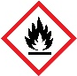
- Magnesium ribbon, pre-cut into 5−10 cm lengths
Fresh, clean magnesium is best for this experiment. If the magnesium is tarnished then learners will need emery or sandpaper to clean it.
DANGER: flammable solid

Health and safety
- Wear eye protection throughout.
- Magnesium ribbon, Mg(s) DANGER: flammable solid
See CLEAPSS Hazcard HC059A, refer to SSERC or contact your local safety advisory body.
- Take steps to prevent theft of magnesium ribbon. Reels of magnesium ribbon should not be left out in the laboratory. It is good practice to have a limited number of pre-cut lengths and to hand these out to learners as needed.
- Magnesium burns with a bright white light. NEVER look directly at magnesium when it is burning. Note: viewing through fingers, sunglasses, smoked glass blue glass or polaroid filters is no longer recommended.
- Learners should all be standing and should wear eye protection. Learners with long hair should tie it back.
- Ask learners to practice lifting the lid on and off the crucible and the crucible off the pipe clay triangle before they start. This also checks that all the tongs are functioning correctly.
- Light one or two Bunsen burners around the room allow learners to light their own using a splint.
- A significant hazard in this experiment is the hot apparatus. Warn learners that it will take some time to cool down.

Disposal
- Scrap the magnesium oxide left in the crucible using a spatula and dispose of as general waste.
- Crucibles can be soaked for a few hours or overnight in 0.5 mol dm⁻³ hydrochloric acid solution. If any solid remains at the bottom, rinse thoroughly using distilled water.
- Porcelain crucibles tend to crack easily if re-used, consider using stainless steel crucibles instead or the alternative method from CLEAPSS using bottle caps (bit.ly/4buC2IJ).

Method

A full written method can be found in the student sheet (rsc.li/3LXAdtr). Alternatively, watch our Conservation of mass practical video which features a simpler version of this experiment, available here: rsc.li/373X3aW

Teaching notes

Learners should have recorded the following masses:
- mass 1 = crucible + lid
- mass 2 = crucible + lid + magnesium
- mass 3 = crucible + lid + product

This should allow them to calculate the mass of the magnesium (mass 2 – mass 1) and the mass of the product (mass 3 – mass 1). They could also calculate the increase in mass (mass 3 – mass 2), which corresponds to the mass of oxygen.

The equation is:

magnesium $+$ oxygen $→$ magnesium oxide

$$2Mg+ O_{2}→2MgO$$

Learners sometimes get unconvincing results to this experiment for several reasons:
- The magnesium oxide product escapes as they lift the lid.
- Not all the magnesium has reacted (the product will still look a bit grey rather than white).
- They have prodded the product with their splint so not all of it got weighed (more common than you might expect).
- They did not tare the balance correctly when measuring the mass.
- The magnesium was coiled too tightly so that not all of it reacted.

Finding the formula of magnesium oxide
- To find the formula of magnesium oxide, learners will need the mass of the magnesium and the mass of the oxygen. They will also require the relative atomic masses. Magnesium is 24 and oxygen is 16.
- They should divide the mass by the atomic mass for each element. This gives the number of moles of each.
- Having done this for both elements, they should find the ratio between the two by dividing them both by the smallest number.
- The ratio should be close to 1:1 as the formula of magnesium oxide is $MgO$.
- Example calculation:
  - Mass magnesium = 2.39 g
  - Mass magnesium oxide = 3.78 g
  - So, the mass of oxygen = 1.39 g
  - Number of moles $Mg$ = 2.39/24 = 0.0995
  - Number of moles $O$ = 1.39/16 = 0.0868
  - Divide by the smallest ratio to give the ratio, approximately 1 $Mg$ : 1 $O$
  - This would suggest a formula of $MgO$, which is the correct formula

Method 2

Learners will need the mass of the magnesium and the mass of oxygen which has combined with it. You will need a copy of the graph for the class. Groups will need to use different lengths of magnesium in order to plot results along the line.
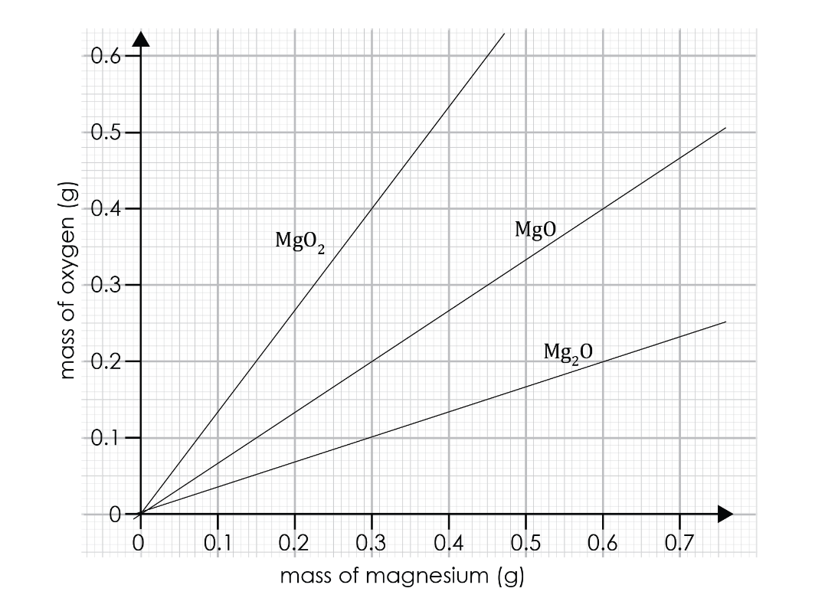

All learners plot their masses of magnesium and oxygen onto the graph. The majority of the results should go on or near the line representing the formula $MgO$, a 1:1 ratio. This shows any anomalous results clearly and will help convince learners who are disappointed by a 1:1.25 ratio, for instance, that the correct formula really is $MgO$.

Answers
- Scaffolded and unscaffolded

Mass increased.
- Scaffolded and unscaffolded
- magnesium + oxygen $→$ magnesium oxide
- $2Mg+ O_{2}→2MgO$
- magnesium and oxygen
- magnesium oxide

- Scaffolded and unscaffolded

The mass during the reaction increased. This is because the oxygen from the air is a gas and also has mass. Therefore, these atoms chemically bond to the magnesium atoms, thus increasing the mass.

- Scaffolded and unscaffolded

Magnesium oxide powder is very fine and could escape from the crucible into the air. This would give a mass reading for the product that is too low.

Unscaffolded answers may also include:

Burning magnesium is dangerous as it produces a large amount of light which can damage your eyes.

