Determining the relative atomic mass of magnesium

Learning objectives
- Measure the volume of hydrogen gas produced during an acid−metal reaction.
- Record accurate measurements of mass and volume in a results table.
- Determine a molar ratio during a chemical reaction using balanced chemical equations.
- Estimate the relative atomic mass of magnesium using your experimental results.

Introduction

In this experiment, you will react magnesium ribbon with dilute hydrochloric acid to produce hydrogen gas. By measuring the mass of magnesium ribbon that you started with and the volume of hydrogen gas produced, you will be able to calculate the molar ratio of hydrogen to magnesium and therefore the relative atomic mass of magnesium.

Equipment

Apparatus
- Safety glasses
- Fine emery paper, a few cm, x 2
- Burette, 50 cm³
Make sure the burette taps are free from leakage, operate smoothly and are secure in their sockets.
- Burette stand
- Funnel, small
- Beaker, 100 cm³
- Beaker, 250 cm³
- Access to a top-pan balance, accurate to +/– 0.001 g
- Access to room temperature and pressure measurements

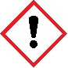
Chemicals
- 25 cm³ 2M hydrochloric acid, IRRITANT
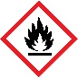
- Magnesium ribbon, cut into lengths of approximately 3–4 cm, DANGER: flammable solid
Clean the magnesium ribbon with emery paper to remove the grey oxide layer, so that it appears shiny and metallic.

Method
- Accurately measure the mass − to the nearest 0.001 g − of a length of magnesium ribbon, approximately 3–4 cm long. The mass should lie between 0.020 g and 0.040 g.
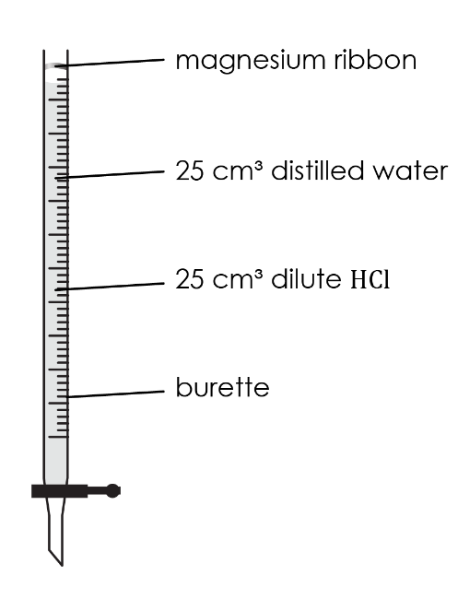
- Make sure the burette tap is closed. Use a small funnel to pour 25 cm³ of dilute hydrochloric acid into the burette, followed carefully by 25 cm³ of water. Try to avoid mixing the two liquids as far as possible. Accurate volume measurements are not needed. This should leave a space of at least 5 cm between the liquid and the top of the burette.

- Carefully push the magnesium ribbon into the open end of the burette, pushing the strip in the middle so that the springiness of the strip holds it in place against the glass. Do not allow it to touch the liquid at this stage.

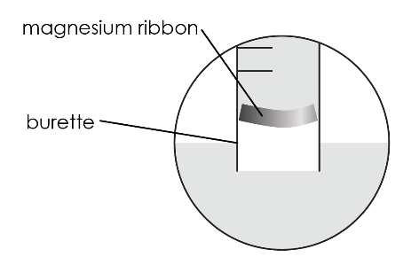
- Add about 50 cm³ of water to a 250 cm³ beaker.

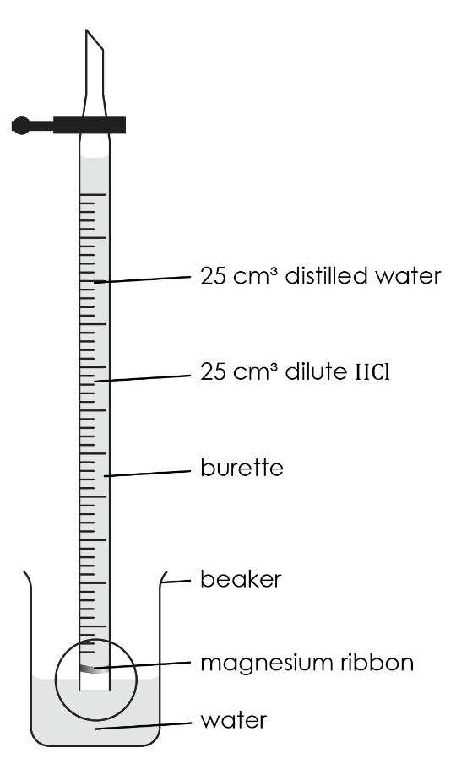
- Rest the top of the burette gently on the lip of the beaker, then quickly turn the burette upside-down and lower the end beneath the water in the beaker. If this is done quickly and carefully (your teacher will demonstrate this first), little or no liquid will be lost. Clamp the burette vertically in this upside-down position.

- Without delay, check that the liquid level in the burette is on the scale – if it is not, open the tap for a moment to allow the level to drop onto the scale.

- Take the burette reading of the liquid level. (Note: the scale is also now upside-down!)

- As the acid diffuses downwards, the magnesium begins to react. Allow the metal to react completely.

- Once the liquid level has stopped changing and no more gas bubbles are being formed, take the final burette reading and record the results.

Results

Mass of magnesium ribbon used / g

Start volume on burette / cm³

End volume on burette / cm³

Volume of hydrogen produced / cm³

Follow-up questions
- Calculate the number of moles of hydrogen produced by following these steps:
(a) State the volume of hydrogen produced in the chemical reaction between magnesium and hydrochloric acid.
Hint: read the volume measurement from the burette.

__________________________________________________________________________________
- Use the volume reading from part (a) to calculate the number of moles of hydrogen produced.
Note: one mole of any gas at room temperature and pressure occupies 24,000 cm³

The equation is:

number of moles = $\frac{volume (answer to part \left(a\right))}{molar volume}$

__________________________________________________________________________________

__________________________________________________________________________________
- (a) Balance the symbol equation for the reaction between magnesium and hydrochloric acid:
$$____Mg + ____HCl → ____Mg{Cl}_{2} + ____H_{2}$$
- Determine the molar ratio between magnesium and hydrogen from the balanced equation above.

__________________________________________________________________________________

- Calculate the number of moles of magnesium that reacted to produce the number of moles of hydrogen determined from question 1.

__________________________________________________________________________________
- Calculate the relative atomic mass of magnesium using the equation below:

M_{r} of magnesium = $\frac{mass of magnesium}{number of moles of magnesium}$

__________________________________________________________________________________

__________________________________________________________________________________
- The relative atomic mass of magnesium is approximately 24.305 (although it is often rounded to 24 on the periodic table). Calculate the percentage error in your calculation using the equation below:

percentage error = $\frac{\text{difference in relative atomic mass}}{\text{actual relative atomic mass}}$x 100

__________________________________________________________________________________

__________________________________________________________________________________
- Suggest two sources of error during the practical which may have led to a difference between the relative atomic mass measured and the actual relative atomic mass.

You may want to consider the following types of error:
- random error − unpredictable and uncontrollable variation in measurements that can cause results to be either too high or too low
- systematic error − causes the measurement to be wrong by the same amount each time
- zero error − caused by equipment that isn’t zeroed properly

__________________________________________________________________________________

__________________________________________________________________________________

__________________________________________________________________________________

__________________________________________________________________________________

Further practice

The experiment was repeated using a small piece of calcium metal in place of the magnesium. The following results were obtained:
Mass of calcium used / g | 0.050
Start volume on burette / cm³ | 2.00
End volume on burette / cm³ | 32.00

Volume of hydrogen produced / cm³

- (a) Calculate the volume of hydrogen produced and add the result to the table.
- Calculate the number of moles of hydrogen produced in the reaction.
Hint: one mole of any gas at room temperature and pressure occupies 24.0 dm³

The equation is:

volume = amount in moles x molar volume

__________________________________________________________________________________
- (a) Balance the symbol equation for the reaction between magnesium and hydrochloric acid:

$$____Ca + ____HCl → ____Ca{Cl}_{2} + ____H_{2}$$

- Determine the molar ratio between magnesium and hydrogen from the balanced equation above.

__________________________________________________________________________________
- Calculate the number of moles of calcium that reacted to produce the number of moles of hydrogen determined from question 1.

__________________________________________________________________________________
- Calculate the relative atomic mass of magnesium using the equation below:

amount in moles = $\frac{mass}{atomic mass}$

__________________________________________________________________________________

__________________________________________________________________________________
- Use your periodic table to find the relative atomic mass of calcium to one decimal place. Calculate the percentage error in your calculation using the equation below:

percentage error = $\frac{\text{difference in relative atomic mass}}{\text{actual relative atomic mass}}$x 100

__________________________________________________________________________________

__________________________________________________________________________________

