The composition and formula of water

Learning objectives
- Describe how water is formed during the redox reaction of copper oxide with hydrogen.
- Accurately record experimental observations and data.
- Determine the formula of water from the experimental data.

Introduction

Your teacher will demonstrate the reaction between copper oxide and hydrogen gas, in which water is a product. During the demonstration, you will record your observations, then use the experimental data to determine the formula of water.

Questions
- Write the word equation for the reaction

__________________ + ________________ → _____________________ + _______________

- Select the correct words to complete the sentences.

In a redox reaction, oxidation and reduction occur at the same time.

Reduction occurs when a substance loses/gains oxygen. Oxidation occurs when a substance loses/gains oxygen.

In this experiment, the copper oxide is oxidised/reduced and the hydrogen is oxidised/reduced.

- Label the diagram using the following words:

concentrated sulfuric acid heat drying tube

combustion tube copper oxide concentrated sulfuric acid

exhaust fumes anhydrous copper chloride hydrogen in
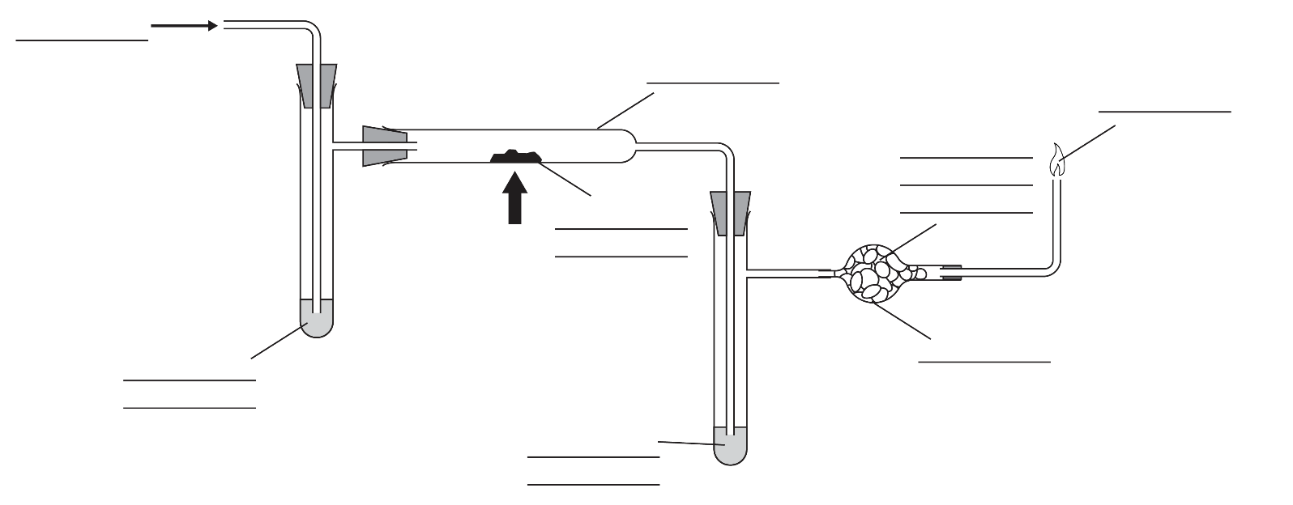

- State why concentrated sulfuric acid was added to the side arms.

Hint: Concentrated sulfuric acid is a drying agent.

It was added to the left-hand arm to dry ______________________________

It was added to the right-hand arm to _________________________________

- List two safety precautions taken during the reaction.
- _________________________________________________________
- _________________________________________________________

- Record the masses in the table.
 | Mass before heating / g | Mass after heating / g
Mass of combustion tube and contents | M1 = ______________ | M2 = _____________
Mass of combustion tube, side arm and contents | M3 = _______________ | M4 = _____________

- Note your observations in the table. Use the final column to explain your observation.

 | Observation | Explanation
Before heating | The solid in the combustion tube was ___________
During heating | _______________ was seen on the side of the combustion tube. It then _____________________
After heating | The solid in the combustion tube was ___________

- Use the data recorded in your table to calculate:

(a) The mass of oxygen lost from the copper oxide (M5) = M1 – M2 = _________ g

(b) The mass of water formed during the reaction (M6) = M4 – M3 = ___________ g

(c) The mass of hydrogen in the water formed (M7) = M6 − M5 = _____________ g

- The relative atomic mass of oxygen is 16 and the relative atomic mass (A_{r}) of hydrogen is 1.

Hint: number of moles = mass/A_{r}

Calculate:
- The number of moles of oxygen in the water = M5/16 = __________ mol
- The number of moles of hydrogen in the water = M7/1 = _________ mol
- The mole ratio of H:O in the water = ________________

- Write the formula of water and describe its composition.

The formula of water is _____________________________.

A molecule of water is made up of two _____________________________ atoms bonded to one _____________________________ atom.

- Complete the balanced symbol equation for the reaction.

$CuO(s)+ H_{2}$(g) → _______________________

